
MEX.TO.NRHP

International Benchmarking Assessment

Supporting the Development of Mexico’s Regulatory and Policy Agenda on Renewable Hydrogen

Deliverable D2
31st January 2026

Title | (D2) International Benchmarking Assessment
Work Package | MEX.TOP.NRHP
Country | Mexico

Version | Date | Reviewer(s)
1 | 28 January 2026 | Shravya Reddy
 |  | Teresa Durand
 |  | Ellie Nutley
2 | 30 January 2026 | Jo Kelly
 |  | Momodou Jack
 |  | Ellie Nutley
3 | 31 January 2026 | Momodou Jack
 |  | Jo Kelly – approved, subject to conditions set out in my email of 31st Jan 2026
4 | 16 February 2026  Final Revisions | Momodou Jack

Disclaimer: The Green Cities, Infrastructure and Energy Programme (GCIEP) is funded by the UK’s Foreign, Commonwealth and Development Office (FCDO) and is led by PricewaterhouseCoopers LLP with an alliance of sub-consultants: Mott MacDonald Ltd, Adam Smith International Ltd, Marriott Davies Yapp LLP and Engineers Against Poverty.
The deliverables that comprise this compendium have been prepared only for the Foreign, Commonwealth and Development Office and solely for the purpose and on the terms agreed with them. We accept no liability (including for negligence) to anyone else in connection with these deliverables, and they may not be provided to anyone else unless agreed within our contract with them.
If you receive a request under freedom of information legislation to disclose any information we provided to you, you will consult with us promptly before any disclosure.

Table of Contents

1 Executive Summary 5
2 Introduction 7
3 Renewable Hydrogen in Mexico 8
4 Global Sector Dynamics 12
5 Methodology and Analytical Framework 14
6 International Benchmarking 18
7 Key Findings 32
8 Conclusion 35
9 References 37
10 Annex 39

Acronyms List
ANLA | National Environmental Licensing Authority (ANLA – Autoridad Nacional De Licencias Ambientales, Colombia)
ASEA | Agency For Safety, Energy And Environment (ASEA – Agencia De Seguridad, Energía Y Ambiente, Mexico)
BMWK | Federal Ministry For Economic Affairs And Climate Action (Germany)
CENACE | National Energy Control Centre (CENACE – Centro Nacional De Control De Energía, Mexico)
CfD | Contract For Difference
CHPS | Clean Hydrogen Power Generation Bidding Market (South Korea)
CONAGUA | National Water Commission (CONAGUA – Comisión Nacional Del Agua, Mexico)
CORFO | Economic Development Agency (CORFO – Corporación De Fomento De La Producción, Chile)
DESNZ | Department For Energy Security & Net Zero (United Kingdom)
FCDO | Foreign, Commonwealth And Development Office (United Kingdom)
FID | Final Investment Decision
GCIEP | Green Cities, Infrastructure And Energy Programme
GoO | Guarantees Of Origin
H2Global | German Government-Backed Hydrogen Procurement Mechanism
HAR | Hydrogen Allocation Rounds (United Kingdom)
HPBM | Hydrogen Production Business Model (United Kingdom)
IEA | International Energy Agency
IDB | Inter-American Development Bank
JOGMEC | Japan Oil, Gas And Metals National Corporation
MNRE | Ministry Of New And Renewable Energy (India)
MOTIE | Ministry Of Trade, Industry And Energy (South Korea)
NDC | Nationally Determined Contributions
NDRC | National Development And Reform Commission (China)
NEA | National Energy Administration (China)
NRHP | National Renewable Hydrogen Policy
PEM | Proton Exchange Membrane Electrolysis
ProInversión | Private Investment Promotion Agency (Peru)
RFNBO | Renewable Fuels Of Non-Biological Origin
SEMARNAT | Ministry Of Environment And Natural Resources (SEMARNAT; Secretaría De Medio Ambiente Y Recursos Naturales, Mexico)
SENER | Ministry Of Energy (SENER; Secretaría De Energía, Mexico)
SOE | State-Owned Enterprise
SOEC | Solid Oxide Electrolysis Cells
ToR | Terms Of Reference
UK | United Kingdom
UPME | Mining And Energy Planning Unit (UPME – Unidad De Planeación Minero Energética, Colombia)

Executive Summary
Mexico is at a formative stage in green hydrogen development. While the country has strong renewable resources and an established industrial base that already consumes hydrogen, most green hydrogen projects remain at concept or feasibility stage. Institutional responsibilities are dispersed and Mexico currently lacks dedicated hydrogen legislation, although initial hydrogen guidelines were issued in 2024.
Hydrogen markets globally are often constrained by common structural barriers including high production costs, revenue uncertainty, regulatory gaps, and insufficient infrastructure. Countries that have progressed beyond pilots typically do so by gradually resolving these constraints through clear leadership, coordinated regulation, and a sequenced policy mix.
This report presents an international benchmarking assessment designed to support Mexico’s Ministry of Energy, SENER (Secretaría de Energía), as it develops the country’s first National Renewable Hydrogen Plan and considers the sequencing, coordination and policy alignment. Eleven markets of different maturities were assessed against a qualitative benchmarking framework that covered three core dimensions:
- Governance & Institutional Arrangements: Leadership structures, coordination, strategic anchoring, monitoring, and stakeholder engagement.
- Legal & Regulatory Foundations: Definitions, permitting frameworks, certification systems, and remaining regulatory gaps.
- Policy Levers: Fiscal incentives, public funding, revenue support mechanisms, standards and certification, and infrastructure-enabling policies.
The eleven countries assessed were agreed with SENER and included: Germany, Netherlands and the United Kingdom, which can generally be considered advanced hydrogen markets in the international context; Japan, Australia, South Korea and China which can be considered to have medium maturity hydrogen markets; India and Chile, which can be considered to have emerging hydrogen markets; and Colombia and Peru which are early stage and can be considered ‘peer’ countries to Mexico.
The results of this assessment provide a structured, evidence-based overview of how these countries have approached the governance, regulatory, and policy foundations needed to enable renewable (green) hydrogen markets. Key findings include:
- Governance maturity is the strongest differentiator between pilot and scaling markets: Countries that have moved beyond pilot projects embed hydrogen within binding national strategies, ensure clear institutional leadership, maintain formal inter-agency coordination and policy coherence.
- Mature markets (e.g., Germany, UK) integrate hydrogen comprehensively across their energy, climate, and industrial policies, resulting in a coherent and mutually reinforcing policy framework.
- Early-stage markets (e.g., Peru, Colombia) rely on fragmented mandates and informal coordination.
- Regulatory certainty evolves incrementally, not all at once: even advanced markets display existing gaps. At early stages, the most critical regulations to address are those that reduce investor risk.
- Advanced markets have clear definitions, operational certification schemes, and hydrogen dedicated regulatory structures.
- Most countries begin by adapting existing energy and environmental laws before developing hydrogen specific regulation. Dedicated hydrogen regulation typically appear only at later stages (e.g., South Korea).
- Policy levers matter less individually and more in how they are sequenced: Successful hydrogen markets employ policy support in a staged progression:
- Early-stage: fiscal incentives, pilots, public funding.
- Scaling stage: revenue stabilisation mechanisms (e.g. public tenders, contracts for differences).
- Advanced stage: coordinated infrastructure investments and system-integration policies.
Countries that fail to progress beyond pilots often rely on isolated levers without evolving toward revenue-risk absorption or infrastructure coordination.
- Infrastructure planning becomes essential once multiple projects emerge: Countries with industrial clusters or export ambitions prioritise shared hydrogen infrastructure (pipelines, ports, hubs). Markets that do not coordinate infrastructure face cost inflation and stalled integration.
- Policies focussed exclusively on production incentives are often insufficient for scaling up: To ensure sustainable growth, demand-side measures that guarantee offtake are equally crucial. Securing long-term demand through targeted policies helps create a stable market environment, reduces investment risks, and encourages the development of comprehensive hydrogen value chains,
Across the benchmark countries, the central finding is that sequencing and alignment, rather than any single policy instrument is most likely to determine whether hydrogen development advances from strategy to bankable investment. Countries that combine clear institutional leadership, progressively refined regulatory frameworks, and evolving policy support that adapts to market maturity are consistently more successful in progressing beyond pilot-level activity.
The next phase for this work under the UK’s Green Cities Infrastructure and Energy Programme will assess Mexico’s existing regulatory and policy framework and examine potential models for cross-government coordination, drawing on international experience and external stakeholder’s perspective to support SENER in strengthening the governance framework for green hydrogen development in Mexico.

Introduction
This report presents an international benchmarking assessment of the governance, regulatory and policy frameworks that countries have applied to enable the development of renewable (green) hydrogen markets. It is intended to support the Government of Mexico, and in particular the Ministry of Energy (SENER, Secretaría de Energía), as it develops the institutional and policy foundations for a future National Renewable Hydrogen Policy.
The assessment is analytical and descriptive in nature. It does not recommend specific policy instruments or seek to replicate international models. Instead, it provides a structured, evidence-based reference on how green hydrogen markets have been organised in practice across different jurisdictions, how responsibilities and frameworks have been allocated, and how policy design and sequencing influences whether projects progress beyond early announcements toward investment and delivery. This positioning is fully consistent with the scope defined in the Terms of Reference and complements parallel technical work on industrial applications and project pipelines.
The report is organised in four parts. It first sets out Mexico’s current national context for renewable hydrogen, focusing on the policy, institutional and market conditions that define the starting point for development. It then examines the green hydrogen sector more broadly, drawing on international experience to outline the structural barriers that commonly constrain deployment. Building on this context, the report applies a consistent analytical framework across international benchmark countries at different stages of market maturity, from early planning through to scaling and later-stage deployment. The framework focuses on three core dimensions, while also recognising the role of infrastructure planning and system integration:
- Governance and institutional arrangements, examining which public entities lead hydrogen policy, how responsibilities are allocated across ministries, regulators and public agencies, and how coordination is managed across the hydrogen value chain.
- Legal and regulatory foundations, assessing the development of hydrogen-specific legislation, permitting frameworks, sustainability criteria and certification systems, and the degree of regulatory clarity provided to developers and investors.
- Policy levers, reviewing the range of instruments applied to support deployment, including fiscal and tax incentives, public funding and CAPEX co-financing, market and revenue support mechanisms, standards and certification, and infrastructure-enabling policies.
Using this framework, the report assesses eleven benchmark countries, selected jointly with SENER, spanning advanced, scaling and peer hydrogen markets, to compare how governance arrangements, regulatory frameworks and policy instruments differ across stages of market maturity and to identify approaches relevant to Mexico’s policy development.
Drawing on this comparative analysis, the report presents a consolidated set of Key Findings and conclusions that draw together findings across governance, regulation and policy design. These findings highlight how different combinations and sequencing of approaches shape market outcomes at different stages of development and clarify the conditions under which countries have moved from strategy and pilots to investable, bankable projects. The analysis provides a grounded reference to inform policy dialogue with SENER and support the next phase of decision-making as Mexico considers how international experience can inform the design and sequencing of its renewable hydrogen policy and associated enabling frameworks.

Renewable Hydrogen in Mexico
Mexico is at a formative stage in the development of a renewable (green) hydrogen sector. The country combines strong renewable resource potential with an established industrial base that already consumes hydrogen, alongside growing interest from private developers. At the same time, the current policy, regulatory and institutional environment reflects an early-stage market, where most announced projects remain at concept or feasibility level and system-level enabling conditions are still evolving.
This section provides an overview of Mexico’s national context relevant to green hydrogen development, focusing on the energy and climate policy landscape, the role of hydrogen in existing industrial activity, the emerging project pipeline, and the current institutional and regulatory setting. This section is descriptive in nature and is solely intended to establish context rather than evaluate policy effectiveness or market performance.

3.1 National Energy and Climate Context
Mexico is undergoing a gradual energy transition within a system that remains heavily reliant on fossil fuels. Approximately three-quarters of electricity generation continues to be supplied by fossil sources, primarily natural gas, while low-carbon generation accounts for a significantly smaller share compared to regional and global averages. In response, the Federal Government of Mexico has articulated objectives to expand clean electricity generation through national energy planning instruments and its updated Nationally Determined Contribution (NDC 3.0), which identifies industrial decarbonisation as a priority area.
Within this context, renewable hydrogen is increasingly considered as a potential complement to direct electrification, particularly for sectors where electrification is technically or economically challenging. International experience suggests that hydrogen deployment is most relevant in hard-to-abate sectors, such as refining, chemicals, fertilisers, mining and selected industrial processes, rather than in applications where direct electricity use is more efficient. Mexico’s exploration of green hydrogen aligns with this global pattern, positioning hydrogen as a potential long-term option rather than an immediate substitute across the energy system.
Mexico’s renewable resource endowment, particularly in solar and wind, is widely recognised as a structural advantage for potential green hydrogen production. Several regions combine high-quality renewable resources with proximity to industrial demand, transport corridors and ports, creating conditions that are commonly associated with early hydrogen clusters in other countries. However, as observed internationally, resource potential alone does not translate into deployment without supportive institutional, regulatory and market frameworks.

3.2 Role of hydrogen in Mexico’s industrial sector
Hydrogen is already used across several strategic industrial sectors in Mexico, most notably in oil refining, chemicals, mining, metals and fertiliser production. At present, this hydrogen is almost entirely fossil-based, produced primarily through steam methane reforming or similar conventional processes. Existing hydrogen use therefore reflects established industrial demand rather than low-carbon deployment.
From a green hydrogen perspective, these sectors represent natural entry points for future substitution. International experience indicates that incumbent hydrogen users are often among the first adopters of renewable hydrogen, as they possess existing technical capabilities, operational familiarity and, in some cases, concentrated demand. Recent sectoral analyses conducted as part of Mexico’s Clean Hydrogen Industrial Strategy estimate indicative, pilot-level substitution potential of over 390,000 tonnes of hydrogen per year across key sectors. This figure reflects technical potential rather than confirmed demand or committed offtake and should be interpreted accordingly.
Geographically, Mexico’s industrial activity and energy infrastructure are concentrated in a limited number of states, including Veracruz, Tamaulipas, Nuevo León, Sonora, Baja California and Durango. Several of these regions also exhibit strong renewable resource availability, creating opportunities for early co-location of renewable generation, electrolysis and industrial demand. International evidence suggests that such clustering can reduce integration costs and infrastructure requirements, particularly at early stages of market development.

3.3 Emerging project pipeline and current stage of development
Publicly available international databases, including those maintained by the International Energy Agency, indicate that interest in green hydrogen projects in Mexico is beginning to emerge across different regions and applications. Announced projects span a range of scales and end products, including hydrogen and hydrogen-derived products such as ammonia.
Table 1. Indicative hydrogen project pipeline in Mexico (IEA)
Project name | Status | Technology | Product | Capacity  (kt H₂/y) | Location | Estimated date
Ikal Solar – DH2 green hydrogen project | Concept | Other  electrolysis | H₂ | 413 | Nuevo León | NA
Aslan Net-zero Energy Mexico (ANEM) –  Phase I | Concept | Other  electrolysis | H₂ | 360 | Sonora | 2028
Aslan Net-zero Energy Mexico (ANEM) –  Phase II | Concept | Other  electrolysis | H₂ | 360 | Sonora | 2030
Tango Solar Sinaloa plant | Concept | Other  electrolysis | H₂ | 140 | Sinaloa | NA
DH2 Sinaloa | Concept | Other  electrolysis | H₂ | 138 | Sinaloa | NA
Mexican Green Hydrogen Hub (Phase 1) | Feasibility study | PEM  electrolysis | Ammonia | 102.0 | Durango | 2028
Neptuno Solar Green Hydrogen Project | Concept | Other  electrolysis | H₂ | 61 | San Luis  Potosí | NA
Dhamma Energy Guanajuato | Concept | Other  electrolysis | H₂ | 42 | Guanajuato | NA
Hy2gen Yucatan Marengo (1) | Concept | Alkaline  electrolysis | Ammonia | 27.1 | Yucatán | 2028
Delicias Solar | Feasibility study | Other  electrolysis | H₂ | 6.1 | Guanajuato | 2026
Hy2gen Yucatan Marengo (2) | Concept | PEM  electrolysis | Ammonia | 6 | Yucatán | 2028
Energía Los Cabos | Feasibility study | PEM  electrolysis | H₂ | 5 | Los Cabos | NA
At this stage, most identified projects remain at concept or feasibility-study phase. No projects have yet reached final investment decision or construction. While some announced capacities are large, these initiatives should be understood primarily as expressions of strategic intent rather than as evidence of a bankable project pipeline.
This early-stage profile is consistent with international experience in countries that are still in the formative phase of hydrogen market development. The diversity of proposed locations, technologies and end uses reflects broad interest, but the lack of progression toward execution suggests that key enabling conditions, such as revenue certainty, regulatory clarity, coordinated infrastructure planning and institutional alignment, are not yet fully in place.

3.4 Institutional and regulatory context for hydrogen
Mexico does not currently have a hydrogen-specific legal or regulatory framework. Hydrogen-related activities are instead governed through existing sectoral laws and cross-cutting regulatory regimes, depending on project configuration, production pathways and end uses.
In the absence of dedicated hydrogen legislation, green hydrogen projects in Mexico may be subject to a combination of the following legal frameworks:
- Hydrocarbons Law (Ley de Hidrocarburos): Applies where hydrogen is integrated into refining, fuel processing or activities linked to regulated hydrocarbon value chains.
- Electricity Industry Law (Ley de la Industria Eléctrica): Governs renewable electricity generation, grid interconnection and electricity supply arrangements relevant to electrolysis-based hydrogen production.
- General Law on Climate Change (Ley General de Cambio Climático): Provides the overarching climate policy context and frames national mitigation objectives relevant to low-carbon hydrogen development.
Environmental, water-use and industrial safety requirements are addressed through cross-cutting regulatory regimes rather than hydrogen-specific rules. As a result, developers must comply with multiple legal and administrative processes in parallel, increasing regulatory complexity at early stages of project development. This reliance on existing legislation is consistent with international experience in early-stage hydrogen markets, where dedicated legal frameworks typically emerge only as deployment begins to scale.
In 2024, the Ministry of Energy issued Hydrogen Guidelines (Lineamientos en Materia de Hidrógeno), which outline general principles for sector development and represent an initial step toward a more dedicated framework. At present, however, hydrogen-specific permitting regimes, sustainability criteria and certification systems are not yet in place, and projects must navigate multiple regulatory processes depending on their design.
From an institutional perspective, responsibility for hydrogen-related activities in Mexico is distributed across multiple federal, state and local authorities, reflecting the cross-sectoral nature of the hydrogen value chain.

Table 2. Mexico Governance Institutions
Institution | Role | Responsibilities
Ministry of Energy  (SENER) | National energy policy leadership and strategic planning | - Define overall energy policy orientation and priorities  - Lead the development of the Renewable Hydrogen Roadmap and National Plan  - Coordinate hydrogen-related activities across federal institutions
Ministry of Environment and Natural Resources  (SEMARNAT) | Environmental policy and regulation | - Conduct environmental impact assessments  - Issue environmental permits applicable to hydrogen, renewable energy and related infrastructure  - Oversee compliance with environmental regulations
National Water Commission  (CONAGUA) | Water resource management and permitting | - Issue water-use permits relevant to electrolysis projects  - Authorise water abstraction and discharge  - Ensure compliance with water availability and resource management regulations
Agency for Safety, Energy and Environment  (ASEA) | Industrial and environmental safety regulation | - Regulate safety and environmental standards for energy-related activities  - Oversee facilities where hydrogen production, storage or handling intersects with regulated energy or fuel activities  - Enforce industrial and environmental safety requirements
Energy Regulatory Commission  (CRE) | Energy market regulation | - Regulate electricity and fuel-related activities  - Approve regulatory requirements relevant to electricity supply for electrolysis  - Oversee compliance with applicable energy regulations
National Energy Control Centre  (CENACE) | Electricity system operation | - Operate the national electricity system  - Manage system dispatch and balancing  - Oversee grid interconnection processes for grid-connected renewable energy and electrolysis projects
State and municipal authorities | Local planning and permitting | - Approve land-use planning and zoning  - Issue construction and local operating permits  - Ensure compliance with subnational planning regulations
Port and transport authorities | Logistics and transport oversight | - Regulate port operations and terminals  - Authorise transport and logistics infrastructure  - Support hydrogen and hydrogen-derived product import and export activities

As observed in benchmark countries, governance arrangements typically evolve as hydrogen markets mature. Early-stage markets often rely on existing institutional structures, with more formalised coordination mechanisms emerging as deployment scales. Mexico’s current institutional landscape reflects this early-stage profile, providing the baseline against which international experience is examined in the sections that follow.

Global Sector Dynamics
Green hydrogen is at an early stage of development globally, with deployment concentrated in pilot projects, demonstration initiatives and a limited number of early commercial applications. While interest in hydrogen has grown rapidly across regions, progress has been uneven, reflecting differences in sectoral demand, infrastructure readiness and the maturity of enabling policy and regulatory frameworks. Mexico’s hydrogen sector exhibits many of the characteristics observed in other early-stage markets, providing a relevant reference point for examining global deployment patterns and constraints.

4.1 Global hydrogen value chain and deployment patterns
Globally, the green hydrogen value chain spans renewable electricity generation, hydrogen production through electrolysis, storage and transport, and end-use applications across industry, energy and transport. International experience shows that these elements rarely develop simultaneously, particularly in early markets.
Deployment has typically begun with pilot and demonstration projects focused on hydrogen production and limited end-use applications. As markets mature, attention shifts toward system integration, shared infrastructure and coordinated development across multiple projects and users. Countries that have progressed beyond pilots have generally addressed value-chain constraints through coordinated approaches rather than isolated, project-level interventions.
In terms of applications, green hydrogen is primarily targeted at sectors where direct electrification is not technically feasible or economically efficient. These include existing hydrogen-consuming industries such as refining, ammonia and chemicals, selected industrial processes, heavy transport and, in some cases, power system balancing. International experience consistently indicates that hydrogen functions as a targeted decarbonisation option rather than a universal solution.

4.2 Common barriers to green hydrogen deployment
Across countries and regions, green hydrogen deployment is constrained by a consistent set of structural barriers. These barriers have been observed across markets with varying resource endowments, policy ambition and stages of development.
- Revenue uncertainty and demand risk
Green hydrogen remains materially more expensive than fossil-based alternatives in most applications. In the absence of predictable long-term revenues or committed offtake, projects face high market risk, limiting bankability and access to project finance. Where demand and revenue risks are not addressed, project pipelines tend to stall at announcement or feasibility stage.
- Regulatory uncertainty and evolving standards
In many jurisdictions, hydrogen-specific definitions, certification systems and permitting regimes are either absent or still evolving. This creates regulatory and compliance uncertainty for developers and financiers, increases transaction costs and slows project development, particularly for first-of-a-kind initiatives.
- High production costs and capital intensity
Green hydrogen production requires substantial upfront investment in electrolysers, renewable generation and associated infrastructure. Under current market conditions, production costs typically exceed those of conventional hydrogen by a significant margin. High capital intensity constrains early deployment and increases reliance on public support or balance-sheet financing.
- Infrastructure gaps and system integration challenges
Hydrogen deployment depends on dedicated infrastructure for production, storage, transport and distribution. In early markets, the absence of shared infrastructure forces projects to rely on bespoke, project-specific solutions, increasing costs and execution risk. As multiple projects emerge, system integration and infrastructure planning become increasingly critical.
- Coordination and execution challenges
Hydrogen value chains involve multiple actors across energy, industry, environment, water, transport and trade. Where institutional roles are unclear or coordination mechanisms are weak, decision-making can be delayed, permitting processes can become fragmented and project timelines can be extended.
These sectoral barriers provide a common reference point for understanding green hydrogen development across countries. International experience shows that differences in deployment outcomes are shaped less by the presence of individual instruments and more by how governance arrangements, regulatory foundations and policy levers are structured and sequenced to address these constraints. The analytical framework applied in the sections that follow examines how different countries have responded to these barriers through alternative institutional, regulatory and policy approaches.

Methodology and Analytical Framework
This assessment applies a structured qualitative benchmarking methodology to compare how different countries have designed and implemented governance arrangements, legal and regulatory frameworks, and policy instruments to support the development of renewable hydrogen markets. The methodology is based on a systematic review of publicly available primary sources, including national strategies, legislation, regulatory instruments, official guidance, programme documentation and government publications, complemented by secondary analysis from international organisations and rigorous analytical literature.
A common analytical framework was designed and applied consistently across all benchmark countries to enable comparison across the different stages of market maturity. The approach is descriptive and comparative rather than evaluative: it documents how policy frameworks are structured and sequenced in practice and how these evolve as markets develop, without scoring, ranking or assessing the effectiveness of individual policies.
The rationale for the selection of the analytical dimensions applied in this framework is set out below.

5.1 Rationale for the Analytical Framework
Alignment with the Terms of Reference
The analytical framework applied in this assessment is directly aligned with the scope and objectives defined in the Terms of Reference (ToR) for Deliverable 2.1. The ToR explicitly require an international benchmarking assessment examining institutional arrangements, regulatory structures, and policy mechanisms relevant to renewable hydrogen market development.
The three-dimensional framework adopted in this report, (i) Governance and Institutional Arrangements, (ii) Legal and Regulatory Foundations, and (iii) Policy Levers, provides a structured approach to systematically address these requirements.
- Governance and Institutional Arrangements respond to the ToR requirement to analyse leadership models, inter-agency coordination and institutional responsibilities across the hydrogen value chain.
- Legal and Regulatory Foundations address the need to assess regulatory clarity, permitting regimes, sustainability criteria and certification systems relevant to hydrogen deployment.
- Policy Levers respond to the requirement to examine the economic and market instruments used internationally to enable renewable hydrogen development.
By structuring the benchmarking assessment across these three dimensions, the framework ensures comprehensive coverage of the institutional, regulatory and economic conditions specified in the ToR, while enabling consistent cross-country comparison across different stages of market maturity.
Methodological and Theoretical Rationale for the Three-Dimensional Framework
The selection of these three dimensions is grounded in established economic theory, technology deployment literature, and methodological approaches used by leading international energy institutions.
International analyses of emerging clean technology markets, including those conducted by the International Energy Agency (IEA), the International Renewable Energy Agency (IRENA), the World Bank, and the OECD, consistently identify a recurring set of structural barriers that determine whether technologies progress from pilot phases to large-scale deployment. Across these assessments, three categories of constraints are repeatedly highlighted: coordination and institutional fragmentation; cost gaps and capital intensity; and revenue, demand and market-formation risks.
These barriers are particularly acute in hydrogen markets, where multi-actor value chains, infrastructure interdependencies and regulatory uncertainty interact to delay investment and scale-up. Drawing on this body of international evidence, the benchmarking framework applied in this section organises the enabling conditions around the following three barrier categories:
- Coordination and Institutional Barriers
Emerging sectors such as renewable hydrogen involve multiple ministries, regulators, system operators and industrial actors. Economic theory recognises coordination failures and fragmented mandates as key barriers in multi-actor markets. Governance clarity and institutional alignment reduce transaction costs, accelerate permitting, and improve policy coherence.
- Regulatory Uncertainty and Investment Risk
Investment theory emphasises that regulatory uncertainty increases risk premiums and delays capital allocation. Clear definitions, permitting regimes, safety standards and certification systems reduce uncertainty, improve predictability, and enable access to finance. International hydrogen assessments consistently identify regulatory clarity as a precondition for bankability.
- Economic and Market Failures
Renewable hydrogen markets face cost gaps relative to incumbent fossil alternatives, demand uncertainty, and infrastructure externalities. Economic theory on market failures, including learning-by-doing, positive externalities and network effects, demonstrates the need for targeted public intervention through fiscal instruments, revenue stabilisation mechanisms and infrastructure coordination.
These three barrier categories map directly onto the three analytical dimensions applied in this report:

Barrier Category | Analytical Dimension
Coordination failures | Governance & Institutional Arrangements
Regulatory uncertainty | Legal & Regulatory Foundations
Economic & market  failures | Policy Levers
This structure reflects the “enabling environment” approach commonly applied by international organisations in assessing clean energy transitions. Rather than focusing exclusively on techno-economic performance, these institutions analyse hydrogen development through governance capacity, regulatory readiness and targeted policy intervention frameworks. For example:
- The IEA’s hydrogen market analyses, including Global Hydrogen Review 2023, emphasise regulatory frameworks, infrastructure readiness and demand-support mechanisms as core determinants of deployment outcomes.
- IRENA’s policy guidance in Geopolitics of the Energy Transformation: The Hydrogen Factor highlights coordinated governance, regulatory clarity and sequenced policy packages as critical to unlocking green hydrogen investment.
- The World Bank’s Scaling Up Green Hydrogen for Development focuses on institutional capacity, regulatory certainty and financial de-risking instruments as principal drivers of hydrogen market
formation.
- OECD analysis in OECD Policy Responses to Hydrogen stresses the importance of coherent policy mixes addressing cost gaps, standards and infrastructure simultaneously.
By structuring the benchmarking analysis across governance, regulation and policy levers, this framework captures the full set of enabling conditions required for hydrogen market development. It therefore provides a comprehensive diagnostic lens that allows comparison across countries at different maturity levels, while avoiding normative scoring or prescriptive judgments.
Together, these three dimensions reflect not only the scope of the project but also internationally recognised methodological practice for assessing emerging clean energy markets.
Scope clarification
The benchmarking presented in this section focuses specifically on institutional, regulatory and policy enabling conditions for green hydrogen market development. It does not include detailed techno-economic modelling (e.g., levelised cost of hydrogen – LCOH analysis), project-by-project bankability assessments, or quantitative scoring and ranking of countries. These dimensions fall outside the scope of this deliverable and are either addressed through other analytical workstreams or require separate, dedicated modelling exercises. The objective of this section is therefore descriptive and comparative, rather than financial or prescriptive.

5.2 Analytical Framework
Countries have adopted a wide range of approaches to enable the development of renewable (green) hydrogen markets, reflecting differences in institutional arrangements, regulatory foundations and policy priorities. These approaches have evolved as markets have moved from early planning and pilots toward deployment at scale. A structured comparative framework is therefore required to examine how governance, regulation and policy design differ across jurisdictions and how these differences relate to observed market outcomes. For the purpose of this assessment, the three following core dimensions were considered.
 |  | Dimension 1: Governance and Institutional Arrangements  Considers which public entities lead hydrogen policy, how responsibilities are distributed across ministries, regulators and public agencies, and how coordination is managed across the value chain.
 |  | Dimension 2: Legal and Regulatory Foundations  Examines the presence or absence of hydrogen-specific legislation, permitting regimes, sustainability criteria and certification systems.
 |  | Dimension 3: Policy Levers  Assesses the potential effectiveness of five core policy levers* that international experience and relevant literature have traditionally maintained are central to green hydrogen deployment.  The policy levers that have been assessed in this report are (1) fiscal and tax incentives; (2) direct public funding and CAPEX co-financing; (3) market and revenue support mechanisms; (4) standards, certification and regulation; and (5) infrastructure-enabling policies.

International Benchmarking
6.1 Benchmarking Scope
The selection of benchmark countries and the analytical approach were developed jointly with the Ministry of Energy (SENER; Secretaría de Energía) to ensure that the international comparison reflects relevant and diverse experiences in green hydrogen development aligned with Mexico’s policy context and strategic interests, including:
The benchmark sample was designed to capture the full range of policy and market conditions relevant to Mexico’s current stage of renewable hydrogen development. It therefore includes advanced markets where hydrogen is already moving toward scale, emerging and scaling markets that are actively transitioning from policy definition to deployment, and peer countries with comparable industrial structures or development trajectories. This breadth is necessary to assess how governance arrangements, regulatory frameworks and policy instruments evolve across different stages of market maturity and to ensure that lessons drawn are applicable across multiple potential development pathways.
- Advanced hydrogen markets, where policy frameworks, infrastructure development and financing mechanisms are already supporting large-scale deployment
- Scaling and emerging markets, where governments are transitioning from policy definition to early deployment and market creation
- Peer countries with comparable industrial structures or development stages, which provide relevant reference points for sequencing and policy design
Based on these criteria, the benchmarking covers eleven countries across Latin America, Europe and Asia–Pacific providing a balanced reference for understanding how green hydrogen markets are being enabled under different institutional, regulatory and economic conditions.
The main body of the report highlights selected insights from the country analyses as illustrative examples, with the full country profiles and detailed assessments available in the Annex.
Figure 1. Map of benchmark countries
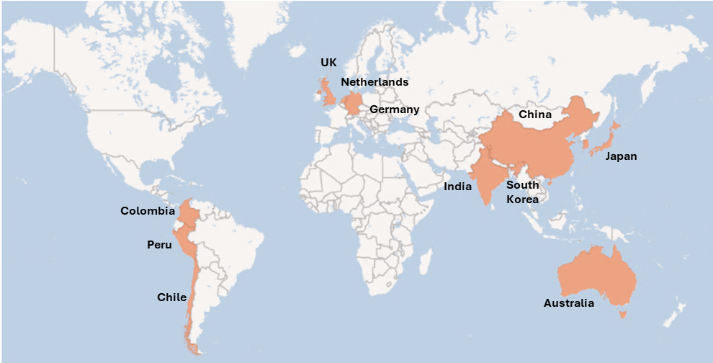
6.2 Governance and Institutional Arrangements
Across the sample of eleven benchmark countries, differences in hydrogen deployment outcomes are strongly associated with how governance arrangements are structured and coordinated. Countries that have progressed beyond pilot stages tend to exhibit clearer institutional leadership, formal coordination mechanisms and explicit strategic anchoring for hydrogen within broader energy and industrial policy. By contrast, early-stage markets typically rely on fragmented mandates and informal coordination, which constrains delivery even where policy ambition exists.
In this assessment, ‘governance’ refers to the institutional framework that underpins hydrogen development, including how responsibilities are allocated across public bodies and how coordination is managed across the value chain. While institutional setups and lead authorities vary across jurisdictions, international experience points to a set of recurring governance practices that support strategic alignment, investment confidence and coordinated delivery.
This section therefore examines the governance models and institutional arrangements observed across the benchmark countries, focusing on the presence of formal strategic anchors, institutional leadership, inter-agency coordination mechanisms, and approaches to oversight, monitoring and stakeholder engagement.
Table 3. Governance and Institutional Arrangements Framework
 | Category | Scope | Evaluation Approach
Strategic policy framework | National hydrogen policy / strategy | Existence of a formally adopted, government-issued national hydrogen strategy, roadmap or mission that sets objectives and direction for hydrogen development. | Yes: strategy or roadmap formally issued or adopted by government  No: hydrogen addressed only indirectly or informally.
 | Integration into energy, climate and industrial policy | Degree to which hydrogen is explicitly integrated into core national policy frameworks, including energy transition plans, climate targets and industrial development strategies. | High: hydrogen embedded across multiple policy domains  Medium: referenced in some policy areas  Low: limited or ad hoc integration.
Institutional arrangements | Institutional leadership for hydrogen development | The type of public institution that leads hydrogen development and where hydrogen is institutionally anchored within government (e.g. energy-focused, economy/industry-focused, technology/innovation-focused, central planning-led, or hybrid models). | Energy-led  Economy / industry-led  Technology / innovation-led  Central planning / state-led  Hybrid model (e.g. energy–industry, federal–state)
 | Inter-institutional coordination | Existence and effectiveness of coordination mechanisms across ministries, regulators and levels of government involved in hydrogen development. | High: formal coordination mechanisms in place  Medium: coordination occurs but is informal or ad hoc  Low: limited coordination.
Implementation capacity | Oversight, monitoring and evaluation | Presence of mechanisms to monitor implementation, track progress and review outcomes of hydrogen-related policies and programmes. | High: structured monitoring and reporting frameworks  Medium: programme-level monitoring only  Low: limited or no systematic monitoring.
Stakeholder engagement | Stakeholder participation | Degree of structured engagement with industry, academia, research institutions, civil society and local communities in hydrogen policy development and delivery. | High: strong, ongoing engagement  Medium: consultation at specific stages  Low: limited engagement.
External engagement | International cooperation | Extent of participation in bilateral, regional or multilateral hydrogen cooperation frameworks that support learning, trade or deployment. | High: active participation in structured cooperation frameworks  Medium: selective bilateral engagement  Low: limited cooperation.

Table 4. Governance and Institutional Arrangements Analysis
 | National hydrogen policy / strategy | Integration into energy, climate and industrial policy | Institutional Leadership for Hydrogen Development | Inter-institutional coordination | Oversight, monitoring and evaluation | Stakeholder participation | International cooperation
Germany | Yes – government-issued National Hydrogen Strategy | High | Hybrid: energy and industry-led | High | High | Strong industry and research engagement | High – EU frameworks and bilateral EU partnerships
Netherlands | Yes – government-issued National Hydrogen Strategy | High | Energy and infrastructure-led | High | High | Strong industry and port authority engagement | High – EU frameworks and North Sea cooperation
United Kingdom | Yes – government-issued UK Hydrogen Strategy | High | Energy-led with delivery focus | High | High | Industry clusters and academic engagement | High – EU, North Sea and US cooperation
Japan | Yes – government-issued Hydrogen Strategy | High | Economy and trade-led | High | High | Industry-led participation | High – supply-chain partnerships (Australia, Middle East)
Australia | Yes – government-issued National Hydrogen Strategy | Medium–High | Hybrid: federal–state, energy and industry-led | Medium | Medium | Industry-led hub participation | High – export partnerships (Japan, Korea, EU)
South Korea | Yes – government-issued Hydrogen Economy Roadmap | High | Industry and energy-led (legislated) | High | High | Industry participation via power sector | Medium–High – Asia-Pacific bilateral cooperation
China | Yes – government-issued national planning guidance | High | Central planning and state-led | High | Medium–High | State-led industrial participation | Low – selective bilateral cooperation
India | Yes – government-issued National Green Hydrogen Mission | Medium | Energy-led, mission-based | Medium | Medium | Growing industry engagement | Medium – EU and bilateral partnerships
Chile | Yes – government-issued National Green Hydrogen Strategy | Medium | Energy-led with export orientation | Medium | Medium | Pilot-focused industry engagement | Medium – EU and export-oriented cooperation
Colombia | Yes – government-issued Hydrogen Roadmap | Low–Medium | Energy-led, early-stage | Low–Medium | Low | Early multi-stakeholder engagement | Medium – regional and EU cooperation
Peru | Yes – government-issued Hydrogen Roadmap | Low | Energy-led, planning-stage | Low | Low | Limited stakeholder engagement | Low – multilateral support only

Illustrative Examples: Governance and Institutional Arrangements (Dimension 1)
- National hydrogen strategy as an institutional anchor
When the sample of benchmark countries is considered, national hydrogen strategies or roadmaps issued by government authorities serve as the primary institutional anchor for hydrogen development. These instruments establish a shared reference point for public institutions and provide an organising framework for subsequent regulatory, funding and planning activities.
Differences are observed in the extent to which these strategies function as binding institutional reference documents versus high-level policy statements. In more mature governance settings, strategies are embedded within formal policy cycles and referenced across institutions. In early-stage settings, strategies tend to play a signalling and coordination role while institutional responsibilities continue to evolve.
Germany
- Institutional approach: A government-issued National Hydrogen Strategy functions as a formal reference for public institutions involved in hydrogen development.
- How it operates: The strategy is used to align mandates across ministries and public agencies and to structure subsequent regulatory and funding initiatives.
- Observed institutional outcome: High institutional consistency in how hydrogen-related responsibilities are defined and coordinated.
India
- Institutional approach: A mission-based national framework provides a central institutional reference for hydrogen development.
- How it operates: The mission establishes objectives and assigns responsibilities, with detailed institutional arrangements introduced progressively.
- Observed institutional outcome: Clear strategic reference, with institutional roles and coordination mechanisms still consolidating.

- Integration into energy, climate and industrial governance frameworks
The degree to which hydrogen is integrated into core energy, climate and industrial policy frameworks shapes how institutions engage with hydrogen development. Higher levels of integration indicate that hydrogen-related responsibilities are embedded within existing governance structures rather than treated as a standalone policy topic.
In practice, integration affects how institutions prioritise hydrogen relative to other policy objectives and how coordination occurs across sectors. Where integration is limited, hydrogen governance often relies on ad hoc coordination mechanisms.
United Kingdom
- Institutional approach: Hydrogen governance is embedded within broader energy transition and industrial decarbonisation frameworks.
- How it operates: Responsibilities for hydrogen are linked to existing institutional structures managing net zero and industrial clusters.
- Observed institutional outcome: Clear alignment between hydrogen-related mandates and existing governance processes.
Chile
- Institutional approach: Hydrogen governance is linked to national energy policy and export-oriented industrial objectives.
- How it operates: Integration into industrial governance is evolving alongside early project development.
- Observed institutional outcome: Growing coherence across institutions, with integration strengthening over time.

- Energy and industry ministries at the helm with cross-sector collaboration
Both Energy and Industrial authorities are fundamental to the development and scaling of green hydrogen: the energy sector oversees production and infrastructure, while the industrial sector represents a significant area of demand and utilization. This alignment underscores the importance of strong collaboration between these ministries to effectively coordinate strategies, investments, and policies for the successful advancement of the green hydrogen economy
Germany
- Leadership model: Hybrid energy–industry.
- How it operates: Hydrogen leadership is institutionally anchored at the intersection of energy transition and industrial policy.
- Observed institutional outcome: Responsibilities are distributed across energy and industrial governance structures.
Japan
- Leadership model: Economy and trade-led.
- How it operates: Hydrogen governance is anchored within economic and trade policy, with a strong focus on supply chains.
- Observed institutional outcome: Institutional alignment between hydrogen policy and international trade engagement.

- International cooperation as an institutionalised function
International cooperation reflects the extent to which cross-border engagement on hydrogen is embedded within institutional arrangements. This includes participation in bilateral agreements, regional initiatives and multilateral platforms.
The institutionalisation of international cooperation varies across countries, depending on whether hydrogen development is oriented toward domestic use, exports or international supply chains.
Netherlands
- Institutional approach: Regional cooperation is embedded within European energy governance frameworks.
- How it operates: Participation in EU and North Sea initiatives provides structured channels for coordination.
- Observed institutional outcome: Institutionalised cross-border engagement linked to infrastructure and regulatory coordination.
Japan
- Institutional approach: Bilateral cooperation and international institutions are central to hydrogen governance.
- How it operates: Government-led agreements structure engagement with international supply partners.
- Observed institutional outcome: Formalised international cooperation aligned with domestic governance arrangements (for example Japan is a founding member of Mission Innovation’s Hydrogen Mission focuses on scaling up hydrogen technologies through international cooperation and shared R&D efforts, other collaborations include IRENA and IFC.

6.3 Legal and Regulatory Foundations
Legal and regulatory frameworks for hydrogen tend to evolve incrementally as markets mature. International experience indicates that early deployment is shaped less by the existence of comprehensive hydrogen-specific legislation than by whether core regulatory issues, particularly those affecting safety, permitting and eligibility, are sufficiently resolved to provide confidence for early investment. Differences observed across countries therefore reflect sequencing choices and regulatory prioritisation, rather than the simple presence or absence of regulation.
For the purpose of this assessment, we define ‘legal and regulatory foundations’ as the regulatory architecture that underpins how hydrogen projects are classified, permitted, certified and supervised. This includes the existence of usable definitions for green hydrogen, the presence or absence of hydrogen-specific regulation, the development of certification and sustainability standards, and the identification of regulatory gaps that affect project development.
This assessment examines how countries have structured their legal and regulatory frameworks for hydrogen, and how these frameworks differ in terms of clarity, maturity and alignment with international practices.
Table 5. Legal and Regulatory Foundations Framework
Dimension area | Category | What is assessed | Evaluation approach
Regulatory framework for production | Definitions and criteria for “green hydrogen” | Whether “green hydrogen” (or equivalent: renewable / clean / low-carbon hydrogen) is defined with usable criteria (e.g., emissions thresholds, electricity sourcing rules, accounting approach) and whether it is applied in policy instruments. | High: clear, operational definition used for eligibility and/or permitting  Medium: definition exists but remains partial or evolving  Low: no usable definition beyond general references.
Regulatory framework for production | Dedicated regulation for green hydrogen | Whether hydrogen is governed by a hydrogen-specific legal or regulatory framework (e.g., hydrogen law, hydrogen safety act, dedicated permitting regime), versus being handled under existing energy, fuels, industrial and environmental rules. | Dedicated: hydrogen-specific regulation or law in place  Embedded: regulated via existing laws with some hydrogen-specific guidance/secondary instruments  None: no meaningful hydrogen-specific regulatory instruments beyond planning statements.
Certification and sustainability standards | Certification schemes for green hydrogen | Whether a certification scheme exists and is operational (e.g., Guarantees of Origin, national certification), including sustainability criteria and verification processes. | High: operational and used for eligibility and/or trade  Medium: under development or partially operational  Low: absent or not operational.
Certification and sustainability standards | Alignment with international certification frameworks | Degree of explicit alignment with recognised external frameworks used for market access and/or trade (e.g., EU RFNBO criteria, Guarantees of Origin, other internationally recognised schemes). | High: explicit alignment and practical pathway for recognition  Medium: alignment intent exists but mechanisms still developing  Low: limited or no alignment.
Regulatory gaps | Main regulatory gaps (safety, environmental, administrative) | The main gaps that create uncertainty or delays (e.g., hydrogen safety codes, environmental permitting clarity, fragmentation across agencies, transport and storage rules, grid integration rules for electrolysis). | Limited: gaps mostly operational/implementation-level  Moderate: several missing or incomplete elements  Significant: core elements largely missing or not yet established.

Table 6. Legal and Regulatory Foundations Analysis
Country | Definitions and criteria for “green hydrogen” | Dedicated regulation for green hydrogen | Certification schemes for green hydrogen | Alignment with international certification frameworks | Main regulatory gaps
Germany | High | Embedded | High | High | Limited–Moderate
Netherlands | High | Embedded | High | High | Limited–Moderate
United Kingdom | High | Embedded | High | Medium | Moderate
Japan | Medium–High | Embedded | Medium–High | Medium | Moderate
Australia | Medium | Embedded | Medium | Medium | Moderate
South Korea | High | Dedicated | High | Medium | Limited–Moderate
China | Medium | Embedded | Medium | Low–Medium | Moderate–Significant
India | Medium | Embedded | Medium | Medium | Moderate
Chile | Medium | Embedded | Medium | Medium | Moderate
Colombia | Medium | Embedded | Medium | Medium | Moderate–Significant
Peru | Low | None | Low | Low | Significant

Illustrative Examples: Legal and Regulatory Foundations (Dimension 2)
- Definitions and criteria for “green / renewable hydrogen”
Across the benchmark countries, the establishment of definitions and criteria for green hydrogen has typically preceded the development of more detailed regulatory instruments. In most cases, definitions are first introduced through national strategies or missions and then progressively operationalised through eligibility rules for support schemes and certification frameworks. As a result, definitions often evolve over time, moving from high-level concepts to more precise technical criteria.
Germany
- Regulatory approach: Green hydrogen is defined using EU-aligned criteria, including emissions thresholds and electricity sourcing requirements.
- How it operates: Definitions are applied consistently across support mechanisms and certification schemes.
- Observed regulatory outcome: A common regulatory reference is used across institutions and programmes.
India
- Regulatory approach: Definitions for green hydrogen have been introduced as part of a national mission framework.
- How it operates: Criteria guide early programmes while technical parameters continue to be refined.
- Observed regulatory outcome: A usable but evolving regulatory reference for hydrogen classification.

- Dedicated regulation for green hydrogen
International experience shows that most countries do not initially adopt hydrogen-specific legislation. Instead, hydrogen is commonly regulated through existing energy, industrial and environmental laws, with hydrogen-specific provisions added incrementally. Dedicated hydrogen regulation tends to emerge later, as deployment expands and regulatory complexity increases.
South Korea
- Regulatory approach: Hydrogen development is governed under dedicated hydrogen legislation.
- How it operates: Hydrogen-specific rules address safety, certification and market participation within a single legal framework.
- Observed regulatory outcome: Clear legal scope and reduced ambiguity for regulated entities.
Netherlands
- Regulatory approach: Hydrogen is regulated through existing energy and infrastructure laws aligned with EU frameworks.
- How it operates: Hydrogen-specific elements are introduced through secondary regulation and guidance.
- Observed regulatory outcome: Regulatory coverage without a standalone hydrogen law, with provisions evolving alongside deployment.

- Certification schemes for green hydrogen
Certification schemes have typically developed after initial definitions are established. Across countries, certification frameworks range from fully operational systems to schemes under development, often influenced by the requirements of domestic support mechanisms or export markets. Certification is commonly used as an enabling tool rather than as a primary driver of deployment.
European Union / Germany
- Regulatory approach: Certification based on Guarantees of Origin and RFNBO criteria.
- How it operates: Certification is operational and linked to eligibility for support schemes and market participation.
- Observed regulatory outcome: A functioning certification system that supports regulatory clarity and consistency.
Australia
- Regulatory approach: National hydrogen certification scheme under development.
- How it operates: Certification frameworks are being designed to align with export market requirements.
- Observed regulatory outcome: Clear direction of travel, with certification maturity increasing over time.

- Regulatory gaps and areas of uncertainty
Despite progress in definitions and certification, regulatory gaps remain common across countries, particularly in early-stage markets. These gaps most frequently relate to hydrogen safety standards, environmental permitting processes, administrative fragmentation, and rules governing transport, storage and grid integration. The presence of such gaps increases regulatory uncertainty and administrative complexity.
Peru
- Regulatory approach: Hydrogen regulation remains at roadmap and planning stage.
- How it operates: Projects are governed through existing laws with limited hydrogen-specific guidance.
- Observed regulatory outcome: Significant gaps across safety, permitting and certification.
United Kingdom
- Regulatory approach: Definitions and certification standards are in place, while other regulatory elements continue to evolve.
- How it operates: Hydrogen projects navigate a mix of established and emerging regulatory requirements.
- Observed regulatory outcome: Moderate regulatory gaps remain, particularly related to scaling and system integration.

6.4 Policy Levers
Policy levers influence hydrogen deployment primarily through how they are combined and sequenced over time. International experience shows that early-stage markets tend to rely on instruments that enable market entry, learning and demonstration, while scaling markets progressively introduce mechanisms that address revenue risk, infrastructure coordination and system integration. In this assessment, ‘policy levers’ refers to the set of public instruments used to address cost, risk and coordination challenges associated with green hydrogen development. These levers operate alongside governance arrangements and regulatory frameworks, shaping how hydrogen initiatives progress from policy intent toward implementation across different stages of market maturity.
The analysis applies a common policy lever framework and is supported by a comparative heatmap that illustrates the relative maturity of policy instruments across countries and categories. The heatmap provides a visual synthesis of where countries concentrate policy effort, how different levers are sequenced, and how policy maturity varies across markets. The policy lever framework and a comparative heatmap summarising policy maturity across benchmark countries are presented below.
Table 7. Policy Levers Framework
Lever | Description | Examples
Fiscal & Tax  Incentives | Tax measures that reduce upfront costs or tax liabilities for hydrogen investments | Income tax deductions, VAT exemptions, accelerated depreciation
Direct Public Funding | Public funding that reduces early-stage and first-of-a-kind project risk. | CAPEX grants, public co-financing, pilot and demonstration funding
Market &  Revenue  Support | Mechanisms that provide revenue certainty or demand signals to close the cost gap. | CfD-type schemes, long-term offtake contracts, hydrogen auctions
Standards &  Certification | Rules that define eligible clean hydrogen and reduce regulatory uncertainty, including the stringency of greenhouse gas accounting methodologies, emissions thresholds and certification requirements. | Emissions thresholds, GHG accounting methodologies, Guarantees of Origin, RFNBO criteria
Infrastructure  Enablers | Policies enabling shared, system-level hydrogen infrastructure. | Hydrogen backbones, ports and hubs, pipeline repurposing, power grid readiness and capacity to accommodate electrolyser load

Figure 2. Policy Levers Heatmap Analysis
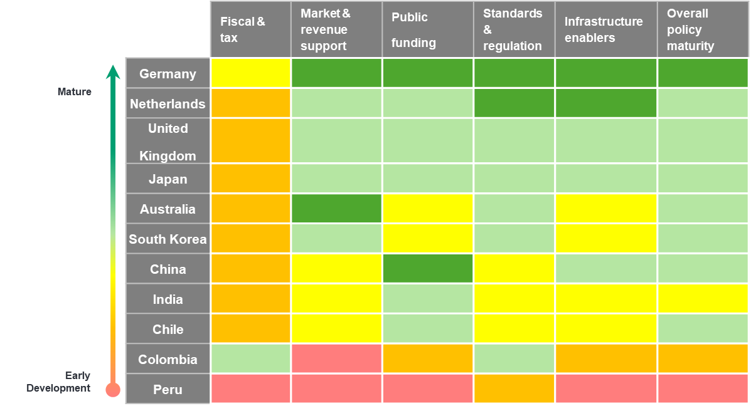
KEY
Score | Overall Green  Hydrogen  Development Status | Description
 | Very early / nascent policy stage | Policy activity is limited to high-level statements, roadmaps or exploratory analysis, with no dedicated policy instruments or structured policy framework in place.
 | Early-stage policy framework | Initial policy enablers exist, such as strategies, guidance or pilot-oriented instruments, but the policy framework remains partial, fragmented or largely untested.
 | Emerging policy framework | A defined set of policy instruments is in place, supporting early implementation and learning, although policy coverage, coordination and clarity remain incomplete.
 | Established policy framework | A coherent and structured policy framework is in place, with multiple complementary instruments designed to address key barriers and provide consistency across policy areas.
 | Advanced policy framework | A mature and well-integrated policy framework exists, with clear objectives, stable instruments and alignment across governance, regulation and policy domains.

The heatmap indicates that policy frameworks for green hydrogen differ not only in overall maturity, but also in the configuration of policy levers applied. In countries such as Germany, the Netherlands and the United Kingdom, multiple policy levers are present simultaneously, including fiscal incentives, public funding, revenue support mechanisms and infrastructure-enabling measures. In these cases, no single lever dominates; instead, policy instruments are distributed across categories, reflecting frameworks where different tools coexist and are applied in parallel.
By contrast, other countries display more concentrated patterns. Australia and South Korea show stronger emphasis on public funding and infrastructure-related measures, with more limited use of revenue support mechanisms. China’s policy profile reflects a planning-led approach with strong public funding and standards, but less reliance on market-based revenue instruments. In India, Chile, Colombia and Peru, policy levers are more narrowly distributed, with greater reliance on fiscal incentives, standards and early-stage public support, and limited development of revenue support or infrastructure enablers. These patterns illustrate how countries apply different combinations of policy levers at different stages of policy framework development, setting the context for the lever-specific analysis that follows
Illustrative Examples: Policy levers (Dimension 3)
- Fiscal and tax incentives
Fiscal and tax incentives are used to reduce upfront investment costs or tax liabilities associated with hydrogen-related assets. These instruments are commonly applied across low-carbon technologies and, in many countries, form part of broader fiscal frameworks rather than hydrogen-specific regimes.
Germany
- Policy approach: Application of tax measures and fiscal incentives available to renewable and low-carbon investments, including hydrogen.
- How it operates: Fiscal provisions reduce effective capital costs and improve early-stage project economics.
- Observed policy outcome: Hydrogen projects benefit from existing fiscal frameworks alongside other policy instruments.
Chile
- Policy approach: Use of general renewable energy tax incentives applicable to hydrogen projects.
- How it operates: Fiscal incentives apply across technologies without hydrogen-specific differentiation.
- Observed policy outcome: Provides baseline fiscal support while more targeted hydrogen instruments develop.

- Direct public funding
Direct public funding reduces early-stage and first-of-a-kind project risk through grants, co-financing and pilot funding. This lever is frequently used to support learning, demonstration and early commercial activity, particularly where capital intensity is high.
Germany
- Policy approach: Public funding programmes supporting electrolysers, infrastructure and industrial hydrogen applications.
- How it operates: Grants and co-financing share upfront risk between the public sector and project developers.
- Observed policy outcome: Enables implementation of early and large-scale projects within a structured funding framework.
Australia
- Policy approach: Public funding focused on hydrogen hubs and demonstration projects.
- How it operates: CAPEX support targets shared infrastructure and first-of-a-kind initiatives.
- Observed policy outcome: Supports early project development and informs subsequent policy design.

- Market and revenue support mechanisms
Market and revenue support mechanisms provide revenue certainty or demand signals to bridge the cost gap between green hydrogen and incumbent alternatives. These instruments typically emerge as policy frameworks mature and seek to provide longer-term visibility for project revenues.
Germany (H2Global)
- Policy approach: Government-backed procurement using CfD-type contracts awarded through competitive processes.
- How it operates: The public sector absorbs the price difference between contracted supply prices and market resale prices.
- Observed policy outcome: Establishes a structured revenue support mechanism within the policy framework.
United Kingdom
- Policy approach: Standardised long-term revenue contracts awarded through Hydrogen Allocation Rounds.
- How it operates: Contracts provide predictable revenues and are integrated with cluster-based deployment.
- Observed policy outcome: Creates a repeatable mechanism for supporting hydrogen producers.

- Standards and certification
Standards and certification frameworks define eligible clean hydrogen and provide regulatory clarity for eligibility, compliance and verification. These frameworks often underpin access to support schemes and, in some cases, trade.
European Union / Germany
- Policy approach: Application of RFNBO criteria and Guarantees of Origin.
- How it operates: Certification is operational and linked to eligibility for support and compliance frameworks.
- Observed policy outcome: Provides a common reference for classification and verification across programmes.
Australia
- Policy approach: Development of a national hydrogen certification scheme aligned with export markets.
- How it operates: Certification frameworks are designed to meet international requirements.
- Observed policy outcome: Supports future market access and policy coherence as frameworks mature.

- Infrastructure enablers
Infrastructure-enabling policies support shared, system-level assets such as pipelines, hubs, ports and grid connections. These policies address integration challenges and reduce reliance on project-specific solutions.
Netherlands
- Policy approach: Infrastructure-led hydrogen development model.
- How it operates: Planning and regulation of hydrogen backbones and port-based hubs.
- Observed policy outcome: Enables coordination across multiple projects and users.
Australia
- Policy approach: Hub-based infrastructure development aligned with renewable resource zones.
- How it operates: Public support and planning focus on shared infrastructure assets.
- Observed policy outcome: Reduces duplication and supports early system development.
United Kingdom
- Policy approach: Integration of hydrogen production within electricity system planning and network regulation.
- How it operates: Grid connection rules, network planning and coordination with electricity system operators are used to manage large electrolyser loads and system impacts.
- Observed policy outcome: Provides a structured framework for integrating electrolysers into the power system, reducing uncertainty around grid access and system compatibility.

Key Findings
This section presents the key findings emerging from the comparative benchmarking analysis across governance, legal and regulatory foundations, and policy levers. The findings synthesise observed patterns across the benchmark countries, highlighting how these dimensions interact and evolve together at different stages of hydrogen market development. They are analytical rather than evaluative in nature and do not assess the effectiveness of individual policies in isolation or imply direct causality between specific instruments and deployment outcomes.

7.1 Governance and Institutional Arrangements
Across benchmark countries, governance maturity is characterised by the presence of binding strategic anchors, clear institutional leadership and formal coordination mechanisms, which together provide the stability and delivery capacity required for hydrogen markets to progress beyond pilots.

- Strategic Anchoring and Policy Coherence: Countries that scale hydrogen anchor it in binding national strategies and embed it across energy, climate, and industrial policy, creating institutional coherence and priority-setting.

- Binding strategies create institutional consistency and durability: Where strategies are embedded in policy cycles, mandates are clearer and more stable (e.g., Germany) than in mission-based or evolving setups (e.g., India).
- Deep policy integration separates scaling markets from pilot markets: Hydrogen is embedded across energy, climate, and industrial policy in mature systems (e.g., UK, Germany) but referenced selectively in early-stage ones (e.g., Colombia, Peru).
- National hydrogen strategies anchor institutional alignment across government: In all countries, strategies organize action; in mature systems they are binding (e.g., Germany, UK) while in early-stage markets they mainly signal intent (e.g., Peru).

- Institutional Leadership and Delivery Capacity: Scaling markets combine clear leadership with formal coordination and monitoring mechanisms; early-stage markets remain constrained by diffuse mandates and weak delivery capacity.

- Hybrid energy–industry leadership dominates in scaling hydrogen markets: Mature systems span energy and industrial authorities (e.g., Germany, Japan), while early-stage countries rely on energy-only leadership (e.g., Peru, Colombia).
- Formal coordination mechanisms distinguish mature from developing governance: Established markets use formal cross-ministerial coordination (e.g., Germany, UK), while early-stage systems depend on informal or project-based coordination (e.g., Peru).
- Monitoring and evaluation capacity increases with governance maturity: Structured tracking frameworks exist in mature markets (e.g., Germany), whereas early-stage systems show limited or no systematic monitoring (e.g., Peru).

- Market Engagement and External Alignment: As hydrogen markets mature, governance shifts from consultation and pilots toward institutionalised engagement with industry and structured international cooperation.

- Stakeholder engagement evolves from consultation to institutionalized participation: Early-stage systems focus on pilots and consultations (e.g., Chile, Peru), while mature markets sustain ongoing engagement with industry and research (e.g., Germany, Netherlands).
- International cooperation is embedded where hydrogen is export-oriented: Export- and supply-chain-led countries institutionalize cooperation (e.g., Netherlands, Japan), while early-stage markets engage selectively (e.g., Peru).

7.2 Legal and Regulatory Foundations
International experience indicates that regulatory certainty for hydrogen emerges progressively, with market development shaped less by the absence of gaps than by whether core regulatory issues affecting safety, permitting and eligibility are sufficiently resolved to support early investment.

- Gaps and Investor Risk: The differentiator across countries is not gaps, but how material they are.

- All markets retain gaps, even regulatory leaders: Advanced jurisdictions still face unresolved issues around scaling and system integration (e.g., UK, Germany).
- Early-stage markets face structural regulatory uncertainty: Missing safety, permitting, and certification frameworks raise project risk and delays (e.g., Peru, Colombia).
- Regulatory clarity improves through iteration, not upfront design: Countries refine rules progressively as projects advance and risks become clearer (e.g., India, Australia).

- Regulatory Sequencing and Market Maturity: Hydrogen regulation evolves sequentially, tightening only as markets move from pilots to scale.

- Clear definitions anchor markets before regulation deepens: Countries first define emissions thresholds, renewable electricity sourcing, and accounting rules, then apply them across support schemes and certification
- Embedded regulation dominates early and mid-stage markets
Most countries adapt existing energy and industrial laws before considering hydrogen-specific frameworks (e.g., Germany, Netherlands, UK).
- Dedicated hydrogen laws appear only at advanced scale
Standalone hydrogen legislation emerges later, reflecting complexity rather than enabling early deployment (e.g., South Korea).

7.3 Policy Levers
The benchmarking shows that policy levers influence deployment outcomes primarily through their sequencing and interaction over time, with early-stage instruments enabling entry and learning, and later-stage mechanisms addressing revenue risk, infrastructure coordination and system integration.

- Policy Sequencing and Market Maturity Logic: Early-stage policy focuses on enabling entry, while advanced policy focuses on system orchestration. Misaligned sequencing leads to stalled pilots.
- Sequencing matters more than any single policy lever: No single instrument explains success. Outcomes depend on how levers are sequenced as markets evolve from pilots to scale.
- Policy mix sophistication increases with market maturity: Early-stage countries rely on isolated levers, while mature markets deploy coordinated policy packages that evolve with scale (e.g., Peru vs. Germany).
- Fiscal and tax incentives are entry tools, not scale drivers: Fiscal incentives primarily support early experimentation and learning, but do not unlock large-scale investment on their own (e.g., Colombia, Peru).

- Risk Allocation and Market Creation Mechanisms: Hydrogen does not scale until someone absorbs market risk. Countries choose different risk anchors, but all successful ones make that choice explicit.
- Revenue support mechanisms separate pilot markets from scaling markets: Countries that move beyond pilots consistently introduce revenue stabilization mechanisms to close the cost gap and enable bankability (e.g., Germany, UK vs. Chile).
- Advanced markets explicitly socialize price and demand risk: In mature ecosystems, governments absorb early market risk to convert policy ambition into bankable cashflows (e.g., Germany H2Global).
- Demand-side anchoring can substitute for production subsidies: Some markets prioritize guaranteed demand through regulated offtake rather than direct production support, especially where domestic production is constrained (e.g., South Korea).

- System Enablers and Structural Readiness: Once scale is visible, coordination beats optimization. Standards and infrastructure determine whether growth is efficient or fragmented
- Standards and certification enable markets but do not drive deployment: Certification frameworks reduce uncertainty and unlock finance but only deliver deployment impact when combined with financial or market levers (e.g., EU RFNBO rules).
- Infrastructure policy becomes critical once projects scale in parallel: As multiple projects emerge, infrastructure coordination shifts from optional to essential to manage integration risk and system costs (e.g., Netherlands, Australia).
- Infrastructure-led strategies dominate in clustered or export-oriented markets: Countries with strong industrial clusters or export ambitions prioritise shared backbones and hubs early to position hydrogen as a strategic system asset (e.g., Netherlands ports, Australia exports).

When considered collectively, the findings indicate that differences in renewable hydrogen deployment across countries are less strongly associated with any single governance model, regulatory instrument or policy lever than with how these elements are combined and sequenced as markets evolve. Across the benchmark countries, hydrogen markets appear more likely to progress beyond pilot stages where institutional responsibilities are clearly anchored, regulatory frameworks provide sufficient clarity to support early investment, and policy support evolves as scale and system complexity increase. Conversely, where governance arrangements, regulatory foundations and policy levers remain fragmented or misaligned, deployment has tended to remain limited despite stated ambition or favourable resource conditions.
These cross-cutting patterns provide the basis for the concluding observations set out in the following section.

Conclusion
This international benchmarking assessment has examined how countries at different stages of market maturity have structured their governance arrangements, legal and regulatory foundations, and policy levers to enable the development of renewable hydrogen markets. The analysis has been undertaken to support SENER, as well as the Government of Mexico more broadly, as it considers the institutional and policy foundations for a future National Renewable Hydrogen Policy, and is intended to provide an analytical reference grounded in observed international experience rather than a prescriptive blueprint.
The benchmarking suggests that progress beyond pilot and announcement stages tends to be shaped less by the presence of individual policy instruments and more by how governance, regulation and policy support are combined and sequenced over time.
For countries that have moved toward investment and delivery, hydrogen development is typically anchored in relatively clear institutional leadership and coordination, supported by regulatory frameworks that provide sufficient clarity to enable early investment, and complemented by policy levers that evolve as markets mature. Where these elements appear fragmented or misaligned, project pipelines are more likely to stall despite strong resource potential or policy ambition.
The various international experiences considered as part of this assessment also indicate that hydrogen policy frameworks generally evolve incrementally. Early-stage markets often rely heavily on existing legal and institutional structures, with hydrogen-specific regulation, certification systems and infrastructure planning emerging progressively as deployment scales and complexity increases. Similarly, policy support commonly shifts over time from early-stage funding and fiscal incentives toward mechanisms that address revenue risk, infrastructure coordination and system integration. These patterns highlight the importance of sequencing and interaction between policy domains, rather than the early adoption of comprehensive or highly prescriptive frameworks.
For SENER, this assessment helps to situate the prevailing national conditions within a broader set of global dynamics observed in the eleven benchmark countries at the different stages of market maturity. While the assessment does not assume that a single model or outcome is universally applicable, the findings presented in this report offer a structured evidence base to inform policy dialogue by clarifying how different countries have organised responsibilities, addressed regulatory uncertainty and applied policy support at comparable stages of development.
In doing so, this report establishes a structured basis for interpreting international experience by examining how governance arrangements, legal and regulatory foundations, and policy levers interact and evolve across different stages of market development. This provides a foundation for considering how such experience could be selectively adapted and appropriately sequenced over time as Mexico advances the development of its first renewable hydrogen policy and associated enabling frameworks.

 | Next phase of this work package  The next phase of this work package under the UK’s Green Cities, Infrastructure and Energy Programme will analyse Mexico’s existing regulatory and policy framework and synthesise policy options. This will be validated through an internal technical validation workshop with GCIEP, SENER and the FCDO Post, alongside stakeholder consultations, to further support SENER in its journey to establish a governance framework for green hydrogen growth in Mexico.

References
International organisations and analytical sources
- International Energy Agency (IEA) (2019). The Future of Hydrogen: Seizing Today’s Opportunities. Paris: IEA. (https://www.iea.org/reports/the-future-of-hydrogen)
- International Energy Agency (IEA) (2023). Energy Technology Perspectives. Paris: IEA. (https://www.iea.org/reports/energy-technology-perspectives-2023)
- International Energy Agency (IEA) (2024). Global Hydrogen Review. Paris: IEA. (https://www.iea.org/reports/global-hydrogen-review-2024)
- International Renewable Energy Agency (IRENA) (2022). Policies for Green Hydrogen. Abu Dhabi: IRENA. (https://www.irena.org/publications/2022/Nov/Green-Hydrogen-Strategy)
- International Renewable Energy Agency (IRENA) (2023). Hydrogen: A Renewable Energy Perspective. Abu Dhabi: IRENA. (https://www.irena.org/publications)
- International Renewable Energy Agency (IRENA) (2024). Green Hydrogen Strategy Design. Abu Dhabi: IRENA. (https://www.irena.org/-/media/Files/IRENA/Agency/Publication/2024/Jul/IRENA_Green_hydrogen_strategy_design_2024.pdf)
- World Bank / ESMAP (2024). Hydrogen for Development (H4D). Washington, DC: World Bank. (https://www.worldbank.org/en/programs/esmap)
- OECD (2021), OECD Policy Responses to Hydrogen, Paris: OECD: (https://www.oecd.org/content/dam/oecd/en/publications/reports/2022/02/innovation-and-industrial-policies-for-green-hydrogen_4cfdd6bd/f0bb5d8c-en.pdf)

Mexico policy, regulation and context
- Government of Mexico (2025). Tercera Contribución Determinada a Nivel Nacional de México (NDC 3.0). (https://unfccc.int/sites/default/files/2025-11/NDC%203.0%20Me%CC%81xico_spanish.pdf)
- Secretaría de Energía (SENER) (2024). Lineamientos en Materia de Hidrógeno. (https://www.gob.mx/sener/documentos/lineamientos-en-materia-de-hidrogeno)
- Secretaría de Energía (SENER) (2023–2024). Prospectiva del Sector Eléctrico and national energy
statistics. (https://www.gob.mx/sener/acciones-y-programas/prospectiva-del-sector-electrico)
- ERM (2024). Estrategia Industrial de Hidrógeno Limpio de México. Prepared for the Asociación Mexicana de Hidrógeno, with analytical inputs from Centro Mario Molina. (https://h2mex.org/wp-content/uploads/ERM_Estrategia_de_Hidrogeno-Resumen-Ejecutivo-Distribucion-Oct-2024.pdf)

International policy frameworks and certification
- European Commission (2023). Delegated Regulation on Renewable Fuels of Non-Biological Origin (RFNBOs). (https://eur-lex.europa.eu/legal-content/EN/TXT/?uri=CELEX:32023R2415)
- European Commission (2022). Guarantees of Origin for Renewable Energy. (https://energy.ec.europa.eu/topics/renewable-energy/renewable-energy-directive/guarantees-origin-renewable-energy_en)

Country-specific strategies and policy frameworks
- Federal Ministry for Economic Affairs and Climate Action (Germany) (2020, updated). National Hydrogen Strategy. (https://adelphi.de/system/files/document/Factsheet%20Germany%27s%20National%20Hydrogen%20Strategy%20Update%202023_0.pdf)
- Government of the Netherlands (2020, updated). National Hydrogen Strategy. (https://english.rvo.nl/sites/default/files/2020/07/Hydrogen-Strategy-TheNetherlands%20-%20English.pdf)
- UK Government (2021, updated). UK Hydrogen Strategy. (https://www.gov.uk/government/publications/uk-hydrogen-strategy)
- Government of Japan (2017, updated). Basic Hydrogen Strategy. (https://www.meti.go.jp/shingikai/enecho/shoene_shinene/suiso_seisaku/pdf/20230606_5.pdf)
- Government of Australia (2019, updated). National Hydrogen Strategy. (https://www.dcceew.gov.au/sites/default/files/documents/national-hydrogen-strategy-2024.pdf)
- Government of the Republic of Korea (2019). Hydrogen Economy Roadmap. (https://h2council.com.au/wp-content/uploads/2022/10/KOR-Hydrogen-Economy-Roadmap-of-Korea_REV-Jan19.pdf)
- Government of China (2022). Medium- and Long-Term Plan for the Development of the Hydrogen Energy Industry. (https://climate-laws.org/document/medium-and-long-term-plan-for-the-development-of-the-hydrogen-energy-industry-2021-2035_37a6)
- Government of India (2023). National Green Hydrogen Mission. (https://cdnbbsr.s3waas.gov.in/s3716e1b8c6cd17b771da77391355749f3/uploads/2023/01/2023012338.pdf)
- Government of Chile (2020). National Green Hydrogen Strategy. (https://energia.gob.cl/sites/default/files/national_green_hydrogen_strategy_-_chile.pdf)
- Government of Colombia (2021). Hydrogen Roadmap. (https://www.minenergia.gov.co/documents/5862/Colombias_Hydrogen_Roadmap_2810.pdf)
- Government of Peru (2022). National Hydrogen Roadmap. (https://h2.pe/uploads/01_Bases-para-la-elaboracion-estrategia-H2V-Peru.pdf)

Annex
Country profiles
The country policy profiles below illustrate how governance structures and legal frameworks shape green hydrogen policy design and implementation across benchmark countries. Each profile highlights who leads and coordinates hydrogen policy, how responsibilities are distributed across institutions, and the degree of regulatory definition in place, providing essential context for interpreting the policy instruments summarised in the sections that follow.
The expanded profiles are presented in a structured table format to ensure consistency and comparability across countries. In line with SENER’s request, the tables incorporate additional coverage on the broader renewable energy context, hydrogen value chain positioning, stage of development and strategic objectives, key stakeholders involved, and reference to official policy portals and public sources. These elements are integrated within the standardised table structure rather than presented as separate narrative headings, maintaining coherence with the overall benchmarking framework.

Australia
Australia operates under a federal–state governance model. National authorities set strategic direction and funding frameworks, while state governments lead hydrogen hub development, permitting and infrastructure delivery. Public agencies such as ARENA administer grants and innovation funding, and the Clean Energy Regulator (CER) oversees renewable certification and emissions accounting relevant to hydrogen.
Hydrogen certification and regulatory frameworks are still evolving, particularly to ensure export market credibility. Institutional roles, however, are clearly delineated across federal and state levels. Australia is positioned at a scaling, export-oriented stage, with governance designed to support large, hub-based projects linked to ports and renewable resource zones.
Green Hydrogen  production capacity  Operational  (kt H₂/y) | Green Hydrogen production capacity Planned  (kt H₂/y) |  | Hydrogen  pipelines  (km) |  | Ammonia port  storage capacity  (Thousand tonnes) |  | Dominant market model
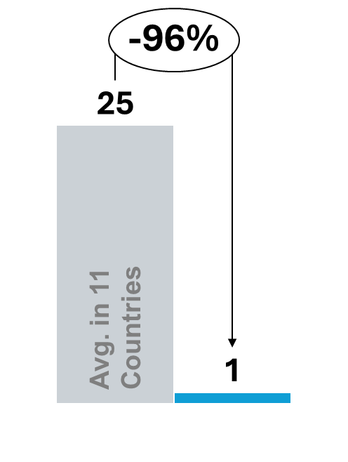 | 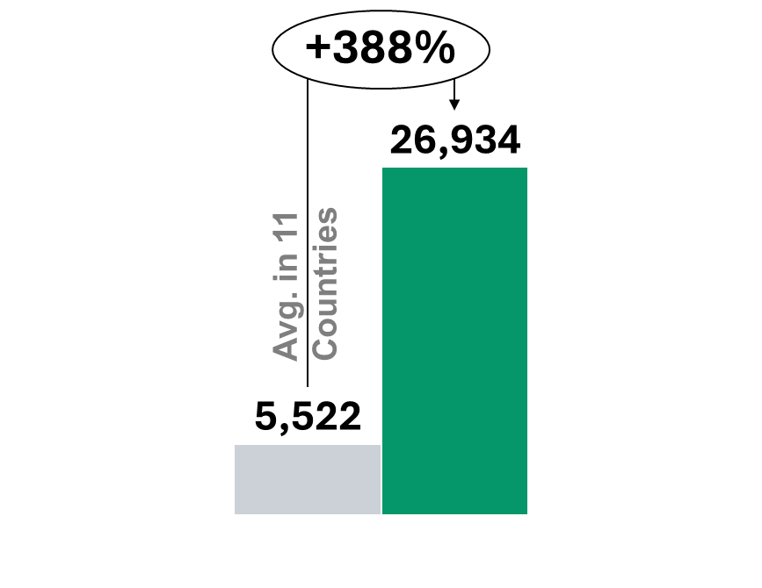 |  | 828  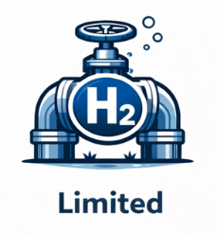 |  | 173.0  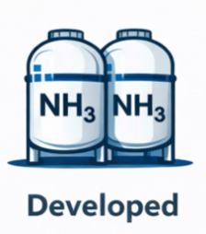 |  | 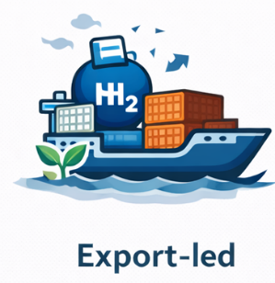
Overall Status |  | Strategies |  | Road Map |  | Implementation &  Development Plans
- Export-led hydrogen market focused on large-scale, capital-intensive projects  - Policy framework designed to address high upfront investment risk and global price uncertainty  - Combines shared hub infrastructure with revenue support contracts to enable project viability  - Model tailored to export-scale hydrogen and ammonia linked to ports and renewable resource zones |  | - Positions green hydrogen as a strategic export  industry  - Leverages abundant renewable resources to supply international markets, particularly ammonia  - Focuses on:  - Export-oriented production at scale  - Development of hydrogen hubs linked to ports  - Domestic decarbonisation is supported where economically viable, but export markets are the primary driver |  | - Strategy adoption (2019–2020): National hydrogen strategy establishes export-oriented ambition  - Pilot and hub development phase (2020–2022): Early pilots and planning of large-scale hydrogen hubs  - Market activation phase (current): Deployment of Hydrogen Headstart and CAPEX support for hubs  - Next phase: Scaling export-oriented production aligned with global hydrogen and ammonia demand |  | - Execution coordinated across federal and state governments  - Key instruments include:  - CAPEX support for hydrogen hubs and shared infrastructure  - Hydrogen Headstart revenue support contracts for large-scale projects  - Delivery involves public agencies and private developers, focused on export corridors and port infrastructure
Policies Framework
Fiscal & Tax  Incentives | - No hydrogen-specific tax credits are applied at the national level  - Deployment relies on non-tax instruments, rather than fiscal incentives
Market and revenue support  mechanisms | - Hydrogen Headstart provides contract-based revenue support to large-scale hydrogen projects selected through competitive processes  - Contracts are designed to bridge the cost gap during early market formation, when global hydrogen prices and long-term offtake remain uncertain  - The mechanism reduces merchant and price risk by providing predictable revenues over an initial operating period  - Revenue support is explicitly linked to export-scale projects, enabling investment decisions for hydrogen and ammonia production connected to port-based hubs
Direct public  funding | - Federal and state governments provide CAPEX support through grants and co-investment  - Funding targets shared hub infrastructure, including:  - Power and water interfaces  - Port facilities  - Storage and logistics  - Reduces first-mover CAPEX barriers and enables multiple projects to connect to common assets
Standards and  certification | - Certification schemes are under development and aligned with international market requirements  - Certification functions as a market-access enabler for export projects  - Lack of credible certification would limit offtake and financing for hydrogen and derivatives
Infrastructure-  enabling policies | - Infrastructure policy focuses on export hubs and port-linked corridors  - Shared enabling assets are aligned with large renewable resource zones  - Hub-based model supports system-scale deployment, rather than isolated projects
Sectoral focus / Priority sectors
Demand is driven primarily by international export markets, with hydrogen and ammonia produced for shipping fuels, overseas power generation and industrial use. Domestic demand plays a secondary role, focused on early industrial applications and system integration.
Renewable Energy Context
Australia has expanded renewable electricity capacity significantly over the past decade, driven primarily by large-scale solar PV and onshore wind, supported by state-level renewable energy auctions and federal clean energy programmes. Installed renewable capacity now exceeds 70 GW, with renewables representing an increasing share of total electricity generation, particularly in states with high solar penetration.
National and state policies target continued expansion of renewable generation toward 2030, including substantial offshore wind development and large renewable energy zones. Transmission build-out and grid integration remain critical to accommodate growing renewable capacity and large-scale electrolyser deployment. Australia’s
high-quality solar and wind resources, combined with designated renewable energy zones near ports, provide strong
structural conditions for export-oriented green hydrogen production.
Hydrogen Value Chain Structure
Australia follows an export-led, hub-based hydrogen value chain model:
Production:
Large-scale electrolysis projects located near renewable resource zones and connected to dedicated transmission or behind-the-meter arrangements; production is oriented both to domestic industrial use and export (ammonia, liquid hydrogen).
Storage:
Hub-focused storage solutions, including intermediate storage at port-linked facilities and on-site buffer tanks, with growing interest in larger geological options for system flexibility.
Transport / Distribution:
Transport infrastructure organised around hub-and-spoke models linking renewable zones, ports and industrial clusters; port terminals and shipping logistics are central for export pathways rather than a national hydrogen pipeline backbone in the near term.
Applications:
Primary focus on export markets (ammonia, shipping fuels) alongside targeted domestic industrial decarbonisation in mining, chemicals and heavy industry clusters; potential future use in power and heavy transport as domestic markets mature.

Strategic Stage & Objective
Current Stage: Scaling / Export-focused hub deployment.
Overall Objective:
Develop competitive, export-scale green hydrogen and derivative supply chains that leverage Australia’s renewable resource endowment to serve international markets, while supporting domestic industrial decarbonisation and local job creation.
Implementation has progressed from strategy and pilot support toward competitive CAPEX support for hubs, revenue contract pilots (e.g., Hydrogen Headstart) and coordinated federal–state delivery arrangements for large
projects.

Key Stakeholders
Key public and private actors involved include:
- Federal government (policy and export strategy) and relevant departments – strategic leadership
- State governments – hub development, permitting and local infrastructure delivery
- ARENA (funding and innovation support) and the Clean Energy Regulator (certification functions)
- Australian Renewable Energy Agency (ARENA) and CEFC (Clean Energy Finance Corporation) – financing and grants
- Port authorities and terminal operators – export logistics
- Major developers, utilities and mining companies – offtake and industrial demand
- International offtakers and bilateral partners
Coordination occurs through federal–state collaboration and competitive funding rounds for hub infrastructure.

Impact on project development:
- CAPEX hub support has reduced upfront execution risk for large-scale projects
- Revenue support contracts have lowered exposure to global price uncertainty
- Shared export infrastructure has enabled multiple projects to develop in parallel
- Combined instruments have supported bankable export-scale hydrogen and ammonia projects
- Policy outcomes reflect a model optimised for global trade readiness, rather than domestic market creation

Official Hydrogen Portals
- Australian Government – National Hydrogen Strategy / policy information:
https://www.dcceew.gov.au
- Australian Renewable Energy Agency (ARENA) – hydrogen projects and funding:
https://arena.gov.au
- Clean Energy Finance Corporation (CEFC) – investment and finance for hydrogen:
https://www.cefc.com.au
- Clean Energy Regulator – renewable certification and reporting:
https://www.cleanenergyregulator.gov.au

Sources:
Strategy, roadmap and governance framework
- Australian Government (2019; updated 2023), National Hydrogen Strategy.
- Department of Climate Change, Energy, the Environment and Water (DCCEEW), Hydrogen policy and strategic updates.
- State Government Hydrogen Strategies (e.g., Western Australia, Queensland, Northern Territory).
Market and revenue support mechanisms (Hydrogen Headstart)
- Australian Government (2023), Hydrogen Headstart Program – official programme documentation and funding guidelines.
- DCCEEW policy announcements related to revenue support mechanisms for large-scale hydrogen projects.
Direct public funding and infrastructure support
- Australian Renewable Energy Agency (ARENA), Hydrogen and Renewable Energy Funding Programmes.
- Federal and State co-investment frameworks for hydrogen hubs and shared infrastructure.
- Clean Energy Finance Corporation (CEFC), relevant low-carbon investment documentation (as applicable).
Standards and certification frameworks
- Australian Government, Hydrogen Certification Scheme documentation (where applicable).
- Clean Energy Regulator (CER), Renewable Energy Guarantee of Origin (REGO) framework and emissions accounting guidance.
Infrastructure enabling policies (hubs and export corridors)
- Hydrogen Hub programme documentation (Commonwealth and State level).
- Port authority publications related to hydrogen and ammonia export infrastructure.
- Regional hydrogen hub development plans aligned with renewable resource zones.
Production capacity / pipeline and deployment status
- International Energy Agency (IEA) (2023), Global Hydrogen Review 2023, Paris: IEA.
- IEA Hydrogen Projects Database (latest available edition).
- Public announcements of large-scale hydrogen and ammonia projects (e.g., Western Green Energy Hub, Asian Renewable Energy Hub).
Renewable energy context
- Australian Energy Market Operator (AEMO), Electricity Statement of Opportunities and renewable capacity statistics.
- Australian Government renewable energy statistics portal.

Chile
Chile has established a centralised but facilitative governance framework for green hydrogen. The Ministry of Energy provides strategic direction, while CORFO acts as the primary implementation agency, administering competitive CAPEX co-financing and pilot programmes. Environmental permitting and project approvals are handled through established national processes, with regional and port authorities supporting export-oriented infrastructure.
Hydrogen has been defined as a strategic priority through a national hydrogen strategy and regulatory roadmap, while certification frameworks continue to mature. Chile is positioned at an early-to-scaling stage, with governance designed to enable execution and pipeline development while keeping long-term market risk largely with the private sector.
Green Hydrogen  production capacity  Operational  (kt H₂/y) | Green Hydrogen production  capacity Planned  (kt H₂/y) |  |  | Hydrogen pipelines  (km) |  | Ammonia port  storage capacity  (Thousand tonnes) |  | Dominant market model
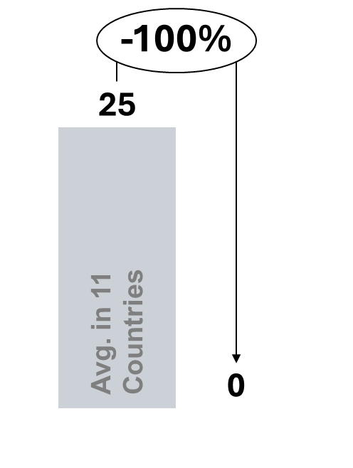 | 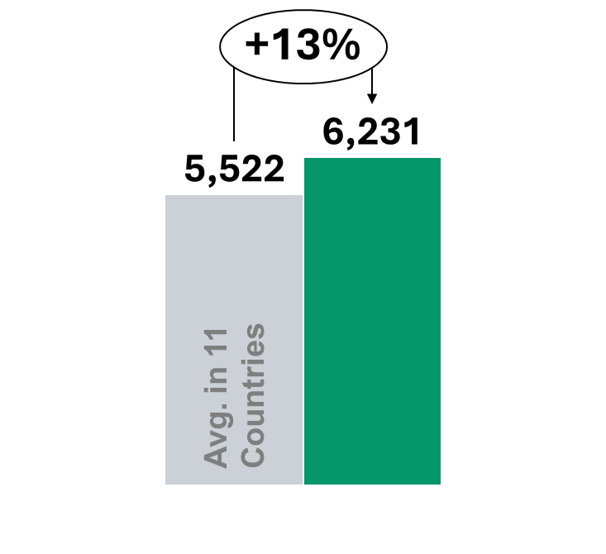 |  |  | 150  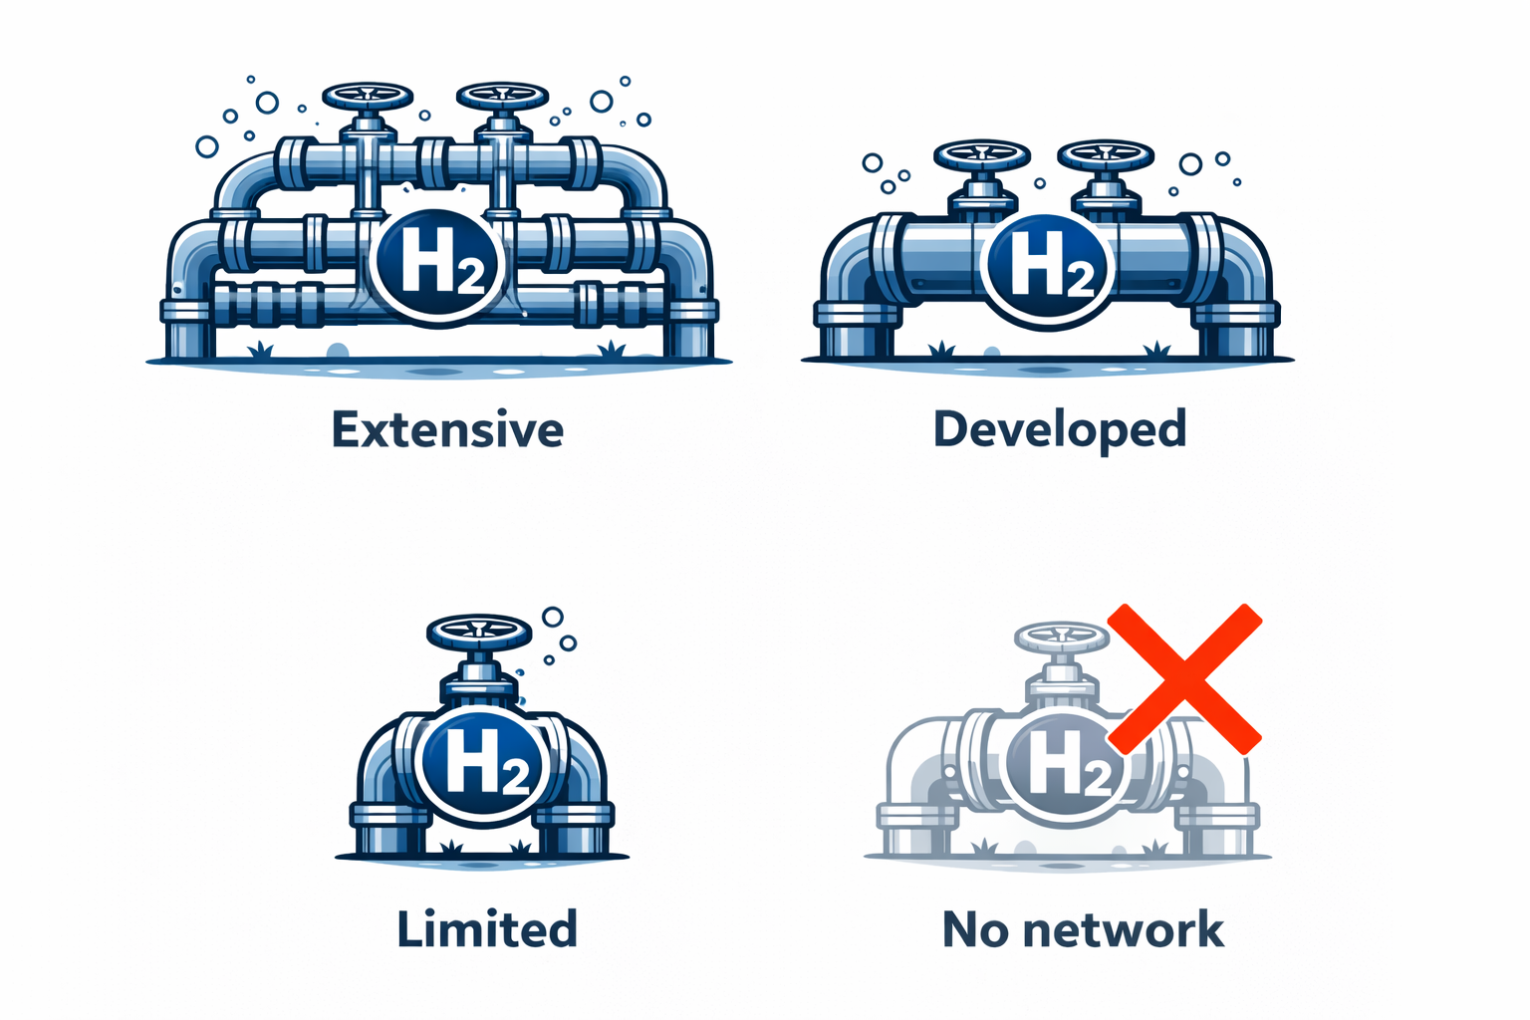 |  | 30.0  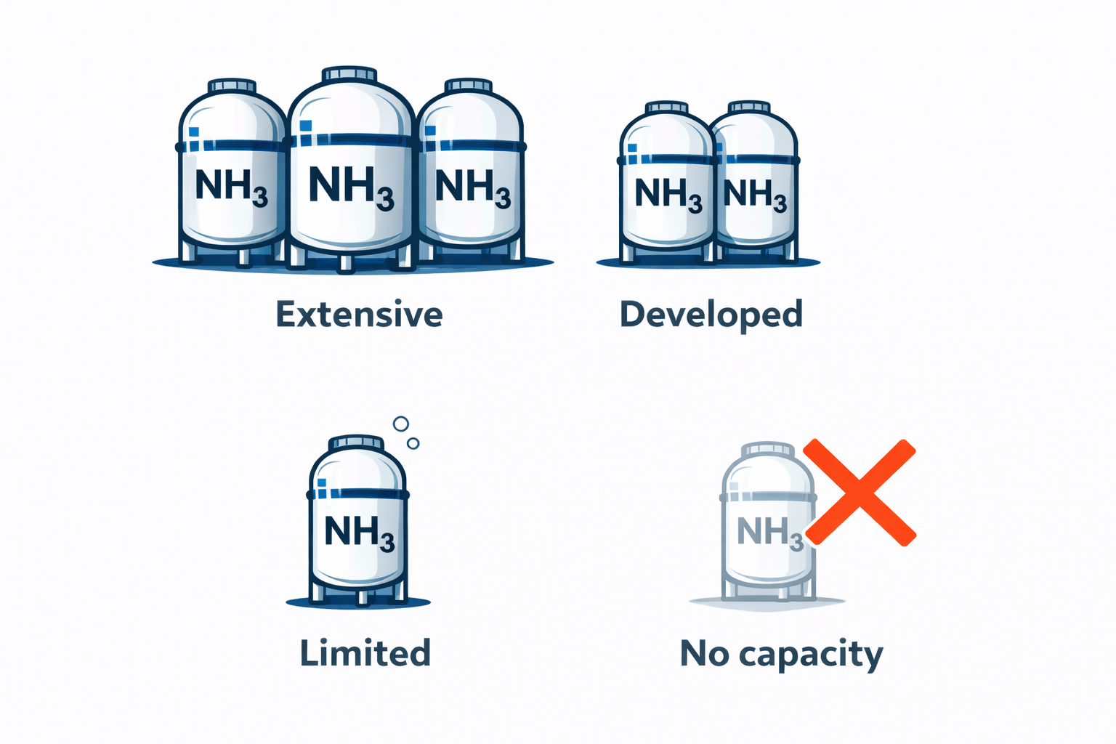 |  | 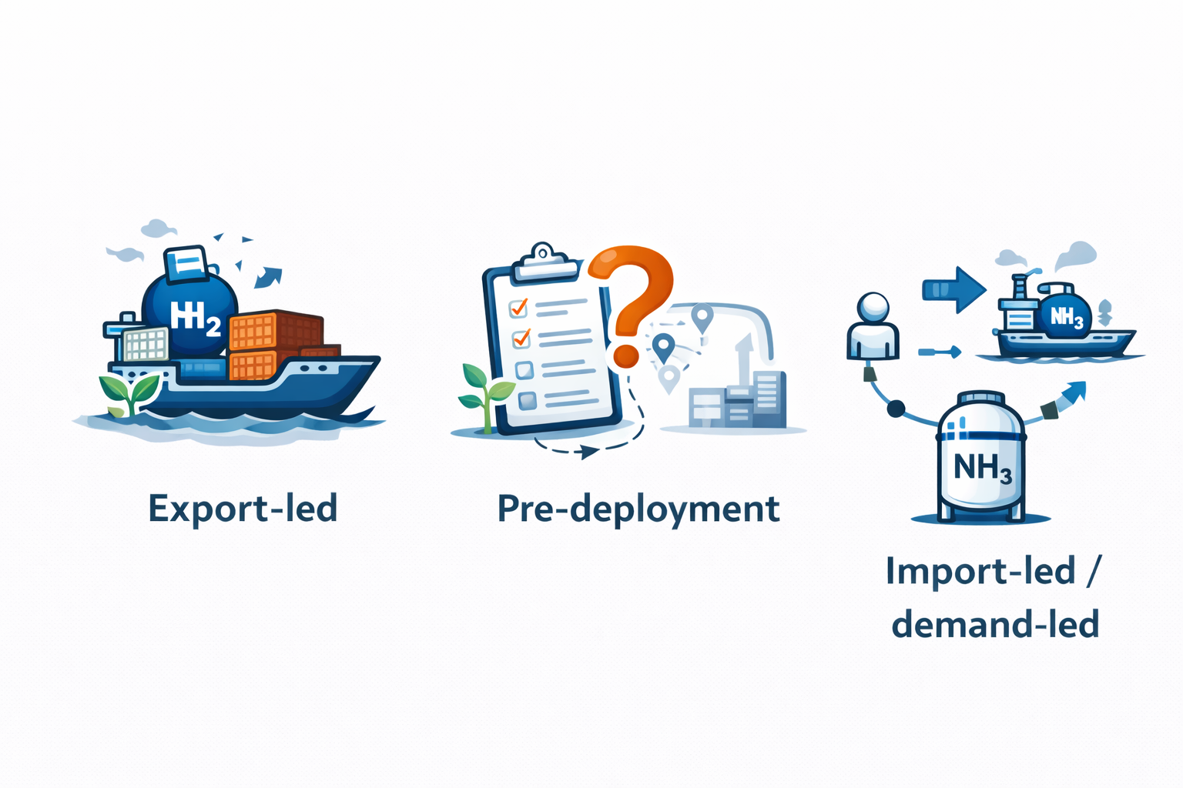
Overall Status |  |  | Strategies |  | Road Map |  | Implementation &  Development Plans
- Early-stage hydrogen market with a clear export-oriented ambition  - Policy framework focused on moving from strategy to execution  - Relies on targeted public co-financing to reduce early-stage and technology risk  - Model designed to enable a credible project pipeline without long-term revenue guarantees |  |  | - Positions green hydrogen as a strategic export-oriented industry  - Leverages strong renewable resource potential to supply international markets  - Focuses on hydrogen and hydrogen-derived fuels (notably e-fuels)  - Supports domestic industrial decarbonisation where relevant, but exports are the primary driver |  | - Strategy adoption (2020): National Green Hydrogen Strategy establishes export-oriented vision  - Pilot and FOAK phase (2021–2022): Public support targets pilot and first-of-a-kind projects  - Early commercial phase (current): Expansion of export-linked projects aligned with port infrastructure  - Next phase: Scaling export-oriented production as international market access and certification mature |  | - Execution led by the  Ministry of Energy  - Core implementation  delivered through CORFO (Corporación de Fomento de la Producción)  - Key instruments include:  - Competitive public  co-financing schemes  - Defined funding envelopes for pilot and FOAK projects  - Programmes specify  eligible project types and implementation timelines
Policies Framework
Fiscal & Tax  Incentives |  | - No hydrogen-specific tax incentives are applied  - Fiscal support through the tax system is minimal
Market and revenue support  mechanisms |  | - No CfD-type price guarantees or standardised revenue contracts  - Market and price risk are intentionally left with the private sector  - Policy choice avoids long-term fiscal exposure and allows market discovery
Direct public  funding |  | - CORFO provides competitive grants and CAPEX co-financing for pilot and first-of-a-kind projects  - Support typically covers a portion of upfront investment, rather than full project costs  - Funding is designed to reduce:  - Early-stage development risk  - Technology and execution risk  - Lever is particularly targeted at export-oriented hydrogen and e-fuels projects
Standards and  certification |  | - National strategy and regulatory roadmap are in place  - Certification frameworks are evolving to define eligibility and sustainability criteria  - Alignment with international standards is prioritised to support export markets
Infrastructure-  enabling policies |  | - Infrastructure policy focuses on:  - Hydrogen hubs  - Industrial clusters  - Port-based export infrastructure  - Alignment with logistics and export corridors reduces system integration risk
Sectoral focus / Priority sectors
Demand is driven by export-oriented hydrogen and synthetic fuels, particularly e-fuels for international markets. Domestic demand also arises from mining operations, where hydrogen can replace diesel and support decarbonisation of energy-intensive processes.
Renewable Energy Context
Chile has rapidly expanded renewable electricity capacity over the past decade, driven primarily by utility-scale solar PV in the northern regions and growing onshore wind deployment. Installed renewable capacity exceeds 30 GW, with renewables representing a significant and growing share of the national electricity mix. The country’s exceptional solar irradiation levels in the Atacama Desert and strong wind resources in the south provide a structural advantage for low-cost renewable generation.
National energy policy targets continued renewable expansion toward 2030, aligned with Chile’s carbon neutrality objective by 2050. Transmission expansion and curtailment management remain important system considerations, particularly in renewable-rich regions. The combination of high renewable potential, geographic concentration and proximity to port infrastructure provides favourable conditions for export-oriented green hydrogen production.
Hydrogen Value Chain Structure
Chile applies an export-oriented and project-led hydrogen value chain model:
Production:
Electrolysis projects co-located with large-scale solar and wind resources, particularly in northern and southern renewable-rich regions; strong focus on ammonia and e-fuels production for export markets.
Storage:
On-site and port-linked storage solutions supporting hydrogen derivatives, with integration into export logistics infrastructure.
Transport / Distribution:
Infrastructure development centred on hydrogen hubs and port corridors, linking renewable generation sites to export terminals; long-distance domestic pipeline networks are not yet a primary focus.
Applications:
Primary emphasis on export of hydrogen derivatives (notably ammonia and e-fuels), alongside emerging domestic applications in mining and heavy industry.
Strategic Stage & Objective
Current Stage: Early-to-scaling, export-driven development.
Overall Objective:
Position Chile as a competitive global exporter of green hydrogen and derivatives by leveraging its renewable resource advantage, while gradually supporting domestic industrial decarbonisation.
Implementation has progressed from strategy publication toward competitive CAPEX support for pilot and first-of-a-kind projects, infrastructure planning for export hubs and alignment with international certification standards.
Key Stakeholders
Hydrogen governance and implementation involve coordinated public and industrial actors:
- Ministry of Energy – strategic leadership and hydrogen policy design
- CORFO (Economic Development Agency) – competitive funding and project co-financing
- Environmental authorities – permitting and environmental approvals
- Port authorities and regional governments – infrastructure and logistics support
- Mining companies and industrial offtakers – potential domestic demand anchors
- International investors and export partners
Stakeholder engagement is structured through competitive funding rounds and public–private collaboration platforms supporting pilot and export-oriented projects.
Impact on project development:
- Public co-financing has reduced upfront risk for pilot and first-of-a-kind projects
- Targeted CAPEX support has enabled projects to progress without revenue guarantees
- Infrastructure alignment with ports has improved export readiness
- Early projects have advanced from pilot to early commercial stages
- Outcomes reflect an execution-oriented early market, rather than a fully de-risked investment environment

Official Hydrogen Portals
- Ministry of Energy – National Green Hydrogen Strategy:
https://energia.gob.cl
- National Green Hydrogen Strategy documentation:
https://energia.gob.cl/hidrogeno-verde
- CORFO – hydrogen funding programmes and co-financing schemes:
https://www.corfo.cl
- InvestChile – investment promotion and hydrogen project information:
https://investchile.gob.cl

Sources:
Strategy, roadmap and governance framework
- Ministry of Energy (Chile) (2020), Estrategia Nacional de Hidrógeno Verde (official national hydrogen strategy).
- Ministry of Energy (Chile) (2023), Plan de Acción de Hidrógeno Verde 2023–2030.
- CORFO (Corporación de Fomento de la Producción), Hydrogen Programme Framework and Implementation Guidelines.
- Government of Chile publications on hydrogen policy coordination within the national energy transition framework.
Market and revenue support mechanisms
- Government of Chile policy communications outlining hydrogen market development and export positioning.
- Ministry of Energy regulatory roadmap publications clarifying market structure and enabling conditions.
- Official government documentation confirming the absence of CfD-type revenue guarantees and reliance on market-based price discovery.
Direct public funding and financing mechanisms
- CORFO competitive funding calls for Green Hydrogen and Derivatives (H2V and e-fuels programmes).
- CORFO public co-financing programme guidelines for pilot and first-of-a-kind (FOAK) hydrogen projects.
- Government award announcements and funding resolutions under national hydrogen innovation programmes.
Standards and certification frameworks
- Ministry of Energy regulatory roadmap outlining certification and sustainability criteria for hydrogen.
- Government publications on alignment with international hydrogen certification standards for export markets.
- National environmental and sustainability eligibility criteria applicable to hydrogen projects.
Infrastructure enabling policies
- Ministry of Energy documentation on hydrogen hubs and regional development initiatives.
- Port authority publications related to hydrogen and derivatives export infrastructure (e.g., Magallanes, Antofagasta).
- Government planning documents on logistics corridors and port-based hydrogen integration.
Production capacity / pipeline and deployment status
- International Energy Agency (IEA) (2023), Global Hydrogen Review 2023, Paris: IEA.
- IEA Hydrogen Projects Database (latest available edition).
- Public announcements from HIF Global, ENAP, Engie and other hydrogen/e-fuels project developers in Chile.
Renewable energy context
- Ministry of Energy (Chile), National Energy Balance and Renewable Capacity Statistics.
- Coordinador Eléctrico Nacional (CEN), Electricity Generation and Renewable Deployment Reports.
- International Renewable Energy Agency (IRENA), Renewable Energy Statistics (Chile profile).

China
China’s hydrogen development is embedded within a planning-led, multi-level governance system. Strategic direction is set by central authorities, notably the National Development and Reform Commission (NDRC) and the National Energy Administration (NEA). Provincial governments and state-owned enterprises (SOEs) are responsible for project execution, infrastructure development and financing, typically within industrial parks and renewable energy bases.
Rather than a standalone hydrogen market law, governance is anchored in national and provincial planning frameworks and sectoral regulations. This places China in an industrial-scale, execution-oriented pathway, driven by administrative coordination and SOE investment rather than market-based contracting.
Green Hydrogen production capacity  Operational  (kt H₂/y) | Green Hydrogen production  capacity Planned  (kt H₂/y) |  | Hydrogen pipelines  (km) |  | Ammonia port  storage capacity  (Thousand tonnes) |  | Dominant market model
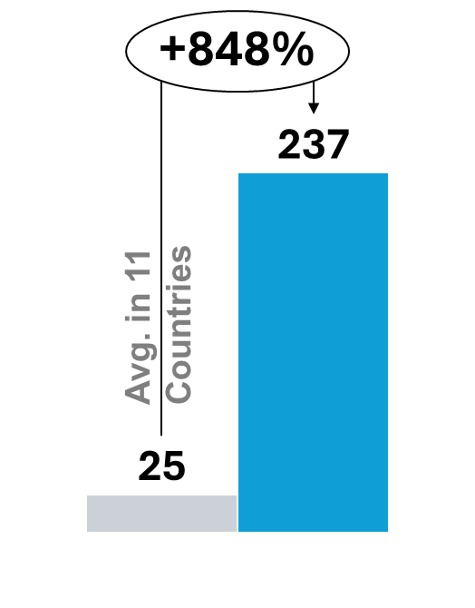 | 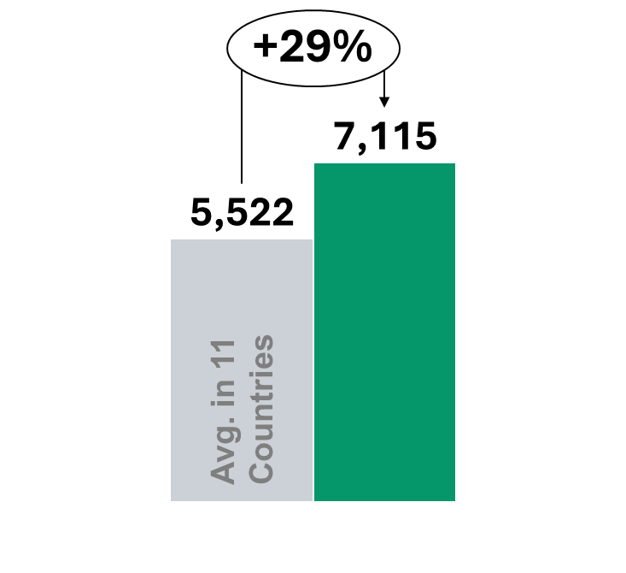 |  | 6,035  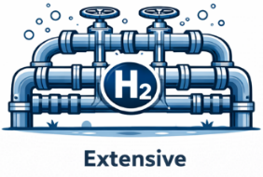 |  | 401.7   |  | 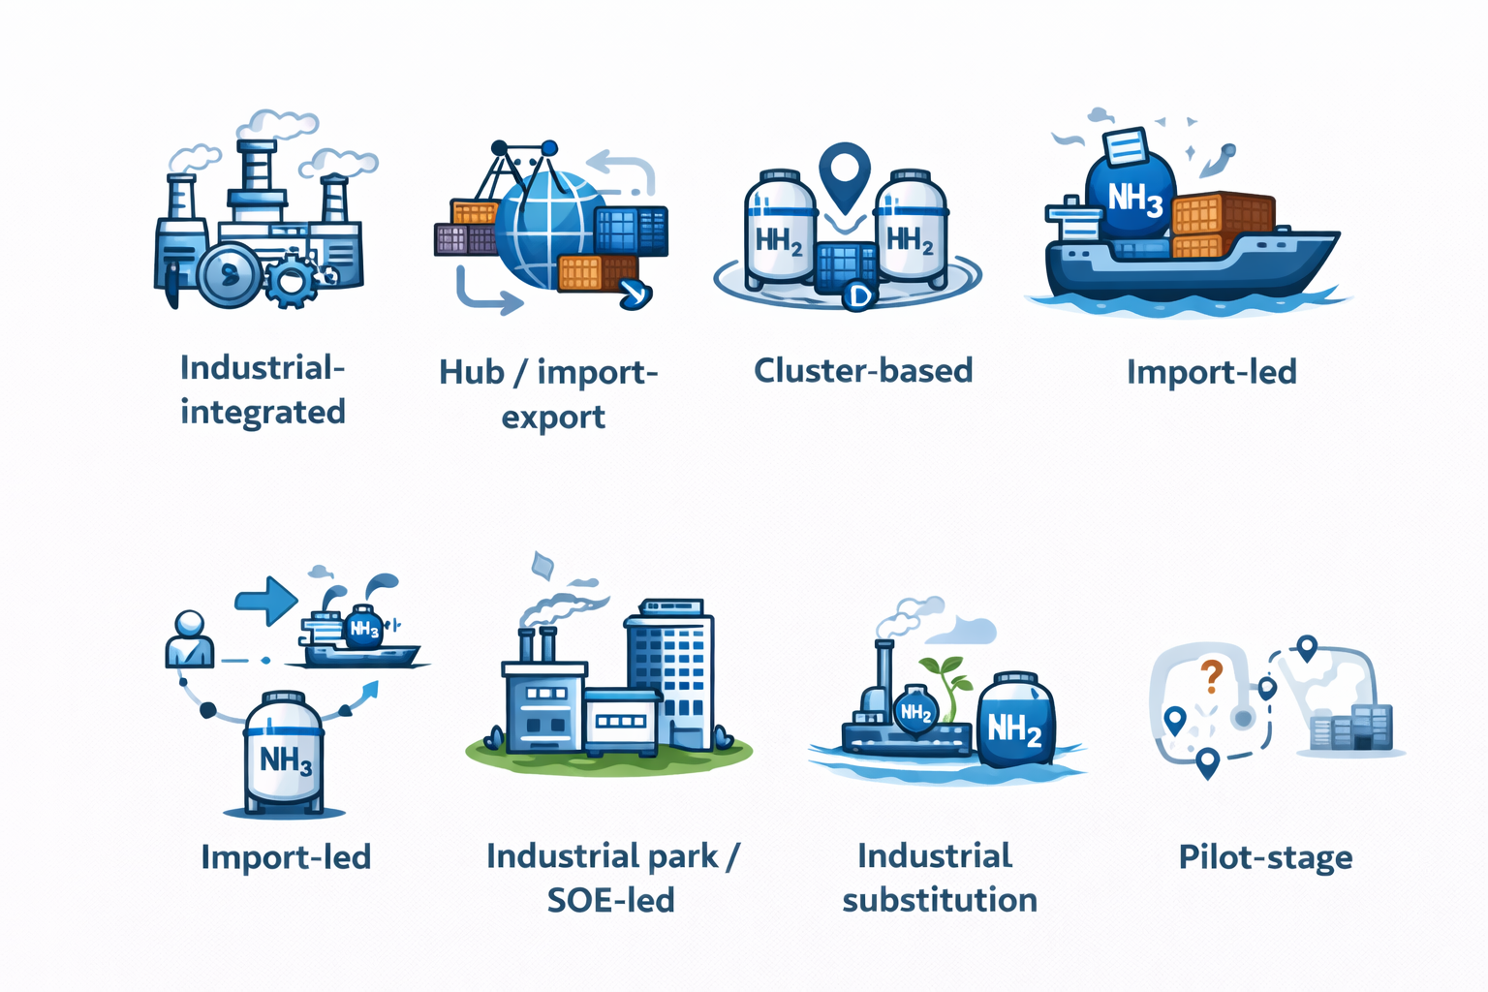
Overall Status |  | Strategies |  | Road Map |  | Implementation &  Development Plans
- Large-scale hydrogen deployment driven by a state-led, planning-based model  - Hydrogen is treated as an industrial input, not as a standalone energy market  - Policy framework prioritises cost reduction, scale and technology learning  - Deployment is embedded in industrial planning and SOE investment, rather than market-based mechanisms |  | - Positions hydrogen as a supporting technology for industrial upgrading and energy system transformation  - Focuses on large-scale use in heavy industry, chemicals and renewable energy integration  - Emphasises scale and learning effects over short-term competitiveness  - Export readiness and market liberalisation are not near-term priorities |  | - Strategic positioning (2019–2020): Hydrogen integrated into national energy and industrial planning frameworks  - Demonstration phase (2020–2022): Deployment through pilot projects and industrial demonstration zones  - Scaling phase (current):  Expansion of hydrogen use within industrial parks and renewable energy bases  - Next phase: Continued industrial-scale deployment aligned with broader energy and industrial planning  cycles |  | - Execution led by central and provincial authorities under NDRC and NEA guidance  - Deployment driven by:  - Provincial governments  - State-owned enterprises (SOEs)  - Projects implemented through industrial parks and cluster-based development  - Financing relies on SOE balance sheets and policy-directed funding, not market contracts
Policies Framework
Fiscal & Tax  Incentives | - No explicit national tax incentives specific to green hydrogen  - Fiscal policy plays a limited role, with support delivered mainly through non-tax mechanisms
Market and revenue support  mechanisms | - No market-based revenue instruments (e.g. CfDs, price guarantees, standardised offtake  contracts)  - Revenue expectations are shaped by planning targets and industrial policy signals  - Investment decisions are guided administratively rather than through contractual demand support
Direct public  funding | - Public funding delivered primarily through provincial governments, SOEs and policy banks  - CAPEX support takes the form of:  - Public equity participation  - Concessional loans  - Land access  - Direct investment in industrial parks and demonstration projects  - Funding allocation is administrative, not competitive, and is closely linked to industrial policy  priorities
Standards and  certification | - Standards and certification are government-led and evolving alongside deployment  - Focus on technical, safety and operational standards for industrial use  - Limited alignment with international or market-oriented certification schemes, constraining export interoperability
Infrastructure-  enabling policies | - Infrastructure development organised around industrial parks and cluster-based deployment  - Hydrogen production, storage and consumption are co-located to support industrial demand  - No emphasis on a national hydrogen pipeline backbone  - Model reduces transport complexity but limits system-wide integration
Sectoral focus / Priority sectors
Demand is driven by heavy industry, including steel, chemicals and refining, where hydrogen is used to replace fossil feedstocks and support industrial upgrading. Additional demand arises from energy storage and industrial hydrogen substitution within state-led industrial parks.
Renewable Energy Context
China has the world’s largest installed renewable electricity capacity, exceeding 1,000 GW when combining solar PV, onshore and offshore wind, and hydropower. Over the past decade, renewable deployment has accelerated significantly, with solar and wind representing the majority of new annual capacity additions. Despite this expansion, coal-fired generation remains a substantial component of the overall electricity mix, reflecting the scale and structure of the national power system.
National planning targets continued renewable expansion toward 2030 and alignment with the 2060 carbon neutrality objective. Large renewable bases in northern and western provinces are increasingly integrated with industrial clusters and designated hydrogen pilot zones, enabling co-location of electrolysis and renewable generation. This scale and regional concentration provide structural conditions for industrial-scale green hydrogen production under provincial and central planning frameworks.
Hydrogen Value Chain Structure
China follows a planning-led, industrial park and SOE-driven hydrogen value chain model:
Production:
State-directed deployment combining electrolytic hydrogen in renewable-rich provinces and large-scale grey/blue hydrogen production within industrial clusters; production decisions frequently aligned with provincial planning and SOE investment priorities.
Storage:
On-site and cluster-level storage solutions co-located with production and industrial users; geological storage and large commercial salt-cavern projects are emerging in select regions.
Transport / Distribution:
Transport generally organised around co-located production and consumption within industrial parks; limited long-distance hydrogen pipelines to date, with road and rail transport and ammonia shipping used for distribution and export-import options.
Applications:
Primary use in heavy industry (steel, chemicals, refining) and industrial feedstock substitution, with growing pilot applications for power balancing and mobility in selected provinces.

Strategic Stage & Objective
Current Stage: Industrial scaling under provincial and central planning.
Overall Objective:
Drive large-scale industrial deployment to reduce carbon intensity in manufacturing and accelerate technology learning at scale, leveraging state investment and SOE-led projects to achieve cost reductions and domestic capability development.
Implementation emphasizes administrative planning, provincial pilot zones and coordinated SOE financing rather than market-based revenue contracts.

Key Stakeholders
Principal actors in governance and delivery include:
- National Development and Reform Commission (NDRC) – strategic planning and policy guidance
- National Energy Administration (NEA) – energy system planning and project approvals
- Provincial governments – regional planning, pilot zones and permitting
- State-owned enterprises (SOEs) – major developers, investors and operators (power, oil & gas, industrial groups)
- State policy banks and provincial financing vehicles – CAPEX and project financing
- Research institutes and domestic electrolyser manufacturers
Coordination is executed through a mix of central directives and provincial implementation led by SOEs.

Impact on project development:
- State-led planning and SOE investment have enabled rapid deployment beyond pilot scale
- Administrative CAPEX support has reduced upfront investment risk without relying on market contracts
- Industrial park integration has facilitated scale and learning effects in heavy industry
- Absence of market-based revenue mechanisms limits bankability and private project finance
Outcomes reflect an industrial scaling model, rather than a market-driven hydrogen ecosystem
Official Hydrogen Portals
- National Development and Reform Commission (NDRC) – Hydrogen policy and national planning guidance:
http://www.ndrc.gov.cn
- National Energy Administration (NEA) – Energy system planning and hydrogen-related implementation:
http://www.nea.gov.cn
- Ministry of Industry and Information Technology (MIIT) – Industrial policy and hydrogen manufacturing development:
http://www.miit.gov.cn
- China Hydrogen Alliance (industry platform supported by NDRC and SOEs):
http://www.chinah2.org

Sources:
Strategy, roadmap and governance framework
- National Development and Reform Commission (NDRC) (2022), Medium and Long-Term Plan for the Development of the Hydrogen Energy Industry (2021–2035).
- National Energy Administration (NEA), Hydrogen and Renewable Energy Policy Updates.
- Provincial Hydrogen Development Plans (e.g., Guangdong, Hebei, Inner Mongolia).
Market and revenue support mechanisms
- NDRC and provincial government planning documents outlining hydrogen deployment targets.
- Government policy releases on industrial integration of hydrogen in steel, chemicals and refining.
- Administrative guidance documents shaping SOE investment in hydrogen projects.
Direct public funding and financing mechanisms
- China Development Bank (CDB), Green and Industrial Financing Programmes (as applicable to hydrogen projects).
- Provincial government funding programmes for hydrogen industrial parks and demonstration zones.
- SOE investment announcements and balance-sheet financing disclosures.
Standards and certification frameworks
- Standardization Administration of China (SAC), Hydrogen-related technical and safety standards.
- Government publications on hydrogen safety and operational standards.
- National technical guidelines for renewable hydrogen integration.
Infrastructure enabling policies (industrial parks and clustering)
- Provincial industrial park development plans incorporating hydrogen production and use.
- Government publications on renewable-hydrogen integration in large renewable energy bases.
- State-owned enterprise infrastructure planning documents.
Production capacity / pipeline and deployment status
- International Energy Agency (IEA) (2023), Global Hydrogen Review 2023, Paris: IEA.
- IEA Hydrogen Projects Database (latest available edition).
- Public announcements from Sinopec, Baowu Steel and other SOEs regarding hydrogen projects.
Renewable energy context
- National Energy Administration (NEA), Renewable Energy Development Reports.
- China Electricity Council (CEC), Annual Electricity Statistics.

Colombia
Colombia remains in an early-stage governance and regulatory-building phase, with hydrogen policy embedded within the broader energy transition agenda. The Ministry of Mines and Energy (MME) leads policy development, supported by planning and regulatory institutions depending on project configuration. Implementation to date has focused on pilots and learning.
Legal recognition and technical standards for hydrogen are under development, complemented by regulatory sandboxes that allow controlled testing. Colombia is positioned as a pilot-oriented market, focused on regulatory clarification rather than system-scale deployment.
Green Hydrogen  production capacity  Operational  (kt H₂/y) | Green Hydrogen production  capacity Planned  (kt H₂/y) |  |  | Hydrogen pipelines  (km) |  | Ammonia port  storage capacity  (Thousand tonnes) |  | Dominant market model
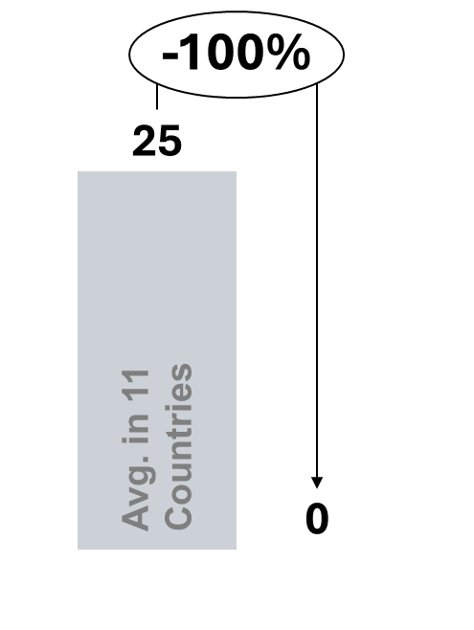 | 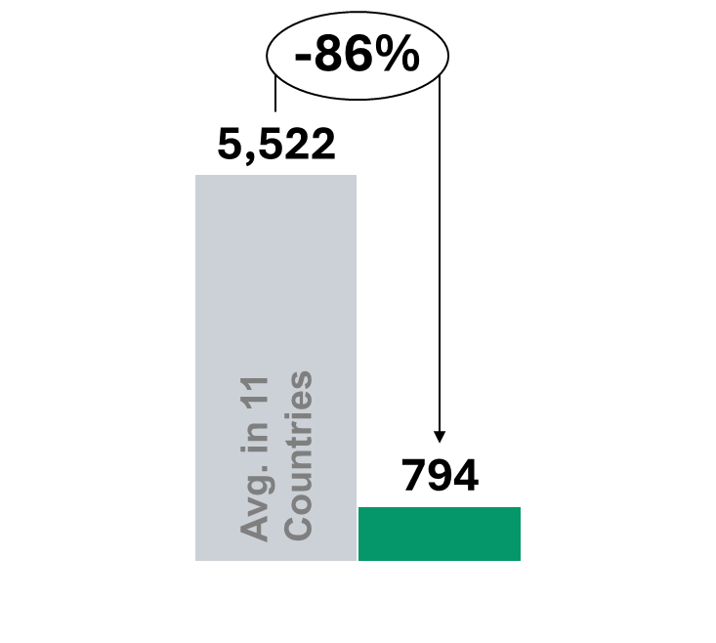 |  |  |  |  | 9.4   |  | 
Overall Status |  |  | Strategies |  | Road Map |  | Implementation &  Development Plans
- Early-stage hydrogen market focused on pilot deployment and regulatory  learning  - Policy framework prioritises early market creation and regulatory clarity  - Deployment remains concentrated in small-scale  pilots, not industrial rollout  - Model relies on fiscal  incentives and regulatory flexibility, rather than  market or infrastructure support |  |  | - Positions green hydrogen as an enabling component of the energy transition  - Initial focus on domestic industrial pilots and learning-by-doing  - Prioritises regulatory definition and early experimentation over scale  - Large-scale deployment and exports are not near-term objectives |  | - Strategy adoption (2021): Hydrogen integrated into national energy transition agenda  - Pilot phase (2021–2023): Deployment of early industrial pilots supported by  fiscal incentives  - Regulatory clarification phase (current): Development of standards and  regulatory sandboxes  - Next phase: Gradual  scaling contingent on future market and infrastructure instruments |  | - Execution led by the Ministry of Mines and Energy (MME)  - Key implementation tools include:  - Fiscal incentives under the renewable energy framework  - Pilot-support programmes and feasibility studies  - Regulatory sandboxes allowing flexible testing of hydrogen projects  - Large-scale infrastructure and revenue support programmes are not yet in place
Policies Framework
Fiscal & Tax  Incentives |  | - Tax exemptions and deductions apply to renewable energy and hydrogen projects  - Incentives include:  - VAT exemptions  - Income tax deductions  - Measures improve project economics at early stages but do not address revenue or demand risk
Market and revenue support  mechanisms |  | - No market-based revenue instruments (e.g. CfDs, price guarantees or demand mandates)  - Projects face full exposure to price and demand uncertainty
Direct public  funding |  | - Public funding is limited and primarily supports:  - Pilots  - Feasibility studies  - Demonstration projects  - No dedicated large-scale CAPEX programmes for industrial hydrogen deployment
Standards and  certification |  | - Legal recognition of green hydrogen has been established  - Technical standards and regulatory sandboxes enable controlled testing  - Regulatory tools support learning, but certification remains at an early stage
Infrastructure-  enabling policies |  | - No dedicated hydrogen transport networks or shared hubs are in place  - Infrastructure planning remains at an early, conceptual stage
Sectoral focus / Priority sectors
Demand is currently driven by existing industrial use, mainly in refining and pilot industrial applications, where hydrogen is tested as a cleaner substitute. Transport pilots also contribute to early demand, though applications remain small-scale.
Renewable Energy Context
Colombia has expanded renewable electricity capacity in recent years, with significant contributions from large-scale hydroelectricity and growing additions of onshore wind and solar PV. Installed renewable capacity exceeds 20 GW, with hydropower still supplying the majority of low-carbon generation; however, solar and wind account for most recent incremental capacity additions. National planning targets and auctions aim to diversify the generation mix and increase variable renewables toward 2030, while transmission reinforcement and regional integration remain key constraints for large-scale electrolyser deployment. The country’s renewable resource distribution and existing hydropower base create opportunities for co-location of hydrogen projects in specific regions with industrial demand.
Hydrogen Value Chain Structure
Colombia follows a pilot-to-scaling, project-led hydrogen value chain model:
Production:
Early-stage electrolysis projects co-located with renewable and hydropower resources; pilot projects focus on technical feasibility and industrial substitution.
Storage:
On-site and cluster-level storage solutions predominate at pilot scale, with larger geological or system-level storage options still at exploratory stages.
Transport / Distribution:
Transport organised around short-distance distribution linking production sites to nearby industrial users and ports; national long-distance hydrogen pipelines are not yet developed.
Applications:
Initial applications target industrial substitution (mining, refining), export potential is assessed but domestic demand for hard-to-abate sectors is the near-term focus.

Strategic Stage & Objective
Current Stage: Early-stage / pilot-to-scaling.
Overall Objective:
Develop a credible domestic pilot pipeline to validate technical and regulatory approaches, clarify permitting, and build investor confidence with a view to scaling industrial substitution and exploring export opportunities.
Implementation has progressed from roadmap and pilot support toward regulatory sandboxes and targeted pilot funding to reduce early-stage execution risk.

Key Stakeholders
Principal public and private stakeholders include:
- Ministry of Mines and Energy (MinEnergia) – strategic leadership and policy coordination
- Mining and Energy Planning Unit (UPME) – planning, project pipeline and system integration analysis
- Energy regulator (CREG) – market and regulatory oversight for energy-related interfaces
- Environmental authorities (ANLA / regional agencies) – permitting and environmental approvals
- Regional governments, port authorities and industrial offtakers (mining, refining) – local implementation and demand anchors
- Private developers, financiers and international technical partners
Stakeholder engagement is emerging through public–private pilots, regulatory sandboxes and multi-stakeholder consultation platforms.
Impact on project development:
- Fiscal incentives have enabled early pilot activity and initial project experimentation
- Regulatory sandboxes have reduced permitting barriers for first movers
- Absence of revenue support leaves projects exposed to price and demand risk
- Lack of shared infrastructure constrains scalability beyond pilots
- Outcomes reflect a learning-focused pilot market, rather than an investable industrial ecosystem

Official Hydrogen Portals
- Ministry of Mines and Energy (MinEnergia) – policy and national planning:
https://www.minenergia.gov.co
- Colombia Hydrogen Roadmap (official documentation):
https://www.minenergia.gov.co/documents/5862/Colombias_Hydrogen_Roadmap_2810.pdf
- Mining and Energy Planning Unit (UPME) – planning and project information:
https://www.upme.gov.co
- Energy and Gas Regulatory Commission (CREG) – regulatory guidance and market rules:
https://www.creg.gov.co

Sources:
Strategy, roadmap and governance framework
- Ministry of Mines and Energy (MME) (2021), Hoja de Ruta del Hidrógeno en Colombia.
- Ministry of Mines and Energy (MME), Hydrogen Policy and Energy Transition publications.
- National Planning Department (DNP), Energy Transition and Decarbonisation policy documents (as applicable to hydrogen).
- UPME (Unidad de Planeación Minero Energética), Planning and technical studies supporting hydrogen deployment.
Market and revenue support mechanisms
- Government of Colombia policy communications outlining hydrogen development under the energy transition agenda.
- Ministry of Mines and Energy publications clarifying the absence of CfD-type revenue support mechanisms.
- Regulatory sandbox documentation for hydrogen pilot projects.
Direct public funding and financing mechanisms
- Government of Colombia pilot support programmes for renewable energy and hydrogen demonstration projects.
- Public funding announcements and feasibility study support linked to hydrogen pilots.
- Multilateral cooperation references supporting hydrogen studies (where applicable).
Standards and certification frameworks
- Legal recognition of green hydrogen within Colombia’s renewable energy framework.
- Technical standards and regulatory sandbox provisions applicable to hydrogen projects.
- Environmental licensing guidance issued by ANLA for energy transition projects (as applicable to hydrogen).
Infrastructure enabling policies
- Government planning documents referencing hydrogen infrastructure development.
- Ministry of Mines and Energy publications on pilot-scale integration within existing industrial facilities.
- Policy documents confirming the absence of dedicated national hydrogen transport networks or hubs.
Production capacity / pipeline and deployment status
- International Energy Agency (IEA) (2023), Global Hydrogen Review 2023, Paris: IEA.
- IEA Hydrogen Projects Database (latest available edition).
- Public announcements of pilot projects led by Ecopetrol and other national energy actors.
Renewable energy context
- Ministry of Mines and Energy, National Energy Balance and Renewable Capacity Statistics.
- UPME electricity and renewable deployment reports.
- International Renewable Energy Agency (IRENA), Renewable Energy Statistics (Colombia profile).

Germany
Germany operates under one of the most consolidated governance frameworks for green hydrogen in the benchmark sample. Strategic leadership is exercised at the federal level by the Federal Ministry for Economic Affairs and Climate Action (BMWK), which defines hydrogen strategy, market mechanisms and alignment with industrial and climate policy. Regulatory oversight of energy systems and future hydrogen networks is provided by the Federal Network Agency (BNetzA), while KfW, the public development bank, plays a central role in financing and risk-sharing. Länder governments are responsible for permitting and regional implementation, particularly for large industrial and IPCEI-supported projects.
From a legal and regulatory perspective, Germany applies EU-aligned sustainability and certification frameworks, including RFNBO criteria and Guarantees of Origin, which define eligibility, emissions accounting and access to support. This combination of clear institutional roles and regulatory certainty places Germany at an advanced, system-scale stage, enabling coordinated deployment of market-based instruments and hydrogen infrastructure.
Green Hydrogen production  capacity  Operational  (kt H₂/y) | Green Hydrogen production  capacity Planned  (kt H₂/y) |  |  | Hydrogen  pipelines  (km) |  | Ammonia port  storage capacity  (Thousand tonnes) |  | Dominant market model
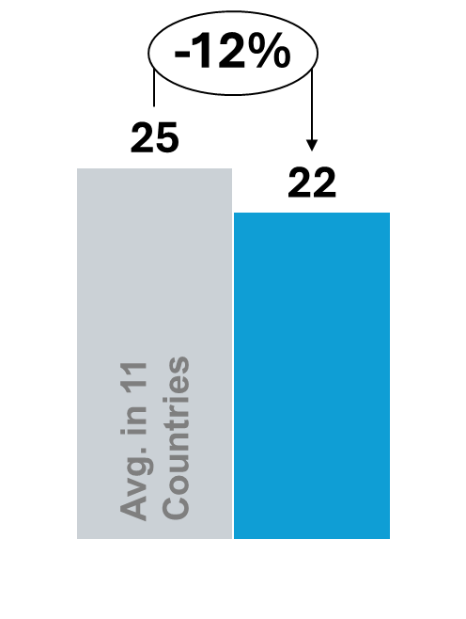 | 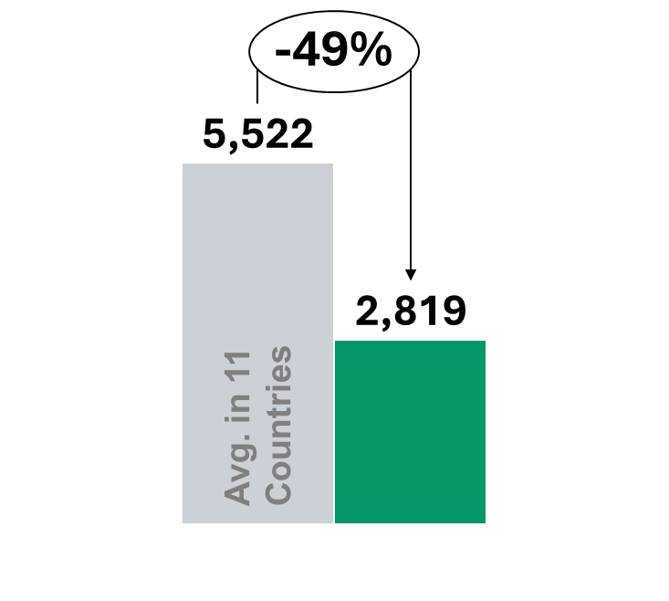 |  |  | 7,023   |  | 204.1 |  | 
Overall Status |  |  | Strategies |  | Road Map |  | Implementation &  Development Plans
- Advanced hydrogen market with bankable, industrial-scale projects  - Policy framework explicitly designed to address:  - High production costs  - Demand and price uncertainty  - Infrastructure and integration risk  - Relies on direct market intervention, not broad fiscal incentives |  |  | - Positions green hydrogen as a core instrument for industrial decarbonization and energy system transformation  - Focuses on hard-to-abate, hydrogen-intensive sectors (steel, chemicals, refining), where electrification is limited  - Emphasizes early demand creation and scale, rather than cost reduction alone  - Designed to integrate hydrogen policy with industrial policy, infrastructure planning and EU climate objectives |  | - Strategy adoption: (2021) National Hydrogen Strategy establishes hydrogen as a strategic priority for industry  - Market creation phase: (2023) Introduction of H2Global and IPCEI to enable first large-scale projects  - Scaling phase (current): Expansion of procurement mechanisms and rollout of hydrogen backbone  - Next phase: Integration with EU hydrogen markets and cross-border infrastructure |  | - Execution focused on three core levers:  - H2Global for demand creation and revenue certainty  - IPCEI for large-scale CAPEX co-financing  - National funding schemes for system-relevant projects  - Infrastructure delivery  prioritizes:  - Hydrogen backbone  - Storage linked to industrial cluster.
Policies Framework
Fiscal & Tax  Incentives |  | - No hydrogen-specific tax credits are used as a deployment tool  - Limited electricity charge relief applies to renewable power used in electrolysis, lowering operating costs  - Fiscal measures are intentionally secondary to direct market intervention
Market and revenue support  mechanisms |  | - H2Global operates as a government-backed procurement mechanism using Contracts-for-Difference–type (CfD-type) contracts, where hydrogen producers are awarded long-term supply agreements through competitive auctions  - Under this model, producers bid the price at which they can supply hydrogen or hydrogen-based derivatives, while the government commits to covering the difference between this contracted price and the prevailing market resale price  - Hydrogen is resold to the market at market-linked prices, and the public sector absorbs the price gap per unit delivered, effectively removing price volatility and demand risk  - This structure converts policy support into predictable, contract-backed revenues, enabling project development and financing without exposure to merchant market  conditions
Direct public  funding |  | - CAPEX co-financing delivered through:  - National hydrogen programs  - IPCEI, supporting first-of-a-kind and system-relevant projects with high capital intensity  - Targets electrolysers, transport infrastructure and industrial conversion assets
Standards and  certification |  | - EU-aligned frameworks apply:  - Renewable Fuels of Non-Biological Origin (RFNBO) criteria  - Guarantees of Origin  - Certification defines eligibility, emissions accounting and verification requirements  - Enables access to finance, public support and cross-border markets
Infrastructure-  enabling policies |  | - Development of a national hydrogen backbone through pipeline repurposing  - Deployment of storage infrastructure linked to industrial demand centres  - Coordinated planning enables system-wide integration at scale
Sectoral focus / Priority sectors
Demand for hydrogen is primarily driven by industrial decarbonisation, especially in steelmaking, chemicals and refining, where hydrogen is used as a reducing agent or feedstock to replace fossil-based inputs. Additional demand arises from power system balancing and industrial heat applications linked to renewable
integration.
Renewable Energy Context
Germany has one of the largest renewable energy systems in Europe. Installed renewable electricity capacity exceeds 170 GW, dominated by onshore wind and solar PV, with renewables accounting for more than 50% of gross electricity generation in recent years. Over the past decade, renewable capacity has expanded steadily, supported by long-term energy transition policies (Energiewende) and competitive auction mechanisms.

National targets aim to increase the share of renewables in electricity generation to at least 80% by 2030, alongside accelerated grid expansion and system integration. This large and growing renewable base provides the structural foundation for domestic green hydrogen production, while acknowledging that Germany will remain partially import-dependent due to land and resource constraints.
Hydrogen Value Chain Structure
Germany applies an integrated, system-scale hydrogen value chain model:
Production:
Domestic production through electrolysis linked to renewable electricity, complemented by large-scale imports of hydrogen and hydrogen derivatives (e.g. ammonia, e-fuels) to meet projected demand.
Storage:
Development of dedicated hydrogen storage infrastructure, including salt caverns and repurposed gas storage facilities, primarily linked to industrial clusters.
Transport / Distribution:
Rollout of a national hydrogen backbone through repurposing of existing natural gas pipelines, coordinated at federal level and integrated with emerging EU cross-border corridors.
Applications:
Primary use in hard-to-abate industrial sectors such as steel, chemicals and refining, with additional applications in power system balancing and selected heavy transport segments.
Strategic Stage & Objective
Current Stage: Advanced / Scaling toward system integration.

Overall Objective:
Position green hydrogen as a central instrument for industrial decarbonisation, energy system transformation and long-term climate neutrality, while reinforcing Germany’s industrial competitiveness within the European Union.

Hydrogen strategy implementation has progressed from early project funding toward coordinated market creation (H2Global), infrastructure rollout and cross-border integration within the EU hydrogen market.
Key Stakeholders
Hydrogen governance and implementation involve multiple public and semi-public actors:
- Federal Ministry for Economic Affairs and Climate Action (BMWK) – strategic leadership
- Federal Network Agency (BNetzA) – energy system regulation and network oversight
- KfW Development Bank – financing and risk-sharing mechanisms
- Länder governments – permitting and regional implementation
- Industrial consortia and IPCEI project developers
- Transmission system operators (TSOs) and Gasunie Deutschland (infrastructure coordination)
- European Union institutions (regulatory alignment and funding frameworks)
Stakeholder engagement is institutionalised through industry platforms and structured consultation processes linked to strategy updates.
Impact on project development:
- Demand-side contracts have converted policy support into predictable revenues, shifting projects from merchant exposure to contract-backed development
- Public co-financing has lowered upfront risk and accelerated industrial-scale project execution
- Infrastructure planning has enabled system-level integration across production, transport and end use
- Regulatory and certification clarity has improved access to finance and cross-border market participation
Together, these elements have supported the emergence of a coordinated, industrial hydrogen ecosystem, rather than isolated pilot projects
Official Hydrogen Portals
- Federal Ministry for Economic Affairs and Climate Action (BMWK) – Hydrogen Strategy:
https://www.bmwk.de
- National Hydrogen Strategy (official documentation):
https://www.bmwk.de/Redaktion/EN/Dossier/hydrogen.html
- H2Global procurement mechanism:
https://www.h2global.de
- Federal Network Agency (BNetzA) – hydrogen network regulation:
https://www.bundesnetzagentur.de

Sources:

Production capacity, project pipeline and infrastructure data
- International Energy Agency (IEA) (2023), Global Hydrogen Review 2023, Paris: IEA.
- International Energy Agency (IEA), Hydrogen Projects Database (latest available edition).
- Federal Network Agency (BNetzA), Hydrogen Network Development Planning documents.
Strategy, roadmap and governance framework
- Federal Ministry for Economic Affairs and Climate Action (BMWK) (2021), The National Hydrogen Strategy.
- BMWK (2023), Update of the National Hydrogen Strategy.
- European Commission (2022–2023), Important Projects of Common European Interest (IPCEI) – Hydrogen documentation.
Market and revenue support mechanisms (H2Global)
- H2Global Foundation, Official Programme Framework and Auction Documentation.
- BMWK, Public Procurement and Hydrogen Market Activation Communications.
Public funding and financing mechanisms
- KfW Development Bank, Hydrogen Financing Instruments and Climate Transition Lending Programmes.
- European Commission State Aid Decisions related to IPCEI Hydrogen.
Standards and certification frameworks
- European Commission, Delegated Acts under the Renewable Energy Directive defining Renewable Fuels of Non-Biological Origin (RFNBO).
- Association of Issuing Bodies (AIB), Guarantees of Origin framework (EECS).
Renewable energy context
- BMWK Renewable Energy Statistics Portal (Energiewende Monitoring).
- IEA Electricity Market Reports – Germany sections.
Hydrogen value chain and infrastructure planning
- European Hydrogen Backbone Initiative (latest published report).
- BNetzA Hydrogen Backbone Planning Documentation.

India
India applies a mission-based governance framework under the National Green Hydrogen Mission (NGHM), with the Ministry of New and Renewable Energy (MNRE) holding the overall mandate for programme design and incentives. Hydrogen development spans multiple ministries, including Power, Petroleum and Natural Gas, Heavy Industry, Ports and Shipping, and Environment, creating a fragmented institutional landscape.
To support coordination, India has established inter-ministerial mechanisms under the NGHM, including a Steering/Oversight Committee chaired by MNRE and an R&D advisory structure led by the Principal Scientific Adviser, alongside multi-stakeholder platforms such as the Strategic Hydrogen Innovation Partnership (SHIP). Legal definitions and certification frameworks are still evolving, positioning India as an emerging, scale-first market focused on rapid capacity build-out and domestic manufacturing.
Green Hydrogen  production capacity  Operational  (kt H₂/y) | Green Hydrogen production  capacity Planned  (kt H₂/y) |  | Hydrogen  pipelines  (km) |  | Ammonia port  storage capacity  (Thousand tonnes) |  | Dominant market model
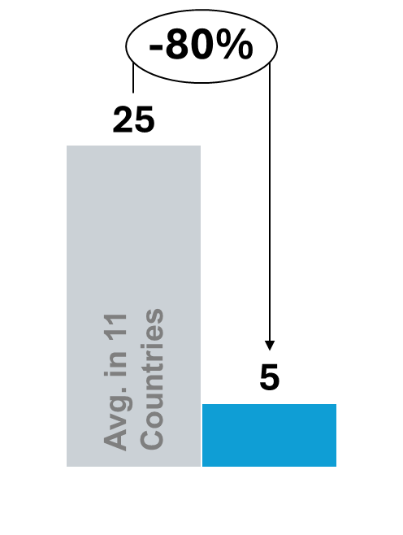 | 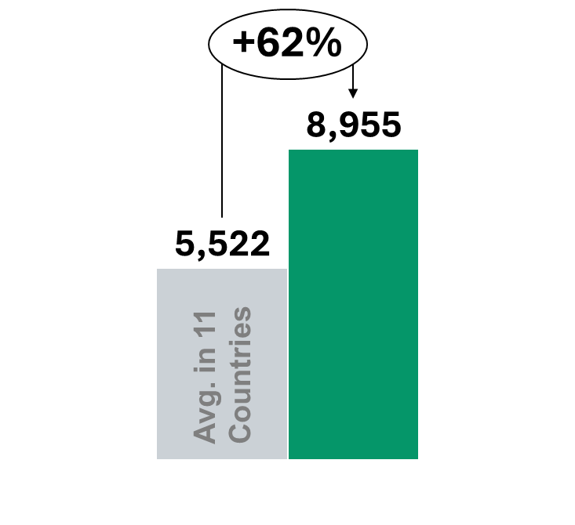 |  |  |  | 330.0  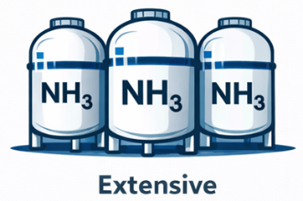 |  | 
Overall Status |  | Strategies |  | Road Map |  | Implementation &  Development Plans
- Mission-led hydrogen market focused on rapid scale-up and cost reduction  - Policy framework prioritises industrial substitution and domestic manufacturing  - Deployment driven by CAPEX incentives, rather than market-based revenue support  - Model designed to accelerate volumes quickly, with market mechanisms evolving later  . |  | - Positions green hydrogen as a strategic tool for industrial decarbonisation and energy security  - Strong focus on substituting existing grey hydrogen in priority sectors:  - Refineries  - Fertilisers  - Chemicals  - Emphasises domestic manufacturing, particularly electrolyser production  - Prioritises scale and learning effects over early market liberalisation |  | - Mission launch (2022): National Green Hydrogen Mission establishes scale-up and cost-reduction  objectives  - Industrial substitution phase (2022–2024): CAPEX incentives target replacement of grey hydrogen in industry  - Scaling phase (current):  Expansion of domestic  hydrogen production and electrolyser manufacturing  capacity  - Next phase: Gradual introduction of demand-side mechanisms as volumes and costs mature |  | - Execution led by the Ministry of New and Renewable Energy (MNRE)  - Core implementation instruments include:  - National Green Hydrogen Mission  - SIGHT (Strategic Interventions for Green  Hydrogen Transition) programme  - Programmes define:  - Eligible projects  - Support levels  - Capacity-linked incentives for production and manufacturing
Policies Framework
Fiscal & Tax  Incentives | - Limited tax incentives available through renewable energy and manufacturing frameworks  - No hydrogen-specific tax credits currently applied
Market and revenue support  mechanisms | - No market-wide revenue stabilisation instruments (e.g. CfDs or price guarantees) in place  - Policy signals future demand through targets and potential obligations under development  - Revenue and price risk largely remain with project developers at this stage
Direct public  funding | - National Green Hydrogen Mission provides CAPEX incentives for hydrogen production and  electrolyser manufacturing  - SIGHT awards support through competitive selection, linked to installed capacity and  cost-reduction targets  - Funding directly reduces upfront investment risk and accelerates deployment at scale  - Mission-based approach prioritises speed, volume and domestic capability building, rather than early bankability
Standards and  certification | - Initial definitions and standards for green hydrogen have been issued under the mission framework  - Standards establish eligibility for public support and reporting requirements  - Certification systems are still evolving and not yet fully aligned with international frameworks
Infrastructure-  enabling policies | - Infrastructure development focuses on on-site industrial integration and early hydrogen hubs  - Priority locations include refineries, fertiliser plants and chemical facilities  - Large national transport networks are deliberately deferred to reduce complexity in early stages
Sectoral focus / Priority sectors
Hydrogen demand is anchored in refining and fertiliser production, where hydrogen is already a critical input, particularly for ammonia synthesis. Emerging demand is also linked to industrial decarbonisation and domestic manufacturing, supported by national policy targets.
Renewable Energy Context
India has rapidly expanded renewable electricity capacity over the past decade, with installed renewable capacity exceeding 180 GW, driven primarily by large-scale solar PV and onshore wind deployment. Renewables account for a growing share of total installed power capacity and represent the majority of new generation additions in recent years. Competitive auctions, falling solar costs and national policy support have accelerated deployment across multiple states.
National energy policy targets 500 GW of non-fossil electricity capacity by 2030, forming a central pillar of India’s long-term decarbonisation strategy. Transmission expansion and grid integration remain critical to accommodate both renewable growth and future electrolyser load. The scale of renewable deployment, combined with strong industrial demand centres, provides structural conditions for domestic green hydrogen production under the National Green Hydrogen Mission.
Hydrogen Value Chain Structure
India follows a mission-led, scale-first hydrogen value chain model:
Production:
Rapid deployment of electrolyser projects co-located with industrial demand and renewable generation zones; strong emphasis on domestic manufacturing of electrolysers and allied supply chains to reduce costs.
Storage:
On-site and cluster-level storage solutions are prioritised for industrial offtake; larger geological storage options are at early assessment stages.
Transport / Distribution:
Distribution focused on site-to-site and short-distance logistics linking production hubs with refineries, fertiliser plants and industrial parks; long-distance pipeline networks are not yet widespread.
Applications:
Primary focus on industrial substitution (refineries, fertiliser, chemicals) and domestic manufacturing feedstocks, with pilot applications in mobility and power-sector blending planned as volumes grow.

Strategic Stage & Objective
Current Stage: Emerging to scaling under the National Green Hydrogen Mission.
Overall Objective:
Rapidly scale domestic green hydrogen production and electrolyser manufacturing to achieve cost reductions, support industrial decarbonisation and enhance energy security through domestic capability building.
Implementation emphasises CAPEX incentives, manufacturing support and target-driven deployment to create domestic supply chains and stimulate early market volumes.

Key Stakeholders
Core public and private stakeholders include:
- Ministry of New and Renewable Energy (MNRE) – mission leadership and programme design
- Ministry of Petroleum & Natural Gas, Ministry of Power and Ministry of Heavy Industry – cross-cutting roles for demand and industry policy
- State governments – site allocation, permitting and local infrastructure delivery
- Public sector undertakings and large industrial offtakers (refineries, fertiliser producers) – primary demand anchors
- Financial institutions and scheme administrators (programme implementation bodies)
- Domestic electrolyser manufacturers, research institutions and industry associations
Coordination is delivered through inter-ministerial committees and mission governance structures to align supply, demand and manufacturing objectives.

Impact on project development:
- CAPEX incentives have enabled early industrial-scale projects by reducing upfront costs
- Mission-based signalling has provided long-term policy confidence to investors and manufacturers
- Domestic manufacturing support has accelerated electrolyser capacity build-out
- Absence of revenue support means projects continue to rely on balance-sheet financing
Outcomes reflect a scale-first deployment model, with market-based bankability expected to emerge over time
Official Hydrogen Portals
- Ministry of New and Renewable Energy (MNRE) – National Green Hydrogen Mission:
https://mnre.gov.in
- National Green Hydrogen Mission official documentation:
https://mnre.gov.in/green-hydrogen
- Strategic Interventions for Green Hydrogen Transition (SIGHT) Programme:
https://mnre.gov.in/green-hydrogen/sight-programme
- Ministry of Petroleum and Natural Gas – hydrogen and industrial integration policies:
https://mopng.gov.in

Sources:
Strategy, roadmap and governance framework
- Government of India (2022), National Green Hydrogen Mission (official policy document).
- Ministry of New and Renewable Energy (MNRE), Hydrogen Mission Implementation Guidelines.
- NITI Aayog, Strategic policy papers related to green hydrogen and industrial decarbonisation.
Market and revenue support mechanisms
- MNRE policy notifications regarding demand targets and green hydrogen procurement frameworks (where applicable).
- Ministry of Power, relevant electricity market integration policies linked to hydrogen production.
- Government releases on potential demand-side mechanisms under development.
Direct public funding and CAPEX support (SIGHT)
- MNRE (2023), Strategic Interventions for Green Hydrogen Transition (SIGHT) Programme Guidelines.
- Government of India announcements on electrolyser manufacturing incentives under the Mission.
- Public tender documents and award announcements under the National Green Hydrogen Mission.
Standards and certification frameworks
- MNRE notifications defining “Green Hydrogen” and eligibility criteria for support schemes.
- Bureau of Energy Efficiency (BEE) or related agencies’ technical definitions and reporting requirements (as applicable).
- Government publications outlining evolving certification and emissions accounting frameworks.
Infrastructure enabling policies (industrial integration)
- Government of India publications on hydrogen hubs and industrial integration (refineries, fertilisers, chemicals).
- Ministry of Petroleum and Natural Gas (MoPNG) documentation on hydrogen blending or refinery integration pilots.
Production capacity / pipeline and deployment status
- International Energy Agency (IEA) (2023), Global Hydrogen Review 2023, Paris: IEA.
- IEA Hydrogen Projects Database (latest available edition).
- Public announcements from NTPC, Indian Oil Corporation (IOCL), Reliance Industries and other major project developers.
Renewable energy context
- Ministry of New and Renewable Energy (MNRE), Renewable Energy Statistics and Capacity Data.
- Central Electricity Authority (CEA), Electricity Generation and Renewable Deployment Reports.

Japan
Japan’s hydrogen policy is governed through a highly centralised institutional framework, reflecting its strategic focus on energy security and demand creation. The Ministry of Economy, Trade and Industry (METI) leads strategy, regulation and funding, while JOGMEC supports financing, risk mitigation and international supply-chain development. MLIT is responsible for port, transport and logistics infrastructure relevant to hydrogen imports.
Japan has established formal safety, handling and regulatory frameworks for hydrogen, providing clarity for downstream deployment and infrastructure investment. Governance is mature and coordinated, positioning Japan as a demand-led market, focused on utilisation and supply-chain readiness rather than large-scale domestic production.
Green Hydrogen production  capacity  Operational  (kt H₂/y) | Green Hydrogen production  capacity Planned  (kt H₂/y) |  | Hydrogen  pipelines  (km) |  | Ammonia port  storage capacity  (Thousand tonnes) |  | Dominant market model
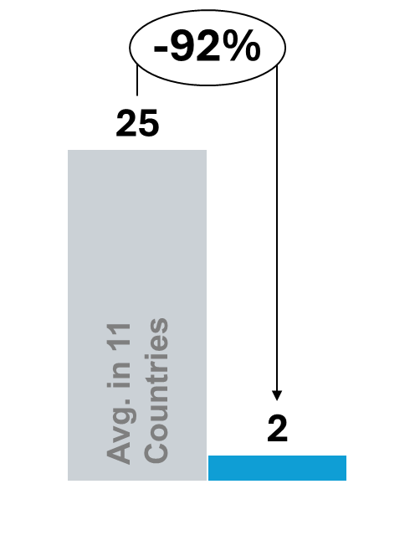 | 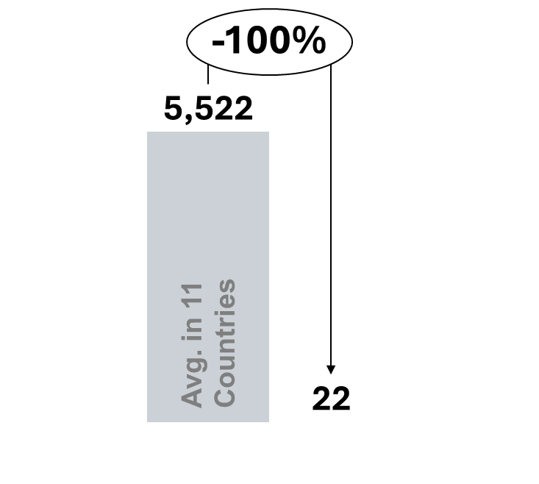 |  | 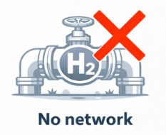 |  | 241.7   |  | 
Overall Status |  | Strategies |  | Road Map |  | Implementation &  Development Plans
- Demand-led hydrogen market focused on energy security and downstream adoption  - Policy framework prioritises affordability and supply-chain readiness, rather than domestic production scale  - Relies on imports and international supply chains to enable hydrogen use at scale  - Designed to make hydrogen a usable commodity for power and industry, even with constrained domestic production |  | - Positions hydrogen as a core pillar of energy security and decarbonisation  - Strong focus on downstream use in power generation and industry  - Emphasises development of international hydrogen supply chains, including imports  - Prioritises demand creation and utilisation over large-scale domestic production |  | - Strategy adoption (2017–2020): Hydrogen Strategy establishes hydrogen as a national priority for energy security  - Demand activation phase (2020–2022): Introduction of price-gap support and supply-chain programmes  - Scaling phase (current): Expansion of hydrogen and hydrogen-derived fuels in power and industrial use  - Next phase: Growth of import volumes and international supply chains aligned with climate targets |  | - Execution led by METI (Ministry of Economy, Trade and Industry), supported by JOGMEC  - Key focus areas:  - Import terminals and storage  - Supply-chain and logistics infrastructure  - End-use infrastructure for power and industry  - Programmes define eligible project types and implementation timelines across the value chain
Policies Framework
Fiscal & Tax  Incentives | - No hydrogen-specific tax credits are applied  - Fiscal support plays a limited role relative to other instruments
Market and revenue support  mechanisms | - Price-gap support mechanisms are implemented under the Hydrogen Society Promotion Act to bridge the cost difference between low-carbon hydrogen and incumbent fossil fuels  - Support is structured to anchor demand, ensuring that hydrogen can be purchased at prices compatible with power generation and industrial use despite higher production costs  - The mechanism functions as a long-term affordability guarantee for buyers, rather than a production subsidy, reducing demand-side risk  - By stabilising end-user prices, the framework enables early commercial deployment and utilisation at scale even when domestic production and global supply chains are still maturing
Direct public  funding | - Substantial public funding delivered through METI programmes and JOGMEC  - Targets:  - Import terminals and storage  - Conversion and utilisation infrastructure  - Supply-chain and demonstration projects  - Funding focuses on de-risking first deployments, not only hydrogen production assets
Standards and  certification | - Clear safety, handling and regulatory requirements for hydrogen are in place  - Formal definitions for low-carbon hydrogen reduce regulatory uncertainty  - Regulatory clarity supports infrastructure build-out and downstream investment
Infrastructure-  enabling policies | - Infrastructure policy prioritises import terminals, storage and logistics  - Focus on delivering hydrogen reliably to power and industrial sites  - National pipeline backbone is not a near-term priority; emphasis is on availability and usability at scale
Sectoral focus / Priority sectors
Hydrogen demand is driven mainly by power generation and mobility, using hydrogen and ammonia as low-carbon fuels. The focus is on imported hydrogen and derivatives, supporting fuel switching in power plants, transport equipment and downstream industrial uses rather than domestic production scale.
Renewable Energy Context
Japan has expanded renewable electricity capacity steadily over the past decade, primarily through solar PV deployment, complemented by wind, hydro and biomass. Installed renewable capacity exceeds 120 GW, with renewables representing an increasing share of the national electricity mix, although fossil fuels and imported LNG remain significant components of the system.
National energy policy targets further expansion of renewables toward 2030 as part of Japan’s carbon neutrality objective for 2050. However, land constraints and grid limitations moderate the pace of domestic renewable expansion. As a result, renewable growth supports hydrogen deployment, but Japan’s strategy remains structurally reliant on international supply chains for large-scale hydrogen imports.

Hydrogen Value Chain Structure
Japan applies a demand-led and import-oriented hydrogen value chain model:
Production:
Limited domestic electrolysis projects linked to renewables, complemented by large-scale imports of hydrogen and hydrogen derivatives (notably ammonia and liquefied hydrogen) from international partners.
Storage:
Development of dedicated storage facilities and import terminal infrastructure to manage liquefied hydrogen and ammonia supply chains.
Transport / Distribution:
Infrastructure focused on port-based logistics, shipping routes and downstream distribution to power plants and industrial facilities, rather than a national hydrogen pipeline backbone.
Applications:
Primary applications in power generation (including ammonia co-firing), mobility (fuel cell vehicles) and selected industrial uses, reflecting a downstream utilisation-focused strategy.

Strategic Stage & Objective
Current Stage: Demand-led scaling with international supply-chain integration.
Overall Objective:
Strengthen energy security and advance decarbonisation by establishing hydrogen as a strategic energy carrier, with emphasis on affordability, stable imports and large-scale downstream adoption.
Strategy implementation has evolved from early technology demonstration toward structured demand activation, price-gap support mechanisms and international cooperation agreements to secure long-term supply.

Key Stakeholders
Hydrogen governance and implementation are highly centralised and coordinated:
- Ministry of Economy, Trade and Industry (METI) – strategic leadership and policy design
- Japan Oil, Gas and Metals National Corporation (JOGMEC) – financing and international supply-chain support
- Ministry of Land, Infrastructure, Transport and Tourism (MLIT) – port and logistics infrastructure
- Major utilities and power generators
- Industrial conglomerates and technology manufacturers
- Financial institutions supporting infrastructure investment
- International bilateral partners (e.g., Australia, Middle East suppliers)
Stakeholder engagement is structured through government-led industry platforms and formalised international partnerships.

Impact on project development:
- Price-gap support has improved affordability for end-users in power and industry
- Public funding has reduced execution risk for supply-chain and import infrastructure
- Import-focused infrastructure has enabled hydrogen delivery without reliance on domestic production scale
- Combined instruments have supported early commercial deployment in downstream applications
- Policy outcomes reflect a demand-ready hydrogen system, rather than production-led market development

Official Hydrogen Portals
- Ministry of Economy, Trade and Industry (METI) – Hydrogen Policy:
https://www.meti.go.jp
- Japan Basic Hydrogen Strategy (official documentation):
https://www.meti.go.jp/english/policy/energy_environment/hydrogen
- JOGMEC – Hydrogen and international supply-chain initiatives:
https://www.jogmec.go.jp
- Hydrogen Society Promotion Act information (METI):
https://www.meti.go.jp/policy/energy_environment/hydrogen

Sources:
Strategy, roadmap and governance framework
- Ministry of Economy, Trade and Industry (METI) (2017; updated 2023), Basic Hydrogen Strategy.
- Government of Japan (2023), Hydrogen Strategy Revision and Implementation Roadmap documents.
- Hydrogen Society Promotion Act (official legal text and related government explanatory materials).
Market and revenue support mechanisms
- METI policy documentation on hydrogen price-gap support mechanisms and hydrogen/ammonia co-firing support schemes.
- Government of Japan publications on hydrogen demand creation programmes in power generation and industrial use.
- Official documentation related to hydrogen and ammonia support under the Green Transformation (GX) policy framework.
Direct public funding and supply-chain support
- JOGMEC (Japan Organization for Metals and Energy Security), Hydrogen Supply Chain Support Programmes.
- METI subsidy programmes for hydrogen production, infrastructure and utilisation projects.
- Government of Japan funding announcements for hydrogen import terminals and storage facilities.
Standards and certification frameworks
- METI and related regulatory guidance on hydrogen safety standards and low-carbon hydrogen definitions.
- Official documentation on emissions criteria for hydrogen and hydrogen-derived fuels under Japanese law.
Infrastructure enabling policies (import, storage and logistics)
- Ministry of Land, Infrastructure, Transport and Tourism (MLIT), Hydrogen import and port infrastructure planning documents.
- Government publications on hydrogen supply-chain demonstration projects (including international import pilots).
Production capacity / deployment status
- International Energy Agency (IEA) (2023), Global Hydrogen Review 2023, Paris: IEA.
- IEA Hydrogen Projects Database (latest available edition).
- Government of Japan releases on operational and planned hydrogen/ammonia projects.
Renewable energy context (if referenced in the profile)
- Agency for Natural Resources and Energy (ANRE), Electricity Generation Statistics.
- Government of Japan energy mix and renewable capacity publications.

Netherlands
The Netherlands follows an infrastructure-led governance model, where hydrogen policy is tightly integrated with regulated network development and port-based coordination. Strategic direction is set by the Ministry of Economic Affairs and Climate Policy, while execution is anchored in Gasunie, the state-owned gas and hydrogen network operator, which leads hydrogen transport planning and pipeline repurposing. Port authorities, particularly the Port of Rotterdam, play a central role in hub development, industrial clustering and import logistics.
Hydrogen transport and distribution are treated as regulated infrastructure assets within an EU-aligned legal framework. Regulatory alignment with EU sustainability rules and streamlined permitting support early system integration. Overall, the Netherlands is positioned as an advanced, infrastructure-first market, focused on reducing integration risk and enabling parallel project development at scale.
Green Hydrogen  production capacity  Operational  (kt H₂/y) | Green Hydrogen production capacity Planned  (kt H₂/y) |  | Hydrogen pipelines  (km) |  | Ammonia port  storage capacity  (Thousand tonnes) |  | Dominant market model
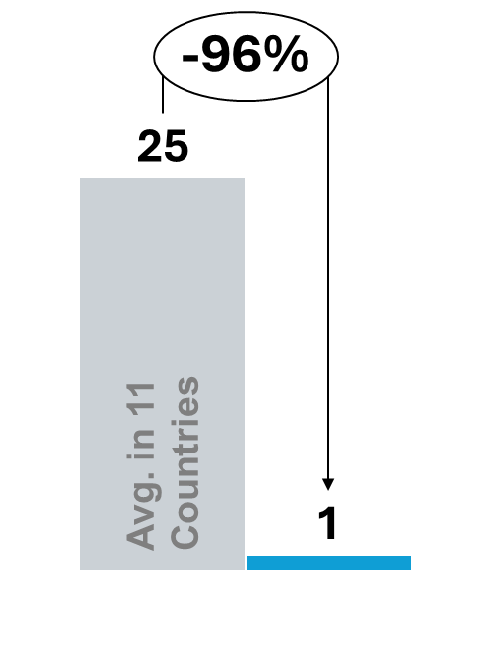 | 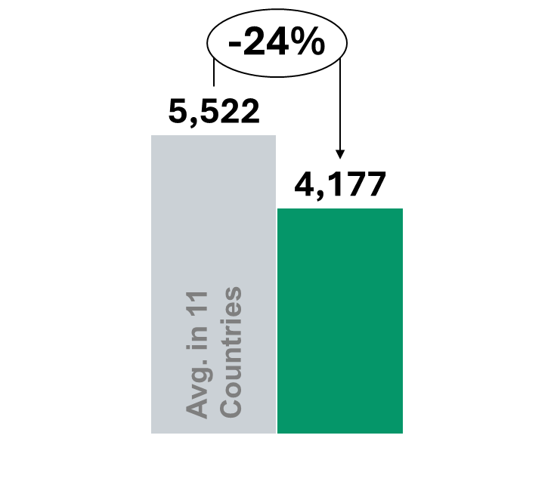 |  | 3,021   |  | 250.2  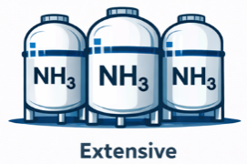 |  | 
Overall Status |  | Strategies |  | Road Map |  | Implementation &  Development Plans
- Advanced hydrogen market with a strong infrastructure-led development model  - Policy framework prioritizes system integration and scale, rather than individual project optimization  - Combines operating cost support with early investment in shared transport and port infrastructure  - Designed to enable parallel development of multiple projects and position the country as a European hydrogen gateway |  | - Positions hydrogen as a strategic system-integration tool within the national energy transition  - Leverages the country’s role as a European industrial and logistics hub  - Focus on:  - Industrial decarbonization  - Large-scale imports  - Integration of domestic production with ports and clusters  - Treats hydrogen infrastructure as a regulated, strategic asset, rather than a project-level add-on |  | - Strategy adoption (2020): National hydrogen strategy establishes infrastructure-led approach  - Infrastructure-first phase (2022): Early planning of hydrogen transport network and port-based hubs  - Market activation phase (current): Deployment of SDE++ to close operating cost gaps and enable projects  - Next phase: Scaling domestic production and imports through an integrated national hydrogen backbone aligned with EU objectives |  | - Execution focused on two core pillars:  - Rollout of a national hydrogen transport network, led by Gasunie  - Deployment of SDE++ operating support for eligible low-carbon hydrogen projects  - Infrastructure delivery  prioritizes:  - Pipelines repurpose  - Port-based hydrogen hubs (notably Rotterdam)
Policies Framework
Fiscal & Tax  Incentives | - Selective investment allowances and accelerated depreciation reduce effective CAPEX  - Fiscal incentives complement, but do not replace, budget-funded support schemes  - Tax measures play a supporting role within an infrastructure-led model
Market and revenue support  mechanisms | - SDE++ (Stimulering Duurzame Energieproductie en Klimaattransitie) provides operating support linked to verified emissions reductions  - Payments compensate the cost gap between low-carbon hydrogen and conventional alternatives  - The mechanism stabilizes early project economics by reducing operating cost exposure
Direct public  funding | - Public support primarily delivered through subsidy-based schemes rather than large CAPEX grants  - Support improves project cashflows over time, strengthening investment viability  - Focus is on enabling production assets facing early cost disadvantages
Standards and  certification | - EU-aligned definitions and sustainability criteria apply to supported projects  - Streamlined permitting and regulatory consistency reduce administrative delays  - Frameworks lower compliance risk for domestic and cross-border projects
Infrastructure-  enabling policies | - Hydrogen transport and distribution are treated as regulated network infrastructure, not project-specific assets  - A national hydrogen backbone is being developed through repurposing of existing gas pipelines, led by Gasunie  - Port-based hydrogen hubs (notably Rotterdam) integrate imports, domestic production and industrial demand  - This model reduces duplication, lowers integration risk and enables parallel development of multiple projects
Sectoral focus / Priority sectors
Hydrogen demand is driven by existing industrial consumption in refining and chemicals, combined with the country’s role as a European import and distribution hub. Hydrogen is used as a feedstock and energy carrier within large industrial clusters and redistributed to neighbouring markets.
Renewable Energy Context
The Netherlands has experienced accelerated renewable energy deployment over the past decade, particularly in offshore wind and solar PV. Installed renewable electricity capacity exceeds 40 GW, with renewables accounting for an increasing share of total power generation, supported by competitive auctions and EU-aligned climate targets.

National policy aims to significantly expand offshore wind capacity by 2030, positioning the Netherlands as a North Sea renewable hub. This expanding renewable base underpins domestic electrolysis ambitions while also supporting the country’s strategy to act as a gateway for imported hydrogen into the European market.
Hydrogen Value Chain Structure
The Netherlands applies an infrastructure-led hydrogen value chain model centred on industrial clusters and port logistics:
Production:
Domestic electrolysis linked to offshore wind expansion, complemented by large-scale imports of hydrogen and ammonia through major ports.
Storage:
Development of salt cavern storage and integration with existing gas storage facilities to provide system flexibility and support industrial demand.
Transport / Distribution:
Creation of a national hydrogen backbone through repurposed natural gas pipelines, led by Gasunie, connecting industrial clusters and ports, with integration into cross-border EU corridors.
Applications:
Primary applications in refining, chemicals and heavy industry within established industrial clusters (notably Rotterdam), alongside redistribution to neighbouring European markets.

Strategic Stage & Objective
Current Stage: Advanced / Infrastructure-first scaling model.
Overall Objective:
Position the Netherlands as a European hydrogen gateway by combining domestic production, large-scale imports and regulated transport infrastructure, enabling industrial decarbonisation and cross-border trade within the EU internal energy market.
Strategic implementation has progressed from policy definition toward coordinated backbone development, port-based hubs and operating cost support through the SDE++ mechanism.
Key Stakeholders
Hydrogen governance and implementation involve coordinated public and infrastructure actors:
- Ministry of Economic Affairs and Climate Policy – strategic leadership
- Gasunie – hydrogen transport network development and backbone coordination
- Port of Rotterdam Authority – hub development and import logistics
- Netherlands Enterprise Agency (RVO) – programme administration and support schemes
- Transmission system operators (electricity and gas)
- Industrial cluster consortia and private project developers
- European Union institutions (regulatory alignment and funding mechanisms)
Stakeholder coordination is structured through infrastructure planning processes and EU-level energy governance frameworks.
Impact on project development:
- Operating cost support has reduced the production cost gap during early market development
- Planned transport and port infrastructure has lowered integration risk for multiple projects in parallel
- Regulated network approach has reduced the need for bespoke, project-specific infrastructure
- The combined effect has enabled industrial offtake clustering and positioned the country as a gateway for domestic and imported hydrogen serving European demand
- Policy outcomes reflect system-scale enablement, rather than isolated project acceleration

Official Hydrogen Portals
- Government of the Netherlands – Hydrogen Strategy:
https://www.government.nl
- Netherlands Enterprise Agency (RVO) – Hydrogen programmes:
https://english.rvo.nl
- Gasunie – Hydrogen backbone development:
https://www.gasunie.nl
- Port of Rotterdam – Hydrogen hub initiatives:
https://www.portofrotterdam.com

Sources:
Production capacity, project pipeline and infrastructure data
- International Energy Agency (IEA) (2023), Global Hydrogen Review 2023, Paris: IEA.
- International Energy Agency (IEA), Hydrogen Projects Database (latest available edition).
- Gasunie, National Hydrogen Network Development Plans and Hydrogen Backbone documentation.
Strategy, roadmap and governance framework
- Ministry of Economic Affairs and Climate Policy (2020), Government Strategy on Hydrogen.
- Dutch National Hydrogen Programme documentation.
- European Commission, EU Hydrogen Strategy and related State Aid decisions (as applicable to the Netherlands).
Market and revenue support mechanisms (SDE++)
- Ministry of Economic Affairs and Climate Policy, SDE++ (Stimulering Duurzame Energieproductie en Klimaattransitie) official scheme documentation.
- Netherlands Enterprise Agency (RVO), SDE++ programme guidelines and eligibility criteria.
Public funding and financing mechanisms
- RVO (Netherlands Enterprise Agency), Hydrogen and Energy Transition Support Schemes.
- Dutch Climate Agreement and related public funding instruments for industrial decarbonisation.
Standards and certification frameworks
- European Commission, Delegated Acts under the Renewable Energy Directive (RFNBO).
- EU Guarantees of Origin framework (AIB / EECS system).
Renewable energy context
- Netherlands Statistics Office (CBS), Renewable Electricity Statistics.
- Ministry of Economic Affairs and Climate Policy, National Energy and Climate Plan (NECP).
Hydrogen value chain and infrastructure planning
- Gasunie, Hydrogen Backbone and Pipeline Repurposing Plans.
- Port of Rotterdam Authority, Hydrogen Hub and Import Infrastructure Documentation.
- European Hydrogen Backbone Initiative (relevant sections on the Netherlands).

Peru
Peru is in a planning-oriented governance phase for green hydrogen. The Ministry of Energy and Mines (MINEM) lead policy development, with current activity focused on roadmaps, studies and stakeholder engagement rather than deployment programmes. ProInversión supports investment promotion and early project structuring.
Hydrogen-specific regulation, certification and permitting frameworks are not yet operational, and no dedicated market or funding instruments are in place. Peru remains at a pre-deployment stage, where governance is oriented toward defining future pathways rather than enabling near-term execution.
Green Hydrogen  production capacity  Operational  (kt H₂/y) | Green Hydrogen production  capacity Planned  (kt H₂/y) |  |  | Hydrogen pipelines  (km) |  | Ammonia port  storage capacity  (Thousand tonnes) |  | Dominant market model
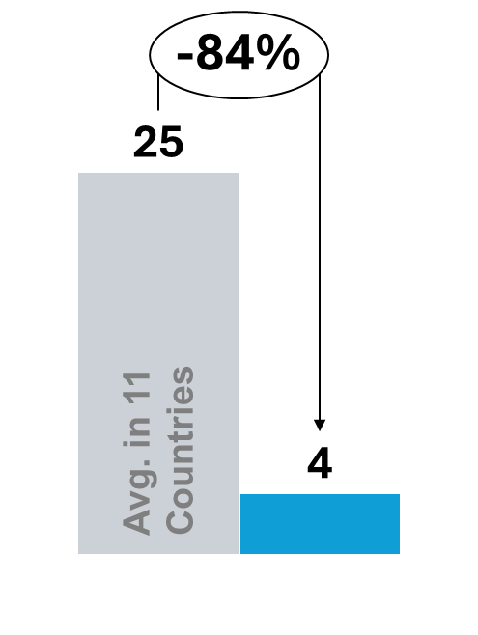 | 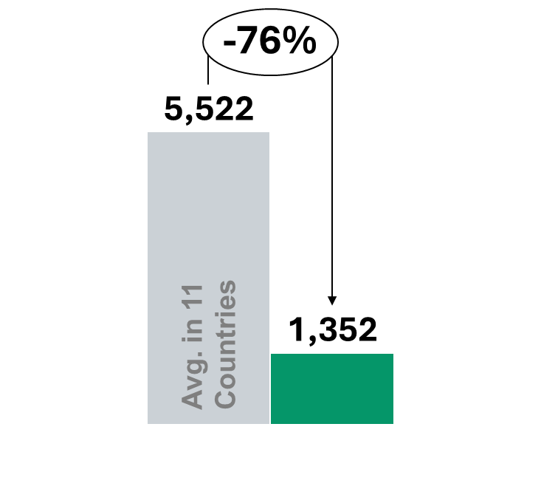 |  |  |  |  |  |  | 
Overall Status |  |  | Strategies |  | Road Map |  | Implementation &  Development Plans
- Pre-deployment hydrogen market with no active project pipeline  - Green hydrogen is framed as a long-term opportunity, not yet an industrial agenda  - Policy focus remains on definition, analysis and sequencing  - No market creation, de-risking or infrastructure deployment instruments are in place |  |  | - Positions green hydrogen as a future component of the energy transition  - Focuses on understanding potential applications rather than enabling deployment  - Does not prioritise near-term production, demand creation or exports  - Strategy remains exploratory and non-committal in implementation terms |  | - Roadmap publication (2022): Green Hydrogen Roadmap outlines potential applications and indicative phases  - Analytical phase (current): Focus on studies, diagnostics and regulatory exploration  - Next phase: Definition of enabling instruments contingent on future policy  decisions |  | - No operational development plans or deployment programmes in place  - Policy activity limited to:  - Planning and analytical studies  - Stakeholder engagement  - Led by the Ministry of Energy and Mines (MINEM)  - No defined funding schemes, market support mechanisms or  infrastructure programmes
Policies Framework
Fiscal & Tax  Incentives |  | - No hydrogen-specific fiscal or tax incentives are applied  - Projects may only access general renewable energy tax provisions, if applicable
Market and revenue support  mechanisms |  | - No revenue support mechanisms (e.g. CfDs, price guarantees or offtake schemes)  - No structured public instruments to reduce price or demand risk
Direct public  funding |  | - No dedicated CAPEX grants or co-financing programmes for hydrogen deployment  - Public activity has focused on studies, diagnostics and planning  - Public funding does not yet function as a de-risking instrument for projects
Standards and  certification |  | - Green Hydrogen Roadmap provides:  - Definitions  - Indicative applications  - High-level regulatory pathways  - No operational certification schemes, permitting rules or emissions accounting frameworks are in place
Infrastructure-  enabling policies |  | - No active system-level infrastructure policies for hydrogen  - No plans for:  - Hydrogen hubs  - Transport networks  - Storage corridors  - Port-linked export infrastructure  - Infrastructure considerations remain at a conceptual stage
Sectoral focus / Priority sectors
Hydrogen demand remains at a planning and conceptual stage, with potential future use identified in mining and heavy transport. These sectors are considered candidates for early hydrogen substitution due to high energy intensity, but no large-scale demand has yet materialised.
Renewable Energy Context
Peru has a diversified electricity mix supported by hydropower, natural gas and a growing share of non-conventional renewables, including solar PV and wind. Installed renewable capacity exceeds 15 GW, with hydropower accounting for the majority of renewable generation, while solar and wind have expanded gradually through competitive auctions and private investment.
National energy planning envisions continued diversification of the generation mix toward 2030, although renewable expansion has progressed more gradually compared to regional peers. Transmission development and geographic dispersion of demand centres remain relevant system considerations. Peru’s renewable resource potential, particularly in solar-rich southern regions and wind corridors, provides long-term structural conditions for green hydrogen development, though large-scale integration remains at a conceptual stage.

Hydrogen Value Chain Structure
Peru currently reflects a planning-oriented and pre-deployment hydrogen value chain model:
Production:
No commercial-scale green hydrogen production is operational; potential electrolysis projects remain at feasibility or conceptual stages, linked to renewable resource zones.
Storage:
Storage solutions are not yet developed beyond conceptual assessments; system-level and geological storage options remain under evaluation.
Transport / Distribution:
No dedicated hydrogen transport infrastructure is in place; distribution pathways would likely rely initially on short-distance logistics or port-based export corridors, subject to future project development.
Applications:
Potential future applications identified in mining, heavy transport and industrial substitution; however, no large-scale demand has materialised to date.
Strategic Stage & Objective
Current Stage: Pre-deployment / planning and diagnostic phase.
Overall Objective:
Define an enabling framework and long-term development pathway for green hydrogen, identifying priority sectors and regulatory adjustments before introducing financial or market-based instruments.
Implementation remains focused on roadmap development, analytical studies and stakeholder engagement, with future scaling contingent on regulatory clarification and investment conditions.
Key Stakeholders
Hydrogen-related governance and policy development involve:
- Ministry of Energy and Mines (MINEM) – strategic leadership and roadmap development
- ProInversión – investment promotion and project structuring support
- Environmental authorities – permitting and environmental compliance
- Regional governments and port authorities – potential infrastructure enablers
- Mining sector representatives – identified as potential early demand anchors
- International organisations and multilateral development partners – technical assistance and policy support
Stakeholder engagement is primarily consultative, focused on studies, diagnostics and early market exploration.

Impact on project development:
- Absence of fiscal, funding and revenue support leaves CAPEX and price risk fully with developers
- Lack of infrastructure planning limits system integration opportunities
- Regulatory frameworks are not yet operational for project permitting or certification
- No conditions are in place to support bankability or scale
- Outcomes reflect a planning-only environment, rather than project execution

Official Hydrogen Portals
- Ministry of Energy and Mines (MINEM) – policy and roadmap information:
https://www.gob.pe/minem
- Peru National Hydrogen Roadmap (official documentation):
https://h2.pe/uploads/01_Bases-para-la-elaboracion-estrategia-H2V-Peru.pdf
- ProInversión – investment promotion and infrastructure projects:
https://www.proinversion.gob.pe
- National Environmental Certification Service (SENACE) – permitting and environmental approvals:
https://www.gob.pe/senace

Sources:
Strategy, roadmap and governance framework
- Ministerio de Energía y Minas (MINEM) (2022), Hoja de Ruta del Hidrógeno Verde en el Perú.
- MINEM, official publications on energy transition and hydrogen development planning.
- Government of Peru (gob.pe), policy communications related to hydrogen and industrial decarbonisation.
- ProInversión, investment promotion documentation referencing hydrogen-related opportunities.
Market and revenue support mechanisms
- MINEM roadmap documentation confirming the absence of dedicated market-based revenue mechanisms (e.g., CfDs, price guarantees or hydrogen auctions).
- Government policy notes outlining potential future instruments under evaluation.
- Public communications indicating that hydrogen deployment remains at a planning and exploratory stage.
Direct public funding and financing mechanisms
- MINEM publications confirming that current public activity is limited to studies, diagnostics and stakeholder engagement.
- Public tender documentation for hydrogen-related feasibility studies (where applicable).
- Government budget documents referencing energy transition analytical support.
Standards and certification frameworks
- MINEM (2022), Hoja de Ruta del Hidrógeno Verde en el Perú — definitions and indicative regulatory pathways.
- National environmental and energy permitting frameworks applicable to energy projects (general applicability; no hydrogen-specific certification framework yet).
- Government publications referencing future regulatory development needs for export alignment.
Infrastructure enabling policies
- MINEM roadmap sections referencing hydrogen hubs, ports and transport corridors at a conceptual level.
- National infrastructure and logistics planning documents (as applicable to potential hydrogen export corridors).
- Government publications confirming that no dedicated hydrogen transport networks or storage systems have yet been established.
Production capacity / pipeline and deployment status
- International Energy Agency (IEA) (2023), Global Hydrogen Review 2023, Paris: IEA.
- IEA Hydrogen Projects Database (latest available edition).
- Public announcements of conceptual or feasibility-stage hydrogen projects in Peru.
Renewable energy context
- MINEM, National Energy Balance and Renewable Capacity Statistics.
- COES (Comité de Operación Económica del Sistema Interconectado Nacional), electricity generation and renewable deployment reports.
- International Renewable Energy Agency (IRENA), Renewable Energy Statistics (Peru profile).

South Korea
South Korea follows a state-led governance model under a dedicated legal framework for the hydrogen economy. The Ministry of Trade, Industry and Energy (MOTIE) leads hydrogen strategy and regulation, supported by cross-ministerial coordination bodies. State-owned enterprises, notably KEPCO and KOGAS, play a central role in implementation, including power-sector deployment, import terminals and storage infrastructure.
A dedicated hydrogen economy and safety law establishes certification and eligibility rules for clean hydrogen. This institutional and legal clarity positions South Korea as a demand-driven scaling market, anchored in power-sector offtake and downstream deployment.
Green Hydrogen  production capacity  Operational  (kt H₂/y) | Green Hydrogen production capacity Planned  (kt H₂/y) |  | Hydrogen  pipelines  (km) |  | Ammonia port  storage capacity  (Thousand tonnes) |  | Dominant market model
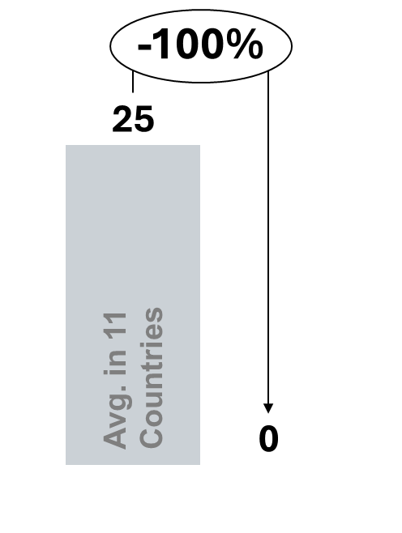 | 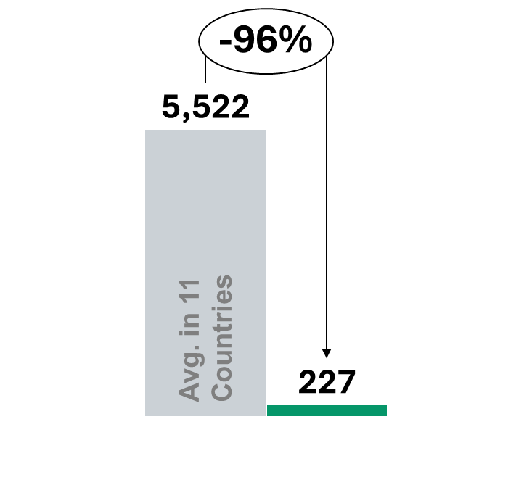 |  | 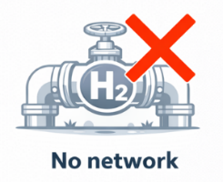 |  | 125.0  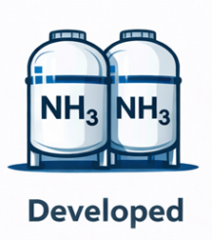 |  | 
Overall Status |  | Strategies |  | Road Map |  | Implementation &  Development Plans
- Demand-led hydrogen market anchored in the power sector  - Policy framework prioritises downstream demand creation and revenue certainty  - Relies on long-term power procurement rather than production subsidies  - Model designed to enable hydrogen and ammonia use at scale, even with limited domestic production |  | - Positions hydrogen as a strategic pillar for energy security and power-sector decarbonisation  - Strong emphasis on downstream deployment, particularly electricity generation  - Demand creation is prioritised over large-scale domestic production  - Imports and supply-chain development are central to the strategy |  | - Legal framework established (2019): Hydrogen Economy Promotion and Hydrogen Safety Management Act enacted  - Demand activation phase (2021–2022): Clean hydrogen policies introduced for power generation  - Market creation phase (current): Deployment of the Clean Hydrogen Power Generation Bidding Market (CHPS)  - Next phase: Expansion of clean hydrogen and ammonia use in power generation and downstream infrastructure |  | - Execution under the Hydrogen Economy Promotion and Hydrogen Safety Management Act  - Core implementation instruments include:  - Clean Hydrogen Power Generation Bidding Market (CHPS)  - Public programmes led by KEPCO and KOGAS  - Infrastructure development focused on import terminals, storage and downstream distribution
Policies Framework
Fiscal & Tax  Incentives | - Targeted tax credits and deductions apply to hydrogen-related facilities and equipment  - Incentives are aligned with national industrial and clean energy objectives
Market and revenue support  mechanisms | - Clean Hydrogen Power Generation Bidding Market (CHPS) creates demand through the  electricity market  - Power generators using clean hydrogen or ammonia co-firing compete in tenders for long-term power contracts (typically up to 15 years)  - Contracts provide predictable, contract-backed revenues, anchoring hydrogen demand  downstream  - While production is not subsidised directly, CHPS reduces demand risk across the hydrogen and ammonia supply chain
Direct public  funding | - Public funding supports hydrogen supply chains and enabling infrastructure  - Focus areas include production facilities, import terminals and storage  - Funding targets early deployment and infrastructure readiness rather than large production CAPEX
Standards and  certification | - Clean hydrogen certification system established under national hydrogen legislation  - Certification defines emissions-based eligibility thresholds and grading criteria  - Eligibility for CHPS and other support schemes is linked to certification compliance
Infrastructure-  enabling policies | - Infrastructure policy prioritises import terminals, storage facilities and downstream distribution  - Development of hydrogen cities and end-use systems is supported  - Limited focus on a national hydrogen pipeline backbone
Sectoral focus / Priority sectors
Hydrogen demand is led by power generation and mobility, particularly fuel cells for electricity generation and hydrogen vehicles. Industrial use and imported hydrogen support the country’s strategy to decarbonise energy consumption while relying on international supply chains.
Renewable Energy Context
South Korea has expanded renewable electricity capacity over the past decade, primarily through solar PV and emerging offshore wind development. Despite this growth, the power system continues to rely significantly on imported fossil fuels and nuclear generation. National energy plans target a gradual increase in the renewable share of electricity generation toward 2030 and 2050 decarbonisation objectives.
Land constraints and high population density limit large-scale onshore renewable expansion, reinforcing the country’s strategy to combine domestic renewable deployment with hydrogen imports. Renewable growth supports electrolysis projects, but hydrogen policy is structurally aligned with energy security and diversified supply chains.

Hydrogen Value Chain Structure
South Korea applies a demand-driven and legislated hydrogen value chain model:
Production:
Combination of domestic electrolysis projects linked to renewables and increasing reliance on imported hydrogen and ammonia to meet projected demand.
Storage:
Development of storage facilities at import terminals and industrial sites, with intermediate storage solutions designed to support power generation and downstream use.
Transport / Distribution:
Infrastructure centred on import terminals, port logistics and regional distribution networks supplying hydrogen to power plants, hydrogen refuelling stations and industrial users; development is coordinated under national legislation.
Applications:
Primary focus on power generation through the Clean Hydrogen Power Generation Bidding Market (CHPS), alongside mobility (fuel cell vehicles) and selected industrial substitution.

Strategic Stage & Objective
Current Stage: Scaling under a dedicated hydrogen legislative framework.
Overall Objective:
Establish a certified and demand-secured hydrogen market anchored in the power sector, accelerating decarbonisation while strengthening energy security through diversified supply chains.
Implementation has progressed from legislative adoption toward structured demand creation mechanisms, long-term power contracts and coordinated development of import and distribution infrastructure.

Key Stakeholders
Hydrogen governance and implementation involve coordinated public and industrial actors:
- Ministry of Trade, Industry and Energy (MOTIE) – strategic leadership and policy design
- Korea Electric Power Corporation (KEPCO) – integration into the electricity market
- Korea Gas Corporation (KOGAS) – import, storage and distribution infrastructure
- Major industrial conglomerates and utilities – project developers and offtakers
- Financial institutions and public funding bodies
- Port authorities and logistics operators
Coordination occurs under the Hydrogen Economy Promotion and Hydrogen Safety Management Act, which formalises institutional roles and certification requirements.

Impact on project development:
- Power-sector demand auctions have created a stable offtake pathway for clean hydrogen and ammonia
- Long-term power contracts have reduced revenue uncertainty for downstream users
- Certification-linked eligibility has aligned demand support with emissions performance
- Import-oriented infrastructure has enabled deployment without reliance on domestic production scale
- Policy outcomes reflect a demand-secured hydrogen ecosystem, anchored in electricity generation

Official Hydrogen Portals
- Ministry of Trade, Industry and Energy (MOTIE):
https://www.motie.go.kr
- Hydrogen Economy Promotion and Hydrogen Safety Management Act information (MOTIE):
https://www.motie.go.kr
- Korea Electric Power Corporation (KEPCO):
https://home.kepco.co.kr
- Korea Gas Corporation (KOGAS):
https://www.kogas.or.kr

Sources:
Strategy, roadmap and governance framework
- Government of the Republic of Korea (2019), Hydrogen Economy Roadmap.
- Ministry of Trade, Industry and Energy (MOTIE), Hydrogen Policy and Implementation Plans.
- Hydrogen Economy Promotion and Hydrogen Safety Management Act (official legal text and amendments).
Market and revenue support mechanisms (CHPS)
- MOTIE (2022–2023), Clean Hydrogen Power Generation Bidding Market (CHPS) framework documentation.
- Korea Power Exchange (KPX), Clean hydrogen power procurement guidelines and auction rules.
- Government publications on hydrogen and ammonia co-firing support schemes.
Direct public funding and infrastructure support
- MOTIE funding programmes for hydrogen supply chains and electrolyser deployment.
- Korea Gas Corporation (KOGAS), Hydrogen import terminal and storage infrastructure documentation.
- Korea Electric Power Corporation (KEPCO), Hydrogen-based power generation programme materials.
Standards and certification frameworks
- Government of Korea, Clean Hydrogen Certification Framework under the Hydrogen Economy Act.
- MOTIE technical and emissions criteria for hydrogen eligibility under CHPS and related schemes.
Infrastructure enabling policies (import, storage and distribution)
- KOGAS documentation on LNG terminal adaptation and hydrogen import infrastructure.
- Government publications on Hydrogen Cities programme and downstream distribution systems.
Production capacity / pipeline and deployment status
- International Energy Agency (IEA) (2023), Global Hydrogen Review 2023, Paris: IEA.
- IEA Hydrogen Projects Database (latest available edition).
- Public announcements of hydrogen power generation and ammonia co-firing projects.
Renewable energy context
- Korea Energy Agency (KEA), Renewable Energy Statistics.
- MOTIE Electricity Supply Plans and renewable deployment statistics.

United Kingdom
The United Kingdom applies a centrally designed governance framework combined with cluster-based delivery. The Department for Energy Security & Net Zero (DESNZ) leads hydrogen strategy, market design and eligibility rules. Ofgem regulates gas and electricity networks, including future hydrogen adaptation, while the Low Carbon Contracts Company (LCCC) acts as the contractual counterparty for hydrogen revenue support mechanisms.
Legal clarity is provided through the UK Low Carbon Hydrogen Standard, which defines emissions thresholds and eligibility for support. Deployment is organised through designated industrial clusters, with coordination across devolved administrations. This structure positions the UK as a scaling market, emphasising standardised contracts and replicable project pathways.
Green Hydrogen production  capacity  Operational  (kt H₂/y) | Green Hydrogen production  capacity Planned  (kt H₂/y) |  | Hydrogen pipelines  (km) |  | Ammonia port  storage capacity  (Thousand tonnes) |  | Dominant market model
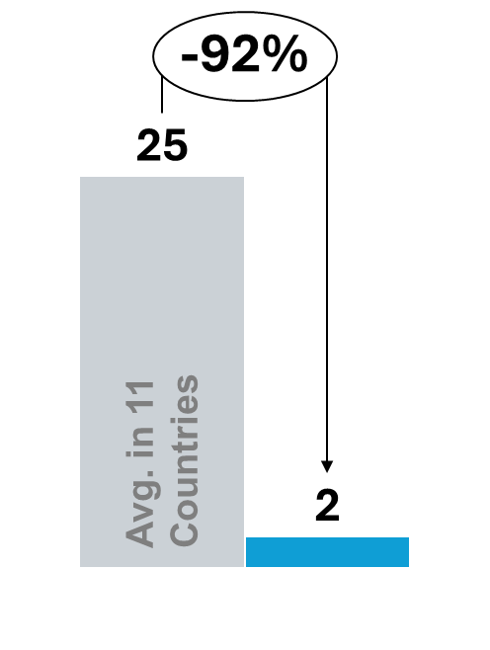 | 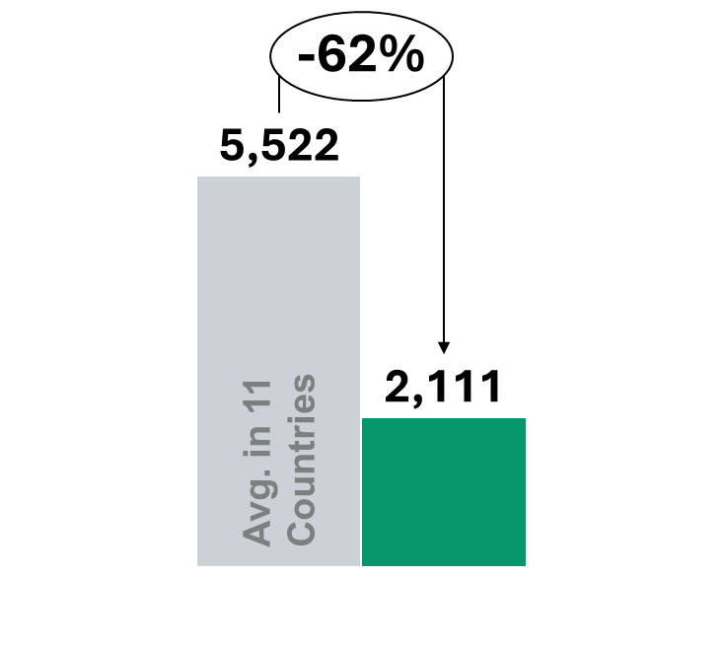 |  | 1,255  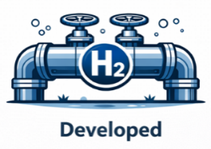 |  | 69.8  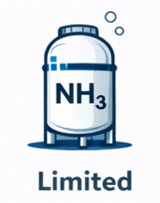 |  | 
Overall Status |  | Strategies |  | Road Map |  | Implementation &  Development Plans
- Scaling hydrogen market with a revenue-contract and cluster-based deployment model  - Policy framework focused on reducing market risk and enabling investable projects  - Combines standardised revenue support with geographically concentrated industrial clusters  - Designed to support replicable project development, rather than one-off pilots |  | - Positions hydrogen as a key instrument for industrial decarbonisation  - Deployment centred on defined regional industrial clusters linked to existing energy and industrial infrastructure  - Prioritises early market creation and scale through standardised contractual frameworks  - Aligns hydrogen deployment with net-zero targets and industrial decarbonisation priorities |  | - Strategy adoption (2021): UK Hydrogen Strategy establishes hydrogen as a pillar of industrial decarbonisation  - Market design phase (2022): Hydrogen Production Business Model (HPBM) and Low Carbon Hydrogen Standard introduced  - Market allocation phase (2023–current): Hydrogen Allocation Rounds (HAR) award revenue contracts to projects  - Next phase: Expansion of cluster-based deployment and scaling of contracted production capacity |  | - Execution focused on three core mechanisms:  - Hydrogen Allocation Rounds under the Hydrogen Production Business Model  - Low Carbon Hydrogen Agreement (LCHA) as the standard contract vehicle  - Cluster-based infrastructure and industrial decarbonisation programmes  - Delivery organised around regional industrial clusters, rather than standalone projects
Policies Framework
Fiscal & Tax  Incentives | - No hydrogen-specific tax incentives are applied  - Projects rely on general capital allowance regimes  - Fiscal policy plays a limited role in deployment
Market and revenue support  mechanisms | - Hydrogen Production Business Model (HPBM) provides revenue support through standardised long-term contracts  - Projects are competitively selected via Hydrogen Allocation Rounds (HAR) and contracted under the Low Carbon Hydrogen Agreement (LCHA)  - Contracts reduce the cost gap between low-carbon hydrogen and conventional alternatives  - The model delivers predictable, contract-backed revenues, reducing revenue uncertainty and enabling replication across projects
Direct public  funding | - Public funding complements revenue contracts through:  - Competitive funding rounds  - Industrial decarbonisation programmes  - Supports early projects, cluster development and enabling infrastructure  - Reduces first-mover risk alongside the contract model
Standards and  certification | - UK Low Carbon Hydrogen Standard defines emissions thresholds and sustainability criteria  - Certification links eligibility for support to verifiable emissions performance  - Reduces regulatory and reputational risk for investors and offtakers.
Infrastructure-  enabling policies | - Infrastructure development organised around hydrogen hubs and industrial clusters  - Integration with existing gas networks and, where relevant, CO₂ transport and storage  infrastructure  - Cluster model enables shared infrastructure, coordinated permitting and aggregated offtake
Sectoral focus / Priority sectors
Demand is concentrated in industrial clusters, where hydrogen substitutes natural gas in industrial heat, refining and chemical processes. Additional demand drivers include power generation with hydrogen-ready turbines and early applications in heavy transport within cluster regions.
Renewable Energy Context
The United Kingdom has significantly expanded renewable electricity capacity over the past decade, driven primarily by offshore wind, onshore wind and solar PV. Installed renewable capacity exceeds 60 GW, with renewables accounting for a growing share of total electricity generation, supported by Contracts for Difference (CfD) auctions and net-zero commitments.
National targets include a substantial increase in offshore wind capacity by 2030, alongside continued decarbonisation of the power sector. This expanding renewable base provides the foundation for electrolysis-based hydrogen production, particularly within designated industrial clusters linked to existing energy infrastructure.
Hydrogen Value Chain Structure
The United Kingdom applies a cluster-based hydrogen value chain model integrated with existing energy systems:
Production:
Electrolysis projects linked to renewable electricity and, in some cases, CCUS-enabled low-carbon hydrogen, supported through competitive allocation rounds under the Hydrogen Production Business Model.
Storage:
Development of geological storage, including salt caverns, particularly within industrial cluster regions to provide flexibility and support large-scale deployment.
Transport / Distribution:
Cluster-based hydrogen networks connected to industrial users, with exploration of pipeline repurposing and regulated network adaptation under Ofgem oversight.
Applications:
Primary applications in industrial heat, refining and chemicals within regional clusters, alongside emerging use in power generation, dispatchable generation and selected heavy transport applications.
Strategic Stage & Objective
Current Stage: Scaling / Contract-based market creation.
Overall Objective:
Establish a replicable, contract-backed hydrogen market that supports industrial decarbonisation and contributes to achieving net-zero emissions by 2050, while maintaining system reliability and competitiveness.
Implementation has progressed from strategy definition toward structured allocation rounds, standardised long-term contracts and coordinated cluster development to enable parallel project deployment.
Key Stakeholders
Hydrogen governance and delivery involve coordinated national and regulatory institutions:
- Department for Energy Security & Net Zero (DESNZ) – strategic leadership and market design
- Ofgem – regulation of gas and electricity networks
- Low Carbon Contracts Company (LCCC) – contractual counterparty for hydrogen revenue support
- Industrial cluster partnerships and private project developers
- National Grid and regional network operators
- UK Infrastructure Bank and public funding bodies
- Devolved administrations (Scotland, Wales, Northern Ireland) for regional implementation
Stakeholder engagement is structured through consultation processes linked to allocation rounds and cluster-based decarbonisation programmes.
Impact on project development:
- Standardised revenue contracts have reduced revenue uncertainty and improved project bankability
- Competitive allocation rounds have created a repeatable pathway from project selection to delivery
- Cluster-based deployment has lowered coordination and infrastructure risk
- The combined approach has enabled parallel development of multiple projects, rather than isolated pilots
- Policy outcomes reflect a scalable and replicable market design, aligned with industrial decarbonisation goals

Official Hydrogen Portals
- UK Government – UK Hydrogen Strategy:
https://www.gov.uk/government/publications/uk-hydrogen-strategy
- Department for Energy Security & Net Zero (DESNZ):
https://www.gov.uk/government/organisations/department-for-energy-security-and-net-zero
- Hydrogen Production Business Model and Allocation Rounds:
https://www.gov.uk/government/collections/hydrogen-production-business-model
- Low Carbon Hydrogen Standard:
https://www.gov.uk/government/publications/low-carbon-hydrogen-standard

Sources:
Strategy, roadmap and governance framework
- Department for Energy Security and Net Zero (DESNZ) (2021), UK Hydrogen Strategy.
- DESNZ (2022), Hydrogen Transport and Storage Business Model (as applicable) and related policy updates.
- UK Government, Hydrogen policy and delivery updates (Hydrogen Allocation Rounds, policy delivery timeline).
Market and revenue support mechanisms (HPBM / HAR / LCHA)
- DESNZ (2022), Hydrogen Production Business Model (HPBM): policy design and implementation documentation.
- DESNZ, Hydrogen Allocation Rounds (HAR): published results and project lists (HAR1 / HAR2 where available).
- Low Carbon Hydrogen Agreement (LCHA): standard contract documentation published by UK Government/DESNZ.
Direct public funding and complementary programmes
- UK Government / DESNZ, Net Zero Hydrogen Fund (NZHF): guidance and award announcements.
- UK Government, Industrial Decarbonisation Strategy and cluster programme documentation (including sequencing and enabling infrastructure support).
- UK Infrastructure Bank (as relevant to low-carbon infrastructure finance).
Standards and certification frameworks
- DESNZ (2023), UK Low Carbon Hydrogen Standard (current version and methodology).
- UK Government guidance on hydrogen emissions accounting and eligibility thresholds for support schemes.
Infrastructure enabling policies (clusters, networks and integration)
- UK Government, Hydrogen transport and storage policy publications (including cluster enablement approach).
- National Grid / relevant UK network operators, published hydrogen transport planning where cited in government policy context.
- Cluster delivery bodies / industrial cluster programme publications (where referenced in the profile).
Production capacity / pipeline and deployment status
- International Energy Agency (IEA) (2023), Global Hydrogen Review 2023, Paris: IEA.
- IEA, Hydrogen Projects Database (latest available edition).
- UK Government publications on selected projects under HAR/NZHF (as applicable).
Renewable energy context (if referenced in the table narrative)
- UK Government, Energy Trends and renewables generation statistics.
- National Grid ESO / DESNZ statistics on electricity generation mix and renewable capacity (as applicable).

International Energy Agency (IEA) (2025). Global Hydrogen Review. Paris: IEA; Government of Mexico (2025). Tercera Contribución Determinada a Nivel Nacional de México (NDC 3.0); Secretaría de Energía (SENER) (2023–2024). Prospectiva del Sector Eléctrico and national energy statistics.
International Energy Agency (IEA) (2019). The Future of Hydrogen: Seizing Today’s Opportunities. Paris: IEA; International Renewable Energy Agency (IRENA) (2022). Policies for Green Hydrogen. Abu Dhabi: IRENA.
International Renewable Energy Agency (IRENA) (2024). Green Hydrogen Strategy Design. Abu Dhabi: IRENA.
International Energy Agency (IEA) (2025). Global Hydrogen Review. Paris: IEA; ERM (2024). Estrategia Industrial de Hidrógeno Limpio de México. Prepared for the Asociación Mexicana de Hidrógeno, with analytical inputs from Centro Mario Molina.
ERM (2024). Estrategia Industrial de Hidrógeno Limpio de México. Prepared for the Asociación Mexicana de Hidrógeno, with analytical inputs from Centro Mario Molina.
International Renewable Energy Agency (IRENA) (2024). Green Hydrogen Strategy Design; World Bank / ESMAP (2024). Hydrogen for Development (H4D) analytical framework.
International Energy Agency (IEA). Hydrogen Production and Infrastructure Projects Database.
International Energy Agency (IEA), Hydrogen Production and Infrastructure Projects Database
International Energy Agency (IEA) (2025). Global Hydrogen Review. Paris: IEA.
International Renewable Energy Agency (IRENA) (2022). Policies for Green Hydrogen; International Energy Agency (IEA) (2025). Global Hydrogen Review.
Secretaría de Energía (SENER) (2024). Lineamientos en Materia de Hidrógeno; International Renewable Energy Agency (IRENA) (2022). Policies for Green Hydrogen.
Government of Mexico. Ley de Hidrocarburos; Ley de la Industria Eléctrica; Ley General de Cambio Climático.
International Energy Agency (IEA) (2025). Global Hydrogen Review. Paris: IEA; International Renewable Energy Agency (IRENA) (2024). Green Hydrogen Strategy Design.
Secretaría de Energía (SENER) (2024). Lineamientos en Materia de Hidrógeno; International Renewable Energy Agency (IRENA) (2022). Policies for Green Hydrogen.
International Energy Agency (IEA). Global Hydrogen Review (latest edition); International Renewable Energy Agency (IRENA). World Energy Transitions Outlook
International Energy Agency (IEA). The Future of Hydrogen; IRENA. Green Hydrogen Cost Reduction: Scaling up Electrolysers to Meet the 1.5°C Climate Goal.
International Energy Agency (IEA). Energy Technology Perspectives; IRENA. Hydrogen: A Renewable Energy Perspective.
International Energy Agency (IEA). Global Hydrogen Review; IRENA. Policies for Green Hydrogen.
International Energy Agency (IEA) (2023), Global Hydrogen Review 2023, Paris: IEA. The report identifies cost gaps, infrastructure constraints, regulatory uncertainty and demand risks as key barriers to hydrogen market scale-up.
I International Renewable Energy Agency (IRENA) (2022), Geopolitics of the Energy Transformation: The Hydrogen Factor, Abu Dhabi: IRENA. Highlights capital intensity, policy coordination challenges and enabling frameworks as determinants of hydrogen deployment.
World Bank (2023), Scaling Up Green Hydrogen for Development, Washington, DC: World Bank. Emphasises institutional readiness, regulatory clarity and risk mitigation mechanisms as preconditions for private investment.
OECD (2021), OECD Policy Responses to Hydrogen, Paris: OECD. Identifies governance alignment, policy sequencing and coordinated public intervention as critical to overcoming coordination failures in emerging hydrogen markets.
International Energy Agency (IEA). Global Hydrogen Review; International Renewable Energy Agency (IRENA). Policies for Green Hydrogen

